**Kevin Steyn**

**P8RYJR114**

**ITDA310 Project 2020**

Table of Contents

Question 1 2

1.1 2

1.2 2

1.3 3

1.4 6

1.5 7

Question 2 13

2.1 13

2.2 16

2.3 23

2.4 25

2.5 27

Question 3 28

3.1 28

3.2 47

3.3 64

3.4 64

3.5 73

Question 4 75

4.1 75

4.2 81

4.3 85

4.4 88

Question 5 96

Interface Walkthrough 96

Code Samples 115

Bibliography 126

# Question 1

## 1.1

|  |
| --- |
| **ENTITY TYPES** |
| * **Appointment** |
| * **AppointmentType** |
| * **CHWDrugAdministration** |
| * **CHWStaffLoginDetails** |
| * **CHWTest** |
| * **CHWToPatientAssignments** |
| * **DiagnosticTest** |
| * **EducationalVideo** |
| * **HouseholdMember** |
| * **Medicine** |
| * **Message** |
| * **MomConnect** |
| * **Patient** |
| * **PatientDiagnosis** |
| * **PatientPrescription** |
| * **PatientTreatment** |
| * **PregnancyStages** |
| * **Staff** |

Note: I intend for an instance of my database to be utilised by each of Broadreach’s branches in a localized fashion. I made this decision based on the fact that the project describes Broadreach being in possession of a separate “national data centre aggregate reporting system” to which data from each local system will be reported. I for this reason decided against creating a “Branch” entity type as all the information in an instance of database will pertain to a single branch.

## 1.2

## 1.3

|  |  |  |  |
| --- | --- | --- | --- |
| **Entity** | **Attribute** | **Type** | **Size** |
| Patient | PatientIdentifier | Int | 12 |
| RegisteredOn | date | N/A |
| PhoneNumber | varchar | 10 |
| Address | varchar | 60 |
| PatientName | varchar | 30 |
| PatientSurname | varchar | 30 |
| EmailAddress | varchar | 30 |
| Gender | varchar | 30 |
| Age | int | 3 |
| Pregnant | boolean | 1 |
| Diabetic | boolean | 1 |
| HIVPositive | boolean | 1 |
| IDNumber | varchar | 13 |
| Staff | StaffIdentifier | Int | 12 |
| PhoneNumber | varchar | 10 |
| Address | varchar | 60 |
| StaffType | varchar | 20 |
| StaffName | varchar | 30 |
| StaffSurname | varchar | 30 |
| EmailAddress | varchar | 30 |
| Gender | varchar | 30 |
| Age | int | 3 |
| CurrentlyEmployed | boolean | 1 |
| IDNumber | varchar | 13 |
| CHWtoPatientAssignments | GroupingIdentifier | Int | 12 |
| StaffIdentifier | int | 12 |
| PatientIdentifier | int | 12 |
| AppointmentType | TypeIdentifier | Int | 12 |
| AppointmentType | varchar | 30 |
| TypeDescription | varchar | 60 |

|  |  |  |  |
| --- | --- | --- | --- |
| **Entity** | **Attribute** | **Type** | **Size** |
| Appointment | AppointmentIdentifier | Int | 12 |
| PatientIdentifier | int | 12 |
| StaffIdentifier | int | 12 |
| ScheduledBy | int | 12 |
| AppointmentType | int | 12 |
| Description | varchar | 300 |
| Attendence | boolean | 1 |
| ClinicalFindings | varchar | 300 |
| Location | varchar | 60 |
| AppointmentDate | Date | N/A |
| AppointmentTime | Time | N/A |
| DiagnosticTest | TestIdentifier | Int | 12 |
| AppointmentIdentifier | int | 12 |
| TestType | varchar | 120 |
| TestResult | varchar | 600 |
| StaffIdentifier | int | 12 |
| PatientDiagnosis | DiagnosisIdentifier | Int | 12 |
| AppointmentIdentifier | int | 12 |
| DeterminedDiagnosis | varchar | 60 |
| DiagnosisDescription | varchar | 300 |
| PatientTreatment | TreatmentIdentifier | Int | 12 |
| TreatmentDescription | varchar | 300 |
| AppointmentIdentifier | int | 12 |
| Medicine | MedicineIdentifier | Int | 12 |
| MedicineName | varchar | 60 |
| MedicineDescription | varchar | 300 |
| PatientPrescription | PrescriptionIdentifier | Int | 12 |
| TreatmentIdentifier | int | 12 |
| MedicineIdentifier | int | 12 |
| MedicineDosage | varchar | 120 |
| PregnancyStages | StageIdentifier | Int | 2 |
| StageName | varchar | 60 |
| StageDescription | varchar | 300 |
| MomConnect | MCIdentifier | Int | 12 |
| StageOfPregnancy | int | 2 |
| PatientIdentifier | int | 12 |

|  |  |  |  |
| --- | --- | --- | --- |
| **Entity** | **Attribute** | **Type** | **Size** |
| HouseholdMember | HMdentifier | Int | 12 |
| PatientIdentifier | int | 12 |
| MemberName | varchar | 30 |
| MemberSurname | varchar | 30 |
| CellphoneNumber | varchar | 10 |
| EmailAddress | varchar | 30 |
| ExistingMedicalConditions | varchar | 30 |
| RelationshipWithPatient | varchar | 30 |
| CHWTest | CHWTestIdentifier | Int | 12 |
| AppointmentIdentifier | int | 12 |
| BloodSugarLevelmmolPerL | double | 5,2 |
| CHWDrugAdministration | AdministrationIdentifier | int | 12 |
| CHWTestIdentifier | Int | 12 |
| DrugAdministered | varchar | 60 |
| DrugDosageINmg | double | 8,2 |
| EducationalVideo | VideoIdentifier | int | 12 |
| VideoTitle | varchar | 300 |
| ProducedBy | varchar | 60 |
| DateOfRelease | date | N/A |
| ReferenceToVideoUrl | varchar | 60 |
| RuntimeInMinutes | int | 4 |
| CHWStaffLoginDetails | StaffIdentifier | int | 12 |
| StaffUsername | varchar | 60 |
| StaffPassword | varchar | 40 |
| Message | MessageIdentifier | int | 12 |
| MessageContent | varchar | 500 |
| StaffMessageRecipient | int | 12 |
| PatientMessageRecipient | int | 12 |

## 1.4

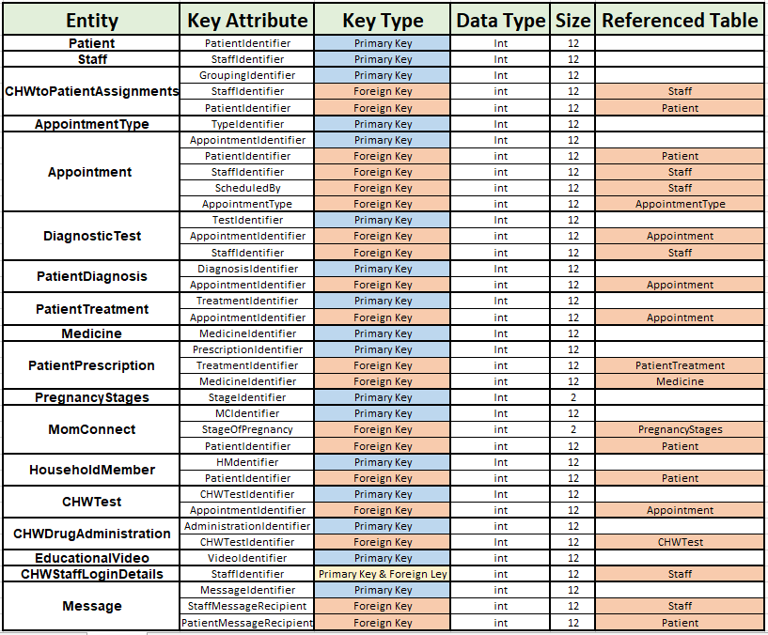

## 1.5

The following Tables Illustrate the formerly described structure of the database, as well as Integrity constraints in the form of required data (null allowances), referential integrity constraints (foreign keys), entity integrity constraints (primary keys) and attribute domain constraints. Attributes requiring unique values are also noted and general constraints in the form of checks will be added to the database during the logical database design in question 2.3.

|  |  |  |  |  |  |
| --- | --- | --- | --- | --- | --- |
| **Patient** | | | | | |
| **Attribute** | **Type** | **Size** | **PK** | **FK** | **Null** |
| PatientIdentifier | Int | 12 |  |  | NO |
| RegisteredOn | date | N/A |  |  | NO |
| PhoneNumber | varchar | 10 |  |  | NO |
| Address | varchar | 60 |  |  | NO |
| PatientName | varchar | 30 |  |  | NO |
| PatientSurname | varchar | 30 |  |  | NO |
| EmailAddress | varchar | 30 |  |  | NO |
| Gender | varchar | 30 |  |  | NO |
| Age | int | 3 |  |  | NO |
| Pregnant | boolean | 1 |  |  | NO |
| Diabetic | boolean | 1 |  |  | NO |
| HIVPositive | boolean | 1 |  |  | NO |
| IDNumber | varchar | 13 |  |  | NO |

Note that Patient(PatientIdentifier), Patient(PhoneNumber), Patient(EmailAddress) and Patient(IDNumber) will require unique values for each record.

|  |  |  |  |  |  |
| --- | --- | --- | --- | --- | --- |
| **Staff** | | | | | |
| **Attribute** | **Type** | **Size** | **PK** | **FK** | **Null** |
| StaffIdentifier | Int | 12 |  |  | NO |
| PhoneNumber | varchar | 10 |  |  | NO |
| Address | varchar | 60 |  |  | NO |
| StaffType | varchar | 20 |  |  | NO |
| StaffName | varchar | 30 |  |  | NO |
| StaffSurname | varchar | 30 |  |  | NO |
| EmailAddress | varchar | 30 |  |  | NO |
| Gender | varchar | 30 |  |  | NO |
| Age | int | 3 |  |  | NO |
| CurrentlyEmployed | boolean | 1 |  |  | NO |
| IDNumber | varchar | 13 |  |  | NO |

Note that Staff(StaffIdentifier), Staff(PhoneNumber), Staff(EmailAddress) and Staff(IDNumber) will require unique values for each record.

|  |  |  |  |  |  |
| --- | --- | --- | --- | --- | --- |
| **CHWtoPatientAssignments** | | | | | |
| **Attribute** | **Type** | **Size** | **PK** | **FK** | **Null** |
| GroupingIdentifier | Int | 12 |  |  | NO |
| StaffIdentifier | int | 12 |  |  | NO |
| PatientIdentifier | int | 12 |  |  | NO |

Note that CHWtoPatientAssignments(GroupingIdentifier) will require a unique value for each record.

|  |  |  |  |  |  |
| --- | --- | --- | --- | --- | --- |
| **AppointmentType** | | | | | |
| **Attribute** | **Type** | **Size** | **PK** | **FK** | **Null** |
| TypeIdentifier | Int | 12 |  |  | NO |
| AppointmentType | varchar | 30 |  |  | NO |
| TypeDescription | varchar | 60 |  |  | YES |

Note that AppointmentType(TypeIdentifier) will require a unique value for each record.

|  |  |  |  |  |  |
| --- | --- | --- | --- | --- | --- |
| **Appointment** | | | | | |
| **Attribute** | **Type** | **Size** | **PK** | **FK** | **Null** |
| AppointmentIdentifier | Int | 12 |  |  | NO |
| PatientIdentifier | int | 12 |  |  | NO |
| StaffIdentifier | int | 12 |  |  | NO |
| ScheduledBy | int | 12 |  |  | NO |
| AppointmentType | int | 12 |  |  | NO |
| Description | varchar | 300 |  |  | YES |
| Attendence | boolean | 1 |  |  | NO |
| ClinicalFindings | varchar | 300 |  |  | YES |
| Location | varchar | 60 |  |  | NO |
| AppointmentDate | Date | N/A |  |  | NO |
| AppointmentTime | Time | N/A |  |  | NO |

Note that Appointment(AppointmentIdentifier) will require a unique value for each record.

|  |  |  |  |  |  |
| --- | --- | --- | --- | --- | --- |
| **DiagnosticTest** | | | | | |
| **Attribute** | **Type** | **Size** | **PK** | **FK** | **Null** |
| TestIdentifier | Int | 12 |  |  | NO |
| AppointmentIdentifier | int | 12 |  |  | NO |
| TestType | varchar | 120 |  |  | NO |
| TestResult | varchar | 600 |  |  | NO |
| StaffIdentifier | int | 12 |  |  | NO |

Note that DiagnosticTest(TestIdentifier) will require a unique value for each record.

|  |  |  |  |  |  |
| --- | --- | --- | --- | --- | --- |
| **PatientDiagnosis** | | | | | |
| **Attribute** | **Type** | **Size** | **PK** | **FK** | **Null** |
| DiagnosisIdentifier | Int | 12 |  |  | NO |
| AppointmentIdentifier | int | 12 |  |  | NO |
| DeterminedDiagnosis | varchar | 60 |  |  | NO |
| DiagnosisDescription | varchar | 300 |  |  | YES |

Note that PatientDiagnosis(DiagnosisIdentifier) will require a unique value for each record.

|  |  |  |  |  |  |
| --- | --- | --- | --- | --- | --- |
| **PatientTreatment** | | | | | |
| **Attribute** | **Type** | **Size** | **PK** | **FK** | **Null** |
| TreatmentIdentifier | Int | 12 |  |  | NO |
| TreatmentDescription | varchar | 300 |  |  | YES |
| AppointmentIdentifier | int | 12 |  |  | NO |

Note that PatientTreatment(TreatmentIdentifier) will require a unique value for each record.

|  |  |  |  |  |  |
| --- | --- | --- | --- | --- | --- |
| **Medicine** | | | | | |
| **Attribute** | **Type** | **Size** | **PK** | **FK** | **Null** |
| MedicineIdentifier | Int | 12 |  |  | NO |
| MedicineName | varchar | 60 |  |  | NO |
| MedicineDescription | varchar | 300 |  |  | YES |

Note that Medicine(MedicineIdentifier) will require a unique value for each record.

|  |  |  |  |  |  |
| --- | --- | --- | --- | --- | --- |
| **PatientPrescription** | | | | | |
| **Attribute** | **Type** | **Size** | **PK** | **FK** | **Null** |
| PrescriptionIdentifier | Int | 12 |  |  | NO |
| TreatmentIdentifier | int | 12 |  |  | NO |
| MedicineIdentifier | int | 12 |  |  | NO |
| MedicineDosage | varchar | 120 |  |  | NO |

Note that PatientPrescription(PrescriptionIdentifier) will require a unique value for each record.

|  |  |  |  |  |  |
| --- | --- | --- | --- | --- | --- |
| **PregnancyStages** | | | | | |
| **Attribute** | **Type** | **Size** | **PK** | **FK** | **Null** |
| StageIdentifier | Int | 2 |  |  | NO |
| StageName | varchar | 60 |  |  | NO |
| StageDescription | varchar | 300 |  |  | YES |

Note that PregnancyStages(StageIdentifier) will require a unique value for each record.

|  |  |  |  |  |  |
| --- | --- | --- | --- | --- | --- |
| **MomConnect** | | | | | |
| **Attribute** | **Type** | **Size** | **PK** | **FK** | **Null** |
| MCIdentifier | Int | 12 |  |  | NO |
| StageOfPregnancy | int | 2 |  |  | YES |
| PatientIdentifier | int | 12 |  |  | NO |

Note that MomConnect(MCIdentifier) will require a unique value for each record.

|  |  |  |  |  |  |
| --- | --- | --- | --- | --- | --- |
| **HouseholdMember** | | | | | |
| **Attribute** | **Type** | **Size** | **PK** | **FK** | **Null** |
| HMdentifier | Int | 12 |  |  | NO |
| PatientIdentifier | int | 12 |  |  | NO |
| MemberName | varchar | 30 |  |  | NO |
| MemberSurname | varchar | 30 |  |  | NO |
| CellphoneNumber | varchar | 10 |  |  | YES |
| EmailAddress | varchar | 30 |  |  | YES |
| ExistingMedicalConditions | varchar | 30 |  |  | YES |
| RelationshipWithPatient | varchar | 30 |  |  | NO |

Note that HouseholdMember(HMIdentifier), HouseholdMember(CellphoneNumber) and HouseholdMember(EmailAddress) will require unique values for each record.

|  |  |  |  |  |  |
| --- | --- | --- | --- | --- | --- |
| **CHWTest** | | | | | |
| **Attribute** | **Type** | **Size** | **PK** | **FK** | **Null** |
| CHWTestIdentifier | Int | 12 |  |  | NO |
| AppointmentIdentifier | int | 12 |  |  | NO |
| BloodSugarLevelmmolPerL | double | 5,2 |  |  | NO |

Note that CHWTest(CHWTestIdentifier) will require a unique value for each record.

|  |  |  |  |  |  |
| --- | --- | --- | --- | --- | --- |
| **CHWDrugAdministration** | | | | | |
| **Attribute** | **Type** | **Size** | **PK** | **FK** | **Null** |
| AdministrationIdentifier | int | 12 |  |  | NO |
| CHWTestIdentifier | Int | 12 |  |  | NO |
| DrugAdministered | varchar | 60 |  |  | NO |
| DrugDosageINmg | double | 8,2 |  |  | NO |

Note that CHWDrugAdministration(AdministrationIdentifier) will require a unique value for each record.

|  |  |  |  |  |  |
| --- | --- | --- | --- | --- | --- |
| **EducationalVideo** | | | | | |
| **Attribute** | **Type** | **Size** | **PK** | **FK** | **Null** |
| VideoIdentifier | int | 12 |  |  | NO |
| VideoTitle | varchar | 300 |  |  | NO |
| ProducedBy | varchar | 60 |  |  | YES |
| DateOfRelease | date | N/A |  |  | YES |
| ReferenceToVideoUrl | varchar | 60 |  |  | YES |
| RuntimeInMinutes | int | 4 |  |  | YES |

Note that EducationalVideo(VideoIdentifier) will require a unique value for each record.

|  |  |  |  |  |  |
| --- | --- | --- | --- | --- | --- |
| **CHWStaffLoginDetails** | | | | | |
| **Attribute** | **Type** | **Size** | **PK** | **FK** | **Null** |
| StaffIdentifier | int | 12 |  |  | NO |
| StaffUsername | varchar | 60 |  |  | NO |
| StaffPassword | varchar | 40 |  |  | NO |

Note that CHWStaffLoginDetails(StaffIdentifier) and CHWStaffLoginDetails(StaffUsername) will require unique values for each record.

|  |  |  |  |  |  |
| --- | --- | --- | --- | --- | --- |
| **Message** | | | | | |
| **Attribute** | **Type** | **Size** | **PK** | **FK** | **Null** |
| MessageIdentifier | int | 12 |  |  | NO |
| MessageContent | varchar | 500 |  |  | NO |
| StaffMessageRecipient | int | 12 |  |  | YES |
| PatientMessageRecipient | int | 12 |  |  | YES |

Note that Message(MessageIdentifier) will require a unique value for each record.

The following ERD helps illustrate the basic structure of the envisioned database and the relationships that exist between its entities. A more detailed ERD will later be provided in question 2.5.

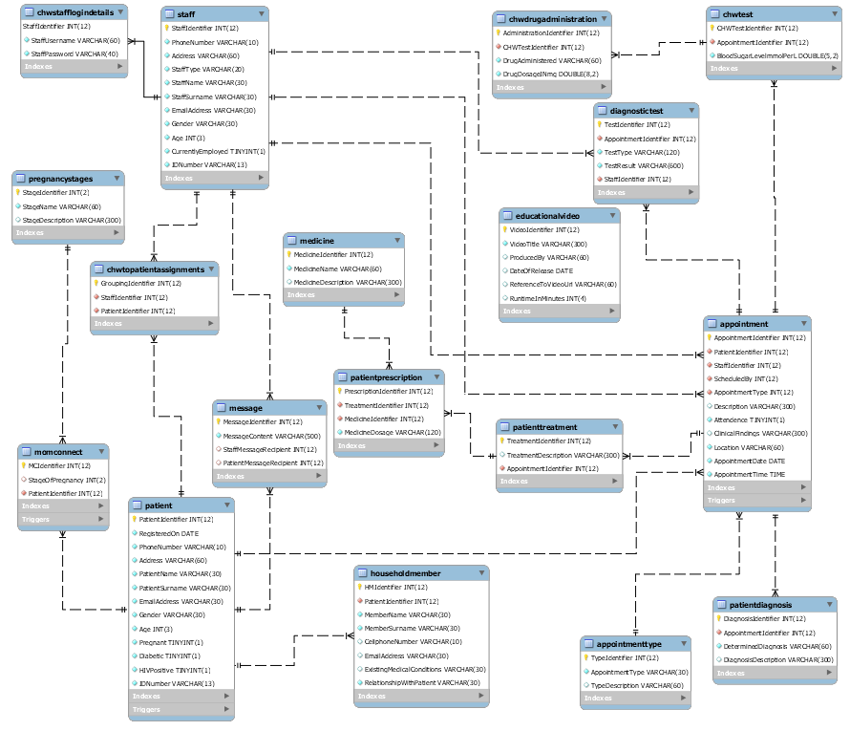

# Question 2

## 2.1

|  |  |  |
| --- | --- | --- |
| **Entity** | **Attributes & Keys** |  |
| **Patient** | **Patient**(PatientIdentifier, RegisteredOn, PhoneNumber, Address, PatientName, PatientSurname,  EmailAddress, Gender, Age, Pregnant, Diabetic, HIVPositive, IDNumber) | ← Entity Attributes |
| **Primary Key** PatientIdentifier |  |
| **Staff** | **Staff**(StaffIdentifier, PhoneNumber, Address, StaffType, StaffName, StaffSurname, EmailAddress, Gender, Age, CurrentlyEmployed, IDNumber) | ← Entity Attributes |
| **Primary Key** StaffIdentifier |  |
| **CHWtoPatientAssignments** | **CHWtoPatientAssignments**(GroupingIdentifier, StaffIdentifier, PatientIdentifier) | ← Entity Attributes |
| **Primary Key** GroupingIdentifier |  |
| **Foreign Key** CHWtoPatientAssignments(StaffIdentifier) references Staff(StaffIdentifier) | ← Foreign Key Description |
| **Foreign Key** CHWtoPatientAssignments(PatientIdentifier) references Patient(PatientIdentifier) | ← Foreign Key Description |
| **AppointmentType** | **AppointmentType**(TypeIdentifier, AppointmentType, TypeDescription) | ← Entity Attributes |
| **Primary Key** TypeIdentifier |  |
| **Appointment** | **Appointment**(AppointmentIdentifier, PatientIdentifier, StaffIdentifier, ScheduledBy, AppointmentType,  Description, Attendence, ClinicalFindings, Location, AppointmentDate, AppointmentTime) | ← Entity Attributes |
| **Primary Key** AppointmentIdentifier |  |
| **Foreign Key** Appointment(PatientIdentifier) references Patient(PatientIdentifier) | ← Foreign Key Description |
| **Foreign Key** Appointment(StaffIdentifier) references Staff(StaffIdentifier) | ← Foreign Key Description |
| **Foreign Key** Appointment(ScheduledBy) references Staff(StaffIdentifier) | ← Foreign Key Description |
| **Foreign Key** Appointment(AppointmentType) references AppointmentType(TypeIdentifier) | ← Foreign Key Description |

|  |  |  |
| --- | --- | --- |
| **Entity** | **Attributes & Keys** |  |
| **DiagnosticTest** | **DiagnosticTest**(TestIdentifier, AppointmentIdentifier, TestType, TestResult, StaffIdentifier ) | ← Entity Attributes |
| **Primary Key** TestIdentifier |  |
| **Foreign Key** DiagnosticTest(AppointmentIdentifier) references Appointment(AppointmentIdentifier) | ← Foreign Key Description |
| **Foreign Key** DiagnosticTest(StafftIdentifier) references Staff(StaffIdentifier) | ← Foreign Key Description |
| **PatientDiagnosis** | **PatientDiagnosis**(DiagnosisIdentifier, AppointmentIdentifier, DeterminedDiagnosis, DiagnosisDescription) | ← Entity Attributes |
| **Primary Key** DiagnosisIdentifier |  |
| **Foreign Key** PatientDiagnosis(AppointmentIdentifier) references Appointment(AppointmentIdentifier) | ← Foreign Key Description |
| **PatientTreatment** | **PatientTreatment**(TreatmentIdentifier, TreatmentDescription, AppointmentIdentifier) | ← Entity Attributes |
| **Primary Key** TreatmentIdentifier |  |
| **Foreign Key** PatientTreatment(AppointmentIdentifier) references Appointment(AppointmentIdentifier) | ← Foreign Key Description |
| **Medicine** | **Medicine**(MedicineIdentifier, MedicineName, MedicineDescription) | ← Entity Attributes |
| **Primary Key** MedicineIdentifier |  |
| **PatientPrescription** | **PatientPrescription**(PrescriptionIdentifier, TreatmentIdentifier, MedicineIdentifier, MedicineDosage) | ← Entity Attributes |
| **Primary Key** PrescriptionIdentifier |  |
| **Foreign Key** PatientPrescription(TreatmentIdentifier) references PatientTreatment(TreatmentIdentifier) | ← Foreign Key Description |
| **Foreign Key** PatientPrescription(MedicineIdentifier) references Medicine(MedicineIdentifier) | ← Foreign Key Description |
| **PregnancyStages** | **PregnancyStages**(StageIdentifier, StageName, StageDescription) | ← Entity Attributes |
| **Primary Key** StageIdentifier |  |
| **MomConnect** | **MomConnect**(MCIdentifier, StageOfPregnancy, PatientIdentifier) | ← Entity Attributes |
| **Primary Key** MCIdentifier |  |
| **Foreign Key** MomConnect(StageOfPregnancy) references PregnancyStages(StageIdentifier) | ← Foreign Key Description |
| **Foreign Key** MomConnect(PatientIdentifier) references Patient(PatientIdentifier) | ← Foreign Key Description |

|  |  |  |
| --- | --- | --- |
| **Entity** | **Attributes & Keys** |  |
| **HouseholdMember** | **HouseholdMember**(HMIdentifier, PatientIdentifier, MemberName, MemberSurname, CellphoneNumber EmailAddress, ExistingMedicalConditions, RelationshipWithPatient) | ← Entity Attributes |
| **Primary Key** HMdentifier |  |
| **Foreign Key** HouseholdMember(PatientIdentifier) references Patient(PatientIdentifier) |  |
| **CHWTest** | **CHWTest**(CHWTestIdentifier, AppointmentIdentifier, BloodSugarLevelmmolPerL) | ← Entity Attributes |
| **Primary Key** CHWTestIdentifier |  |
| **Foreign Key** CHWTest(AppointmentIdentifier) references Appointment(AppointmentIdentifier) | ← Foreign Key Description |
| **CHWDrugAdministration** | **CHWDrugAdministration**(AdministrationIdentifier, CHWTestIdentifier, DrugAdministered, DrugDosageINmg) | ← Entity Attributes |
| **Primary Key** AdministrationIdentifier |  |
| **Foreign Key** CHWDrugAdministration(CHWTestIdentifier) references CHWTest(CHWTestIdentifier) | ← Foreign Key Description |
| **EducationalVideo** | **EducationalVideo**(VideoIdentifier, VideoTitle, ProducedBy, DateOfRelease, ReferenceToVideoUrl,  RuntimeInMinutes) | ← Entity Attributes |
| **Primary Key** VideoIdentifier |  |
| **CHWStaffLoginDetails** | **CHWStaffLoginDetails**(StaffIdentifier, StaffUsername, StaffPassword) | ← Entity Attributes |
| **Primary Key** StaffIdentifier |  |
| **Foreign Key** CHWStaffLoginDetails(StaffIdentifier) references Staff(StaffIdentifier) | ← Foreign Key Description |
| **Message** | **Message**(MessageIdentifier, MessageContent, StaffMessageRecipient, PatientMessageRecipient) | ← Entity Attributes |
| **Primary Key** MessageIdentifier |  |
| **Foreign Key** Message(StaffMessageRecipient) references Staff(StaffIdentifier) | ← Foreign Key Description |
| **Foreign Key** Message(PatientMessageRecipient) references Patient(PatientIdentifier) | ← Foreign Key Description |

## 2.2

**Rules of the 1st normal form:**

* Rule 1 🡪 No cell in the table should be expected to contain more than a single value (Harkins, 2003).
* Rule 2 🡪 Each record in the table should be uniquely identifiable from other records in the table.

**Rules of the 2nd normal form:**

* Rule 1 🡪 In order for a table to be in 2nd normal form it should also abide to the rules of the 1st normal form.
* Rule 2 🡪 There shouldn’t exist any attribute within the table that is only partially dependent on the table’s primary key (SQL WORLD, 2019).

**Rules of the 3rd normal form:**

* Rule 1 🡪 In order for a table to be classified as being in 3rd normal form it should also abide to the rules of the 2nd normal form.
* Rule 2 🡪 Changes made to any non-key attributes of a record in a table should not result in consequential changes having to be applied to the record’s other attributes (Ulman, 2003). There should thus not exist any transitive functional dependencies between the table’s attributes.

Upon revising the entities portrayed in Question 2.1 I did not find any attribute that I expected to hold multiple values per instance of the entity. The unique values associated to each entity has also explicitly been stated in Question 1.5 in which case I am certain that each entity’s rows would be uniquely identifiable. I thus believe that each of the entities formerly portrayed in the document abide by the rules of the 1st Normal Form.

**Each of the entities previously identified in Question 2.1 will now again be displayed, this time coupled with a note relating to its evaluation against the rules of the 2nd and 3rd normal forms:**

|  |  |  |
| --- | --- | --- |
| **Entity** | **Attributes & Keys** |  |
| **Patient** | **Patient**(PatientIdentifier, RegisteredOn, PhoneNumber, Address, PatientName, PatientSurname,  EmailAddress, Gender, Age, Pregnant, Diabetic, HIVPositive, IDNumber) | ← Entity Attributes |
| **Primary Key** PatientIdentifier |  |

I believe all of the attributes in the Patient entity above to directly be relate to a patient. I also don’t believe there to be any transitive dependency present in the entity’s design.

|  |  |  |
| --- | --- | --- |
| **Entity** | **Attributes & Keys** |  |
| **Staff** | **Staff**(StaffIdentifier, PhoneNumber, Address, StaffType, StaffName, StaffSurname, EmailAddress, Gender, Age, CurrentlyEmployed, IDNumber) | ← Entity Attributes |
| **Primary Key** StaffIdentifier |  |

All of the Staff entity’s attributes are directly associated to a member of staff and I don’t believe there to exist any dependencies on non-key attributes.

|  |  |  |
| --- | --- | --- |
| **Entity** | **Attributes & Keys** |  |
| **CHWtoPatientAssignments** | **CHWtoPatientAssignments**(GroupingIdentifier, StaffIdentifier, PatientIdentifier) | ← Entity Attributes |
| **Primary Key** GroupingIdentifier |  |
| **Foreign Key** CHWtoPatientAssignments(StaffIdentifier) references Staff(StaffIdentifier) | ← Foreign Key Description |
| **Foreign Key** CHWtoPatientAssignments(PatientIdentifier) references Patient(PatientIdentifier) | ← Foreign Key Description |

The CHWtoPatientAssignments entity displayed above simply represent the relationship existing between community healthcare workers and patients while containing no additional attributes. For this reason I’m certain that the rules of the 2nd and 3rd normal forms aren’t violated in the entity’s current design.

|  |  |  |
| --- | --- | --- |
| **Entity** | **Attributes & Keys** |  |
| **AppointmentType** | **AppointmentType**(TypeIdentifier, AppointmentType, TypeDescription) | ← Entity Attributes |
| **Primary Key** TypeIdentifier |  |

The AppointmentType entity represented above is actually the result of having altered the Appointment entity below in order for it to abide by the rules of the 3rd normal form. I believe all three of AppointmentType’s attributes to adhere to the rules of normalization up to the 3rd normal form.

|  |  |  |
| --- | --- | --- |
| **Entity** | **Attributes & Keys** |  |
| **Appointment** | **Appointment**(AppointmentIdentifier, PatientIdentifier, StaffIdentifier, ScheduledBy, AppointmentType,  Description, Attendence, ClinicalFindings, Location, AppointmentDate, AppointmentTime) | ← Entity Attributes |
| **Primary Key** AppointmentIdentifier |  |
| **Foreign Key** Appointment(PatientIdentifier) references Patient(PatientIdentifier) | ← Foreign Key Description |
| **Foreign Key** Appointment(StaffIdentifier) references Staff(StaffIdentifier) | ← Foreign Key Description |
| **Foreign Key** Appointment(ScheduledBy) references Staff(StaffIdentifier) | ← Foreign Key Description |
| **Foreign Key** Appointment(AppointmentType) references AppointmentType(TypeIdentifier) | ← Foreign Key Description |

I believe all the attributes listed above to be directly related to any instance of an appointment and don’t believe there to exist any transitive dependencies among the entity’s non-key attributes.

|  |  |  |
| --- | --- | --- |
| **Entity** | **Attributes & Keys** |  |
| **DiagnosticTest** | **DiagnosticTest**(TestIdentifier, AppointmentIdentifier, TestType, TestResult, StaffIdentifier ) | ← Entity Attributes |
| **Primary Key** TestIdentifier |  |
| **Foreign Key** DiagnosticTest(AppointmentIdentifier) references Appointment(AppointmentIdentifier) | ← Foreign Key Description |
| **Foreign Key** DiagnosticTest(StafftIdentifier) references Staff(StaffIdentifier) | ← Foreign Key Description |

I considered creating a separate entity to deal specifically with test types as I would expect there to be some repetition in the DiagnosticTest(TestType) field of DiagnosticTest’s records. I however decided against this decision as I don’t believe there to be any form of additional information that when incorporated to the database would both be dependent on the TestType attribute (warranting its inclusion in a newly created TestType entity) and would benefit the database’s end-users. Aside from this implementation consideration I don’t have any doubt that the DiagnosticTest entity abides by the rules of the 2nd and 3rd normal forms.

|  |  |  |
| --- | --- | --- |
| **Entity** | **Attributes & Keys** |  |
| **PatientDiagnosis** | **PatientDiagnosis**(DiagnosisIdentifier, AppointmentIdentifier, DeterminedDiagnosis, DiagnosisDescription) | ← Entity Attributes |
| **Primary Key** DiagnosisIdentifier |  |
| **Foreign Key** PatientDiagnosis(AppointmentIdentifier) references Appointment(AppointmentIdentifier) | ← Foreign Key Description |

I believe the PatientDiagnosis entity above to be in adherence to the rules of the 2nd and 3rd normal form as the entity only possesses two attributes aside from a foreign key and a primary key, both of which are core to the entity’s purpose. It should be noted that PatientDiagnosis(DiagnosisDescription) is an attribute that will be used to add more information regarding a diagnosis that was made, not add a definition to each diagnosis, and has thus also not been deemed a required value (meaning that it allows for a null value to be held).

|  |  |  |
| --- | --- | --- |
| **Entity** | **Attributes & Keys** |  |
| **PatientTreatment** | **PatientTreatment**(TreatmentIdentifier, TreatmentDescription, AppointmentIdentifier) | ← Entity Attributes |
| **Primary Key** TreatmentIdentifier |  |
| **Foreign Key** PatientTreatment(AppointmentIdentifier) references Appointment(AppointmentIdentifier) | ← Foreign Key Description |

Aside from an auto-incrementing primary key and a foreign key only a single value is held by the PatientTreatment entity and it is thus not possible for the entity’s design to have violated the rules of the 2nd and 3rd normal form.

|  |  |  |
| --- | --- | --- |
| **Entity** | **Attributes & Keys** |  |
| **Medicine** | **Medicine**(MedicineIdentifier, MedicineName, MedicineDescription) | ← Entity Attributes |
| **Primary Key** MedicineIdentifier |  |

Though the Medicine(MedicineDescription) attribute is dependent on the Medicine(MedicineName) attribute (which hasn’t been designated as the primary key of the Medicine entity) it should be noted that I included an auto-incrementing primary key to the entity simply for the sake of simplifying the means by which records of the entity can be made reference to. MedicineIdentifier, similar to other attributes in the database such as the aforementioned PatientTreatment(TreatmentIdentifier), is an attribute that represents an intentional introduction of redundancy to the database’s design.

|  |  |  |
| --- | --- | --- |
| **Entity** | **Attributes & Keys** |  |
| **PatientPrescription** | **PatientPrescription**(PrescriptionIdentifier, TreatmentIdentifier, MedicineIdentifier, MedicineDosage) | ← Entity Attributes |
| **Primary Key** PrescriptionIdentifier |  |
| **Foreign Key** PatientPrescription(TreatmentIdentifier) references PatientTreatment(TreatmentIdentifier) | ← Foreign Key Description |
| **Foreign Key** PatientPrescription(MedicineIdentifier) references Medicine(MedicineIdentifier) | ← Foreign Key Description |

Aside from the primary key and two foreign keys the PatientPrescription entity above only contains a MedicineDosage attribute which is core to the intent behind PatientPrescription’s existence. I also don’t believe there to exist any transitive dependencies nor partial dependencies in the entity’s structure.

|  |  |  |
| --- | --- | --- |
| **Entity** | **Attributes & Keys** |  |
| **PregnancyStages** | **PregnancyStages**(StageIdentifier, StageName, StageDescription) | ← Entity Attributes |
| **Primary Key** StageIdentifier |  |

The PregnancyStages entity above is the result of having altered the MomConnect table beneath in order to abide by the rules of the 3rd normal form. I believe the PregnancyStages entity to adhere to the 3rd normal form’s rules.

|  |  |  |
| --- | --- | --- |
| **Entity** | **Attributes & Keys** |  |
| **MomConnect** | **MomConnect**(MCIdentifier, StageOfPregnancy, PatientIdentifier) | ← Entity Attributes |
| **Primary Key** MCIdentifier |  |
| **Foreign Key** MomConnect(StageOfPregnancy) references PregnancyStages(StageIdentifier) | ← Foreign Key Description |
| **Foreign Key** MomConnect(PatientIdentifier) references Patient(PatientIdentifier) | ← Foreign Key Description |

The MomConnect entity above purely consists of key attributes that I don’t believe to violate the rules of the 3rd normal form.

|  |  |  |
| --- | --- | --- |
| **Entity** | **Attributes & Keys** |  |
| **HouseholdMember** | **HouseholdMember**(HMIdentifier, PatientIdentifier, MemberName, MemberSurname, CellphoneNumber EmailAddress, ExistingMedicalConditions, RelationshipWithPatient) | ← Entity Attributes |
| **Primary Key** HMdentifier |  |
| **Foreign Key** HouseholdMember(PatientIdentifier) references Patient(PatientIdentifier) |  |

All of the HouseholdMember attributes above truly are aspects pertaining to household members. There’s also no dependencies on non-key attributes in which case I believe the entity to abide by the rules of normalization up to the 3rd normal form.

|  |  |  |
| --- | --- | --- |
| **Entity** | **Attributes & Keys** |  |
| **CHWTest** | **CHWTest**(CHWTestIdentifier, AppointmentIdentifier, BloodSugarLevelmmolPerL) | ← Entity Attributes |
| **Primary Key** CHWTestIdentifier |  |
| **Foreign Key** CHWTest(AppointmentIdentifier) references Appointment(AppointmentIdentifier) | ← Foreign Key Description |

The only non-key attribute in the CHWTest entity is the BloodSugarLevelmmolPerL attribute that is core to the CHWTest entity. I don’t believe the CHWTest entity to violate the rules of the 3rd normal form.

|  |  |  |
| --- | --- | --- |
| **Entity** | **Attributes & Keys** |  |
| **CHWDrugAdministration** | **CHWDrugAdministration**(AdministrationIdentifier, CHWTestIdentifier, DrugAdministered, DrugDosageINmg) | ← Entity Attributes |
| **Primary Key** AdministrationIdentifier |  |
| **Foreign Key** CHWDrugAdministration(CHWTestIdentifier) references CHWTest(CHWTestIdentifier) | ← Foreign Key Description |

I believe all of the attributes listed in the CHWDrugAdministration entity above to be directly associated to the nature of the entity itself and that the entity abides by the laws of the 3rd normal form.

|  |  |  |
| --- | --- | --- |
| **Entity** | **Attributes & Keys** |  |
| **EducationalVideo** | **EducationalVideo**(VideoIdentifier, VideoTitle, ProducedBy, DateOfRelease, ReferenceToVideoUrl,  RuntimeInMinutes) | ← Entity Attributes |
| **Primary Key** VideoIdentifier |  |

All of the attributes in the EducationalVideo entity above are related to the nature of the entity. There are no transitive dependencies nor partial dependencies present in the entity’s structure and it thus adheres to the rules of the 3rd normal form.

|  |  |  |
| --- | --- | --- |
| **Entity** | **Attributes & Keys** |  |
| **CHWStaffLoginDetails** | **CHWStaffLoginDetails**(StaffIdentifier, StaffUsername, StaffPassword) | ← Entity Attributes |
| **Primary Key** StaffIdentifier |  |
| **Foreign Key** CHWStaffLoginDetails(StaffIdentifier) references Staff(StaffIdentifier) | ← Foreign Key Description |

All of CHWStaffLoginDetails’ attributes are tied to the entity’s operation and no partial nor transitive dependencies are present in the entity’s design.

|  |  |  |
| --- | --- | --- |
| **Entity** | **Attributes & Keys** |  |
| **Message** | **Message**(MessageIdentifier, MessageContent, StaffMessageRecipient, PatientMessageRecipient) | ← Entity Attributes |
| **Primary Key** MessageIdentifier |  |
| **Foreign Key** Message(StaffMessageRecipient) references Staff(StaffIdentifier) | ← Foreign Key Description |
| **Foreign Key** Message(PatientMessageRecipient) references Patient(PatientIdentifier) | ← Foreign Key Description |

Aside from the MessageContent attribute all other attributes in the Message entity are key attributes and I believe the rules of the 3rd normal form to be adhered to by the entity’s design.

## 2.3

The following tables display the integrity constraints placed upon each entity, similar to that shown in question 1.5 previously though the information of 1.5 has been revised and general integrity constraints in the form of checks have been added where deemed necessary on required data.

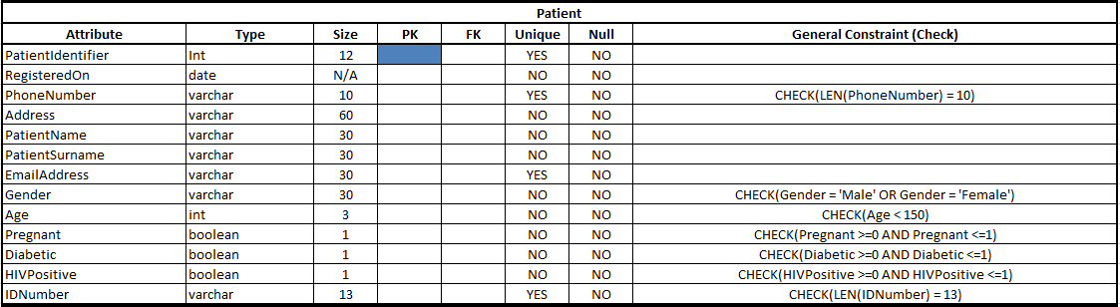

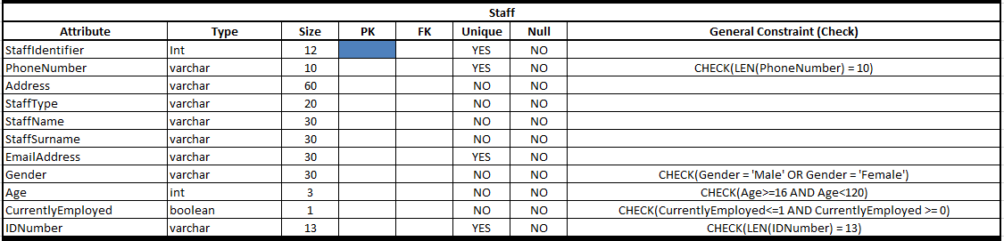   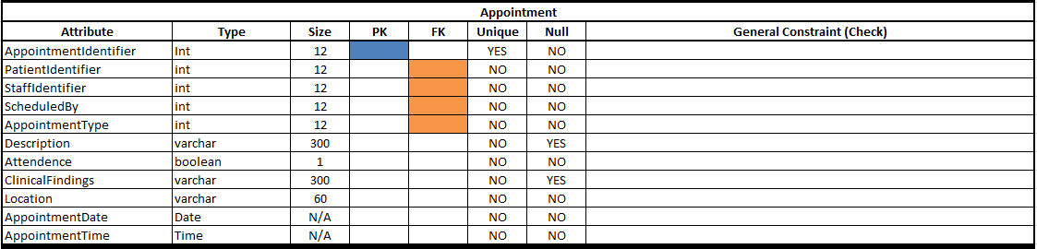 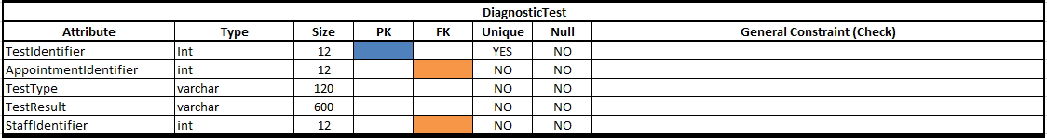 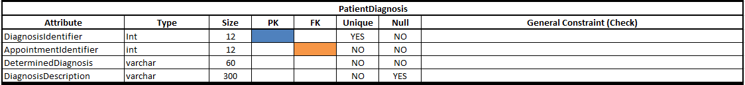   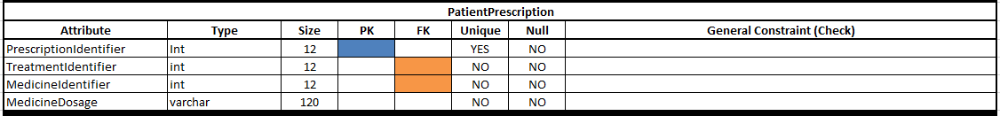   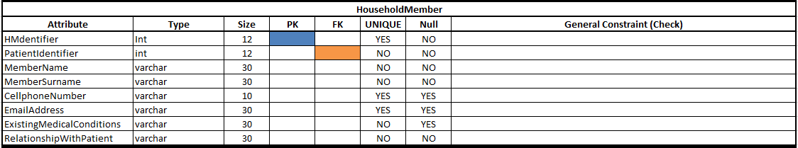  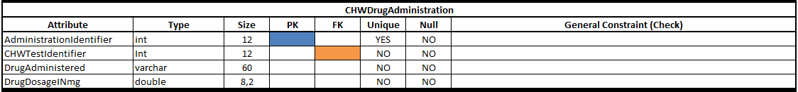 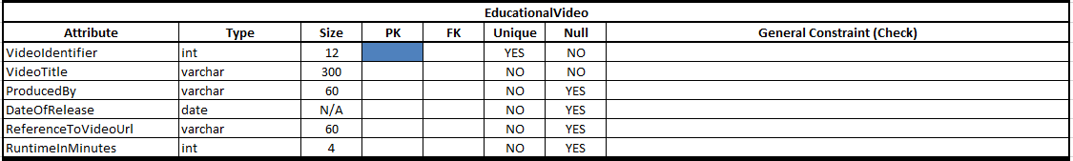  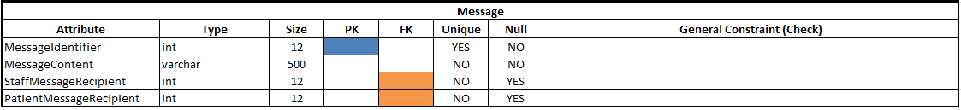

## 2.4

In order to fit the table representing the database’s global data model onto the pages of this document the table was split into 3 separate components of which the first two deal with the database’s entities and the third deals with the views created from these entities.

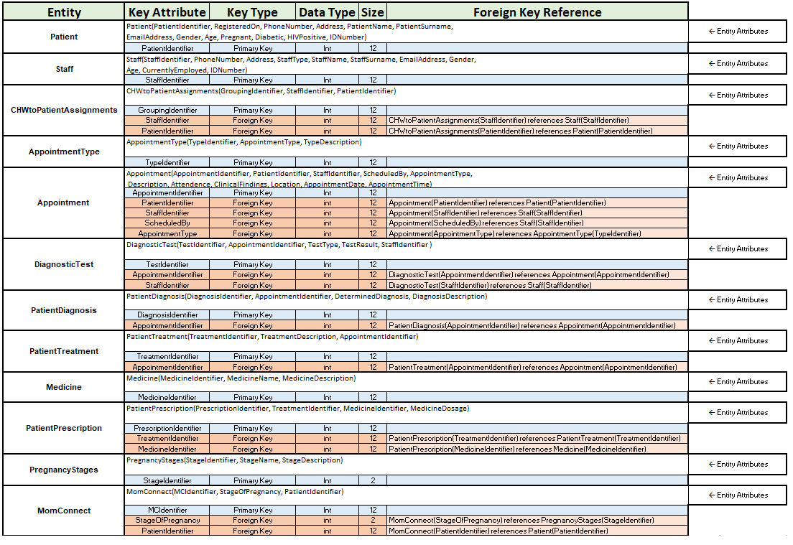

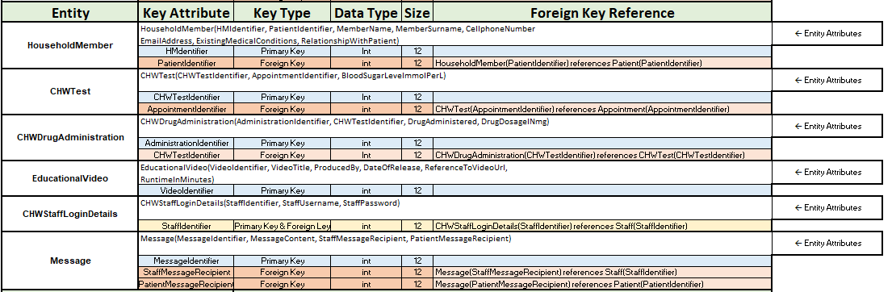

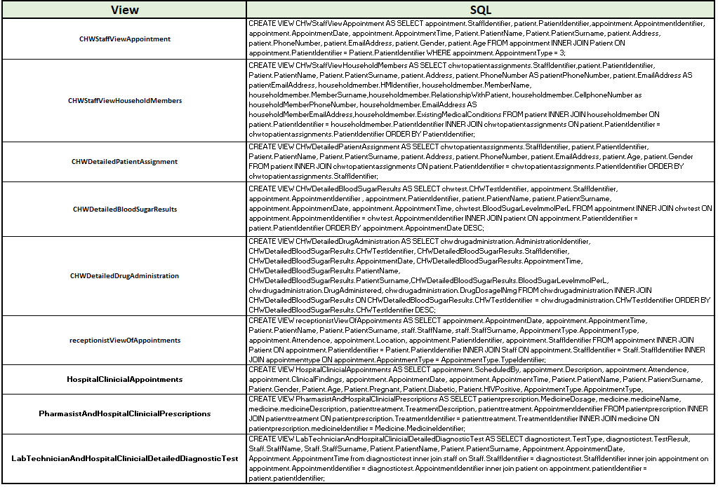

## 2.5

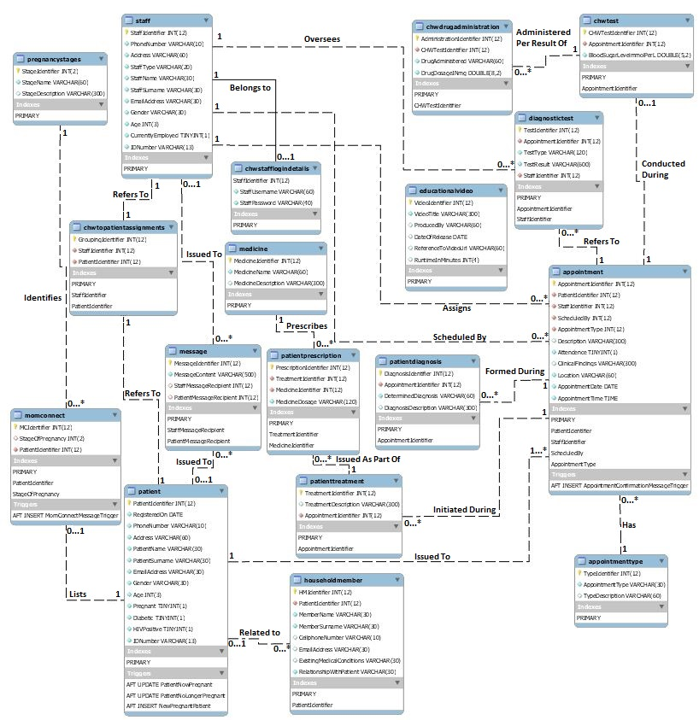

# Question 3

## 3.1

The following Screenshots display the base relations and their relative integrity constraints being implemented in MySQL:

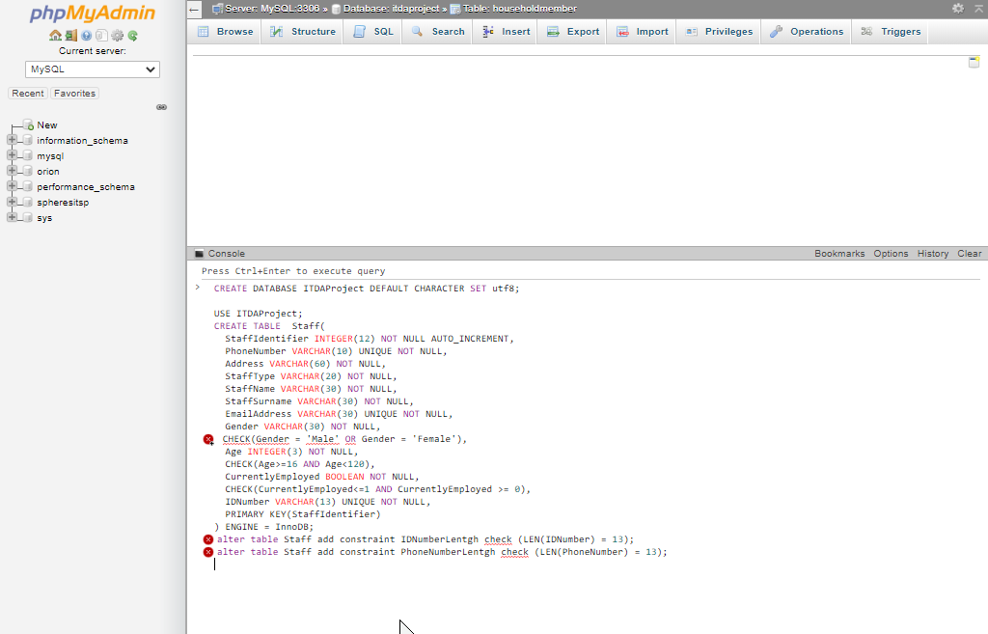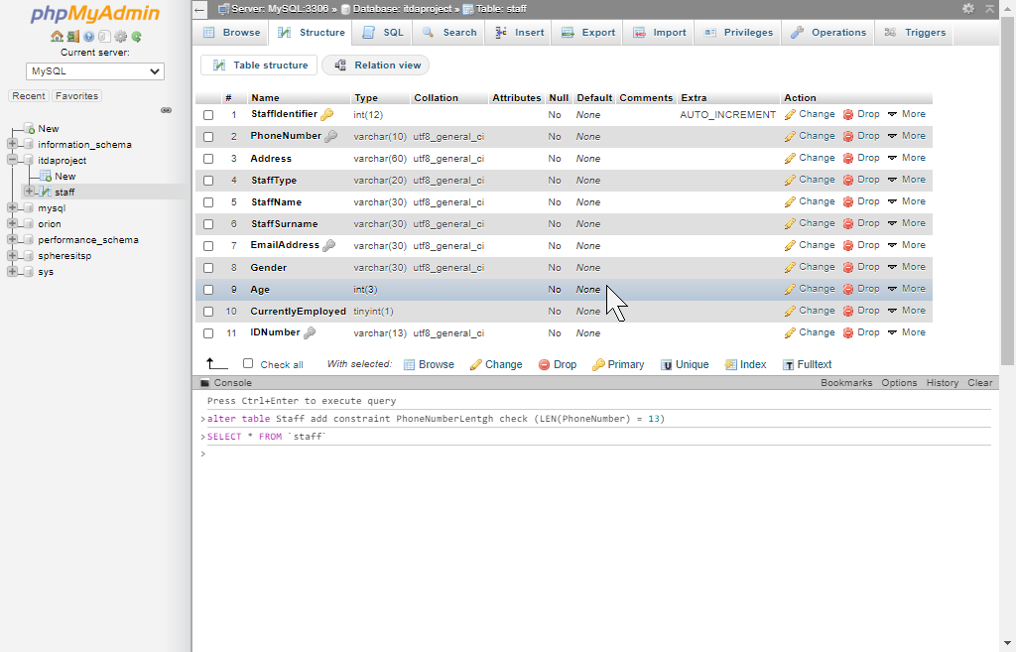

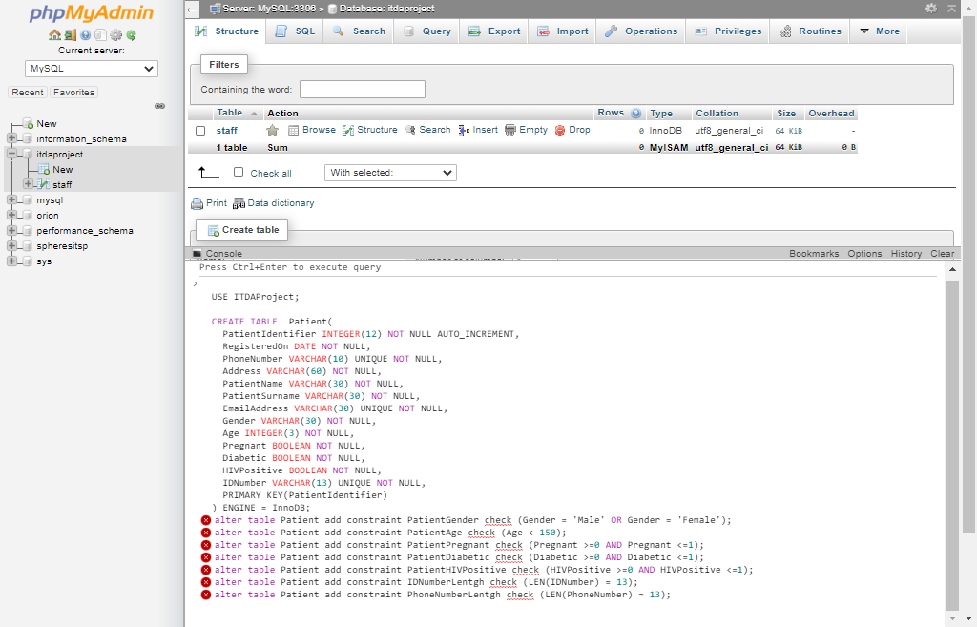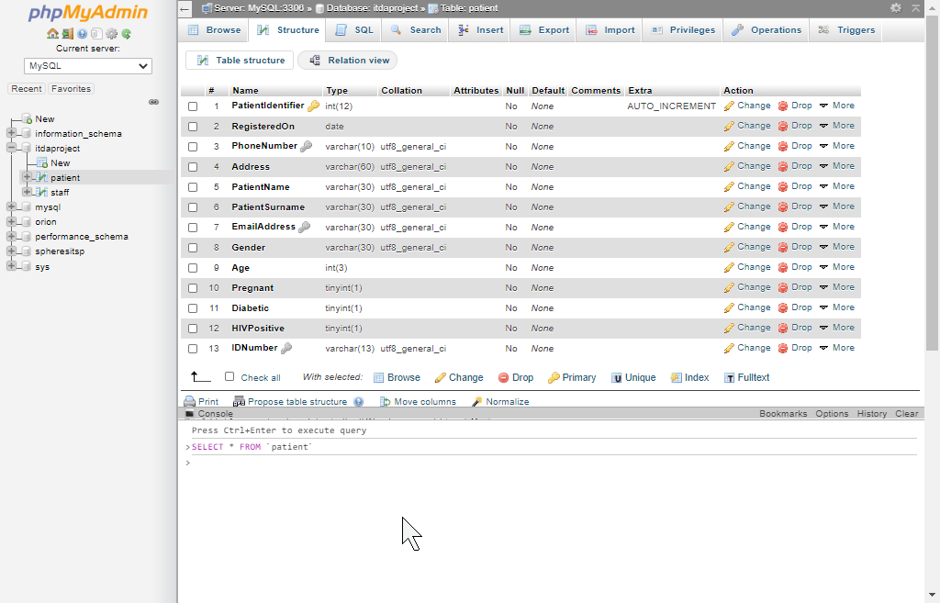

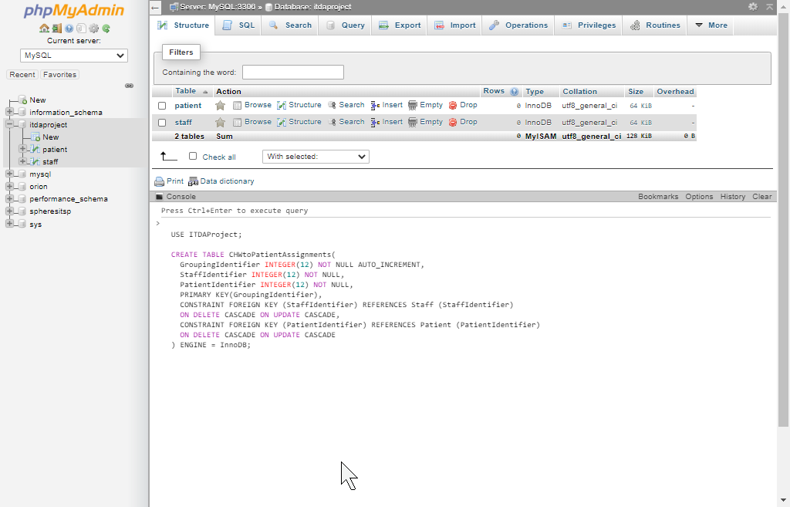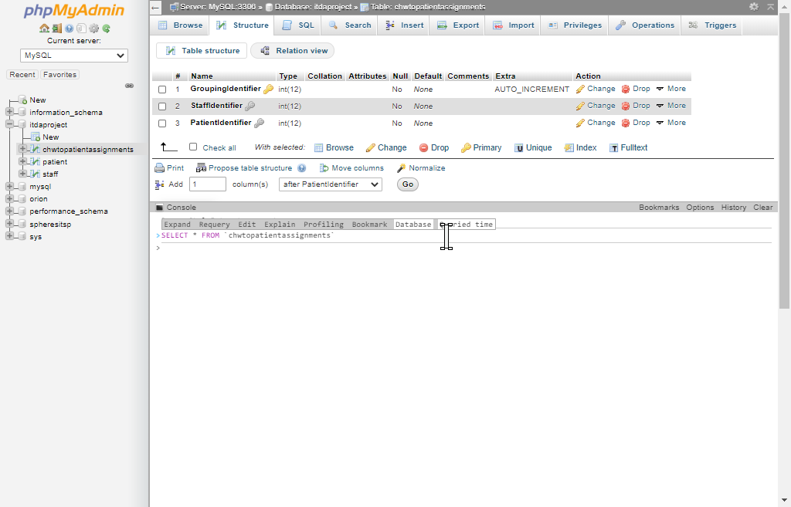

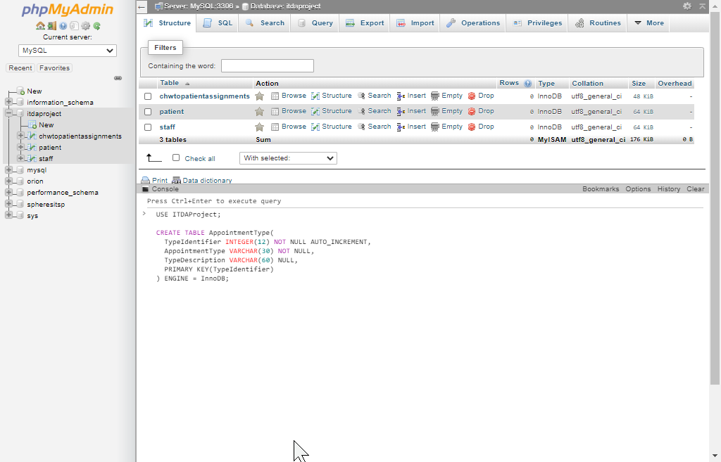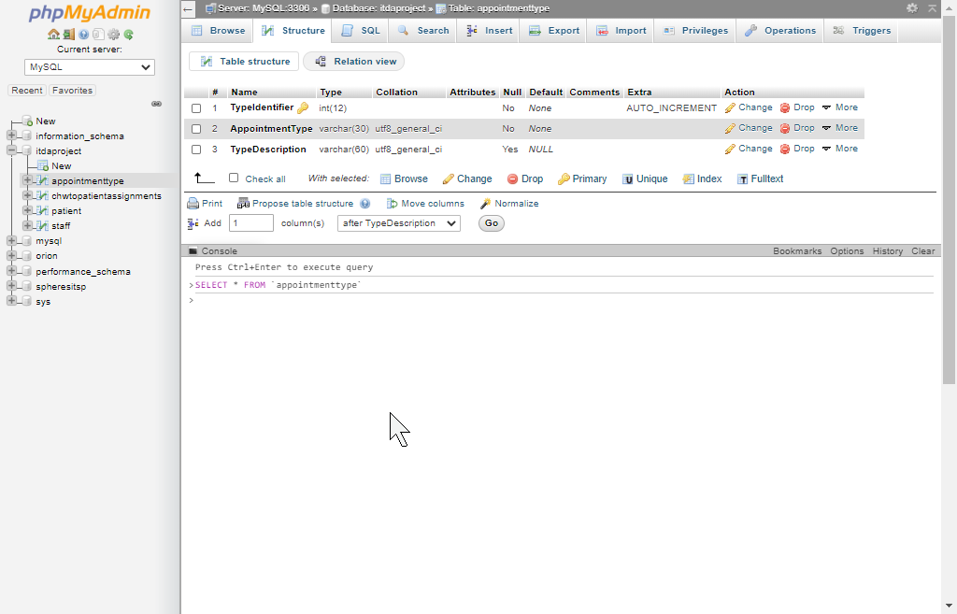

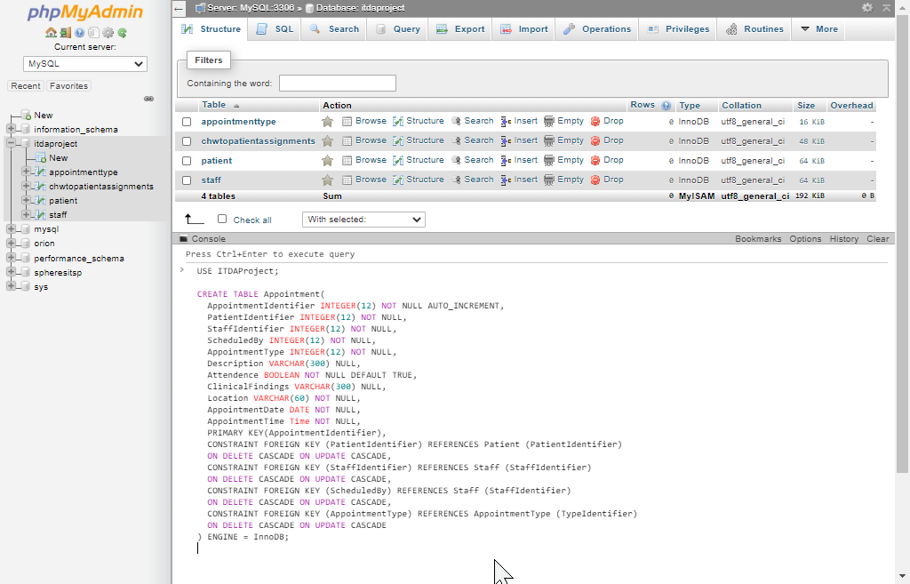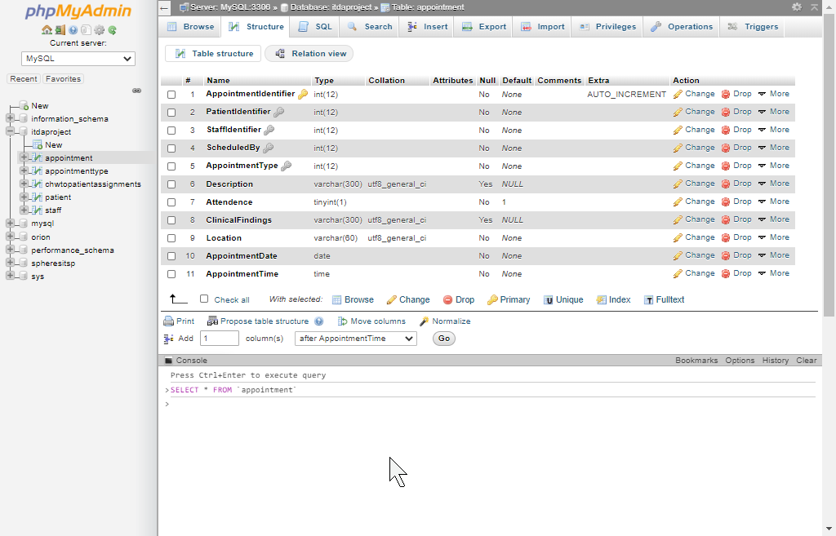

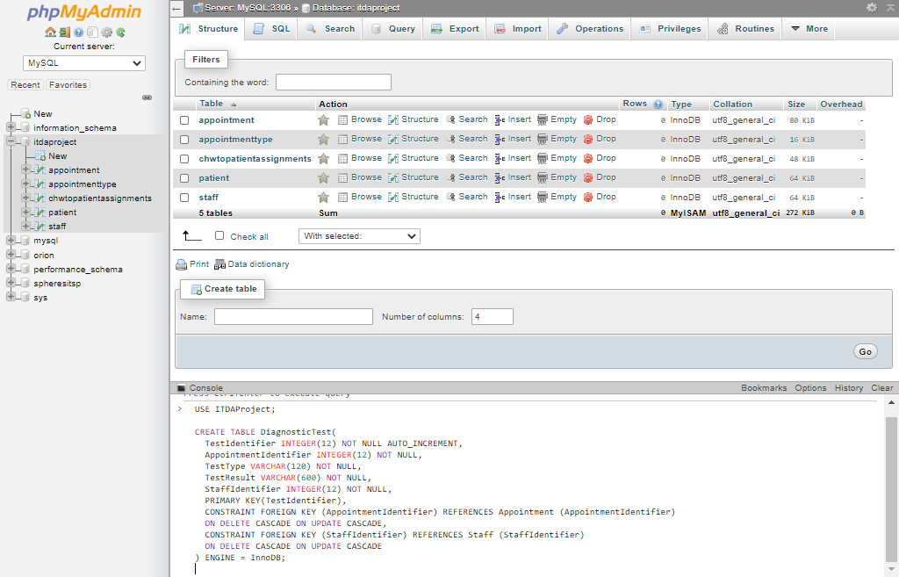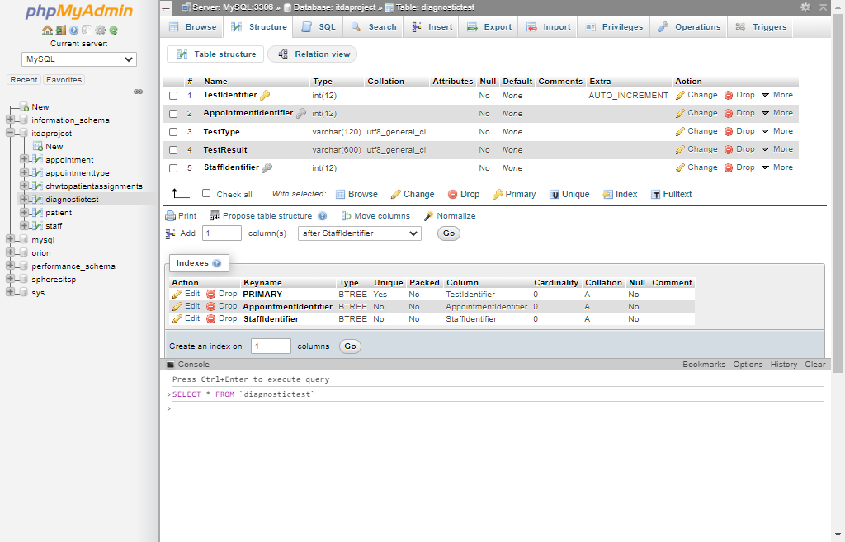

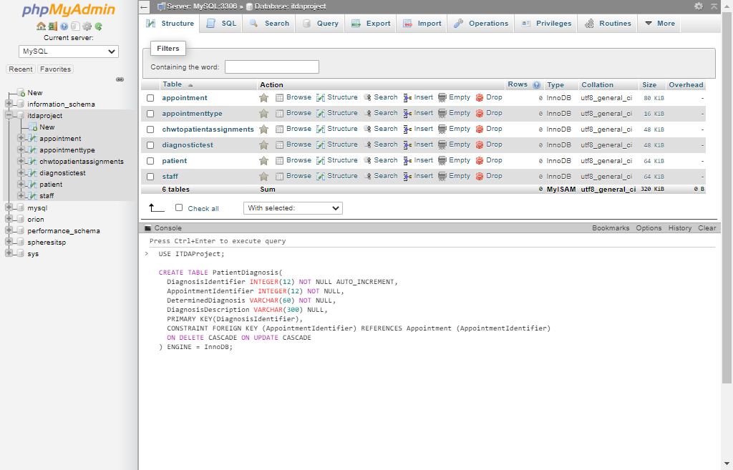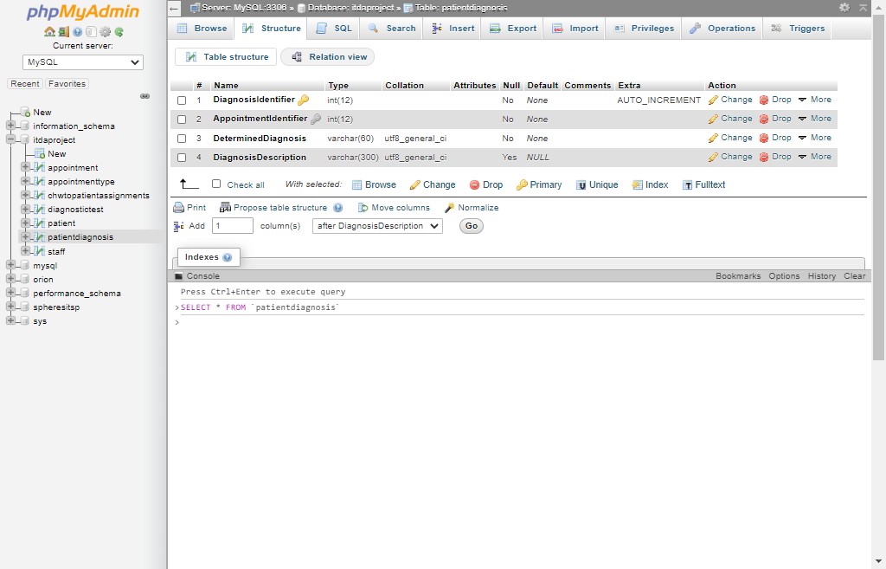

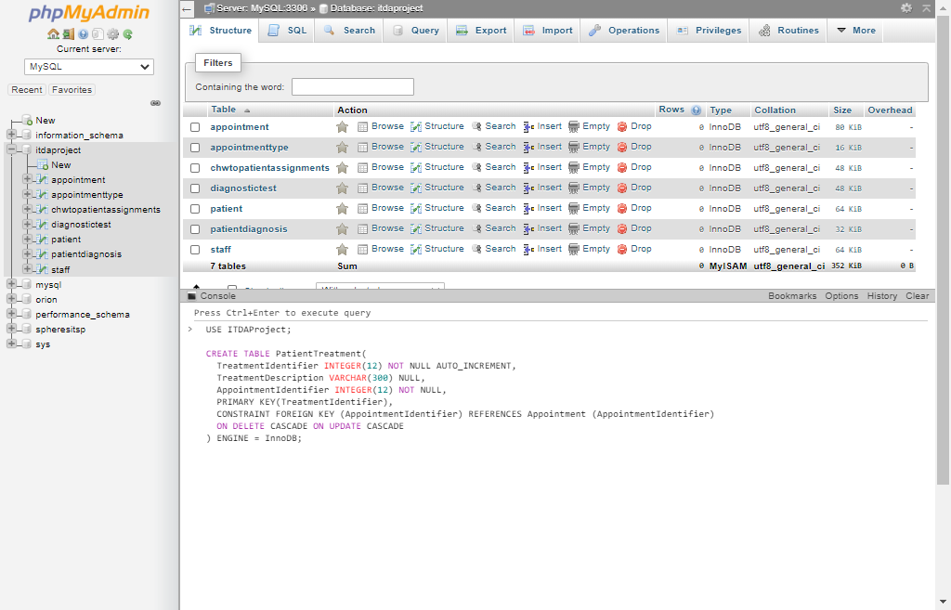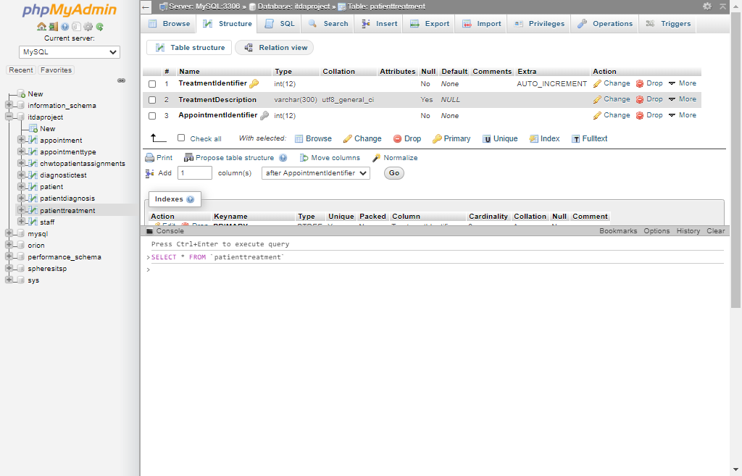

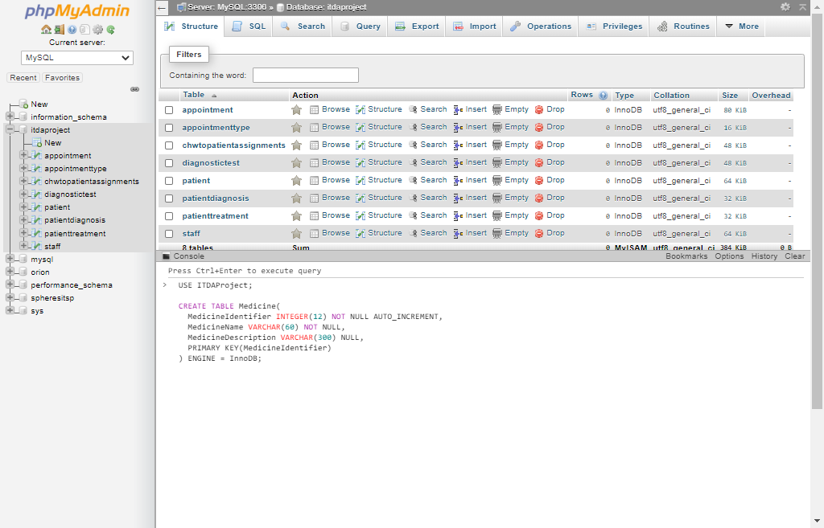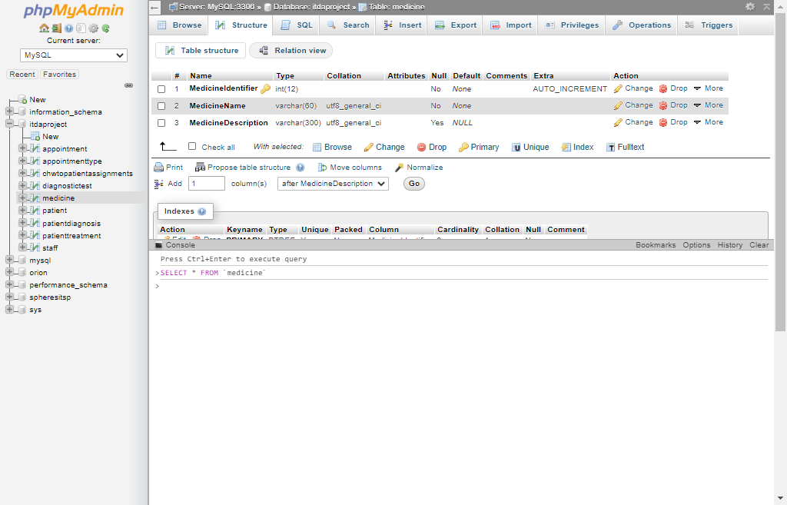

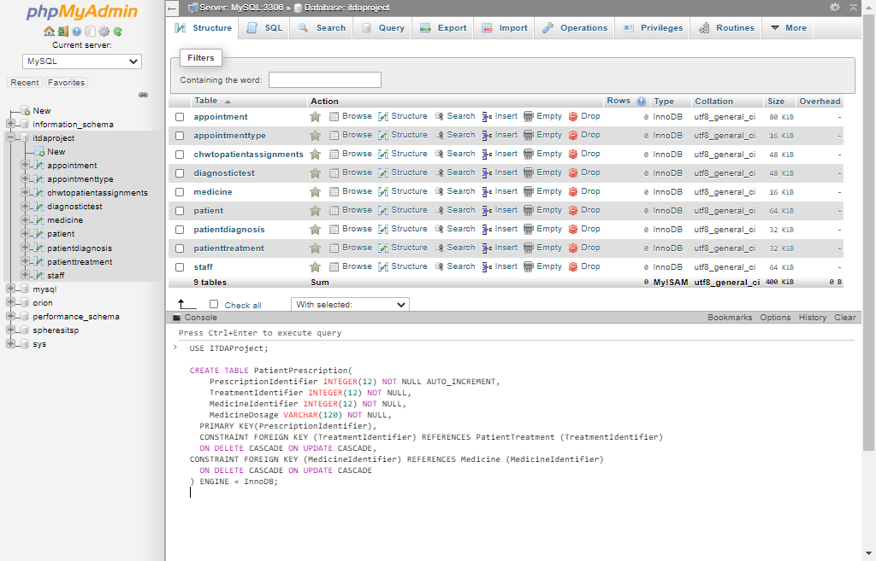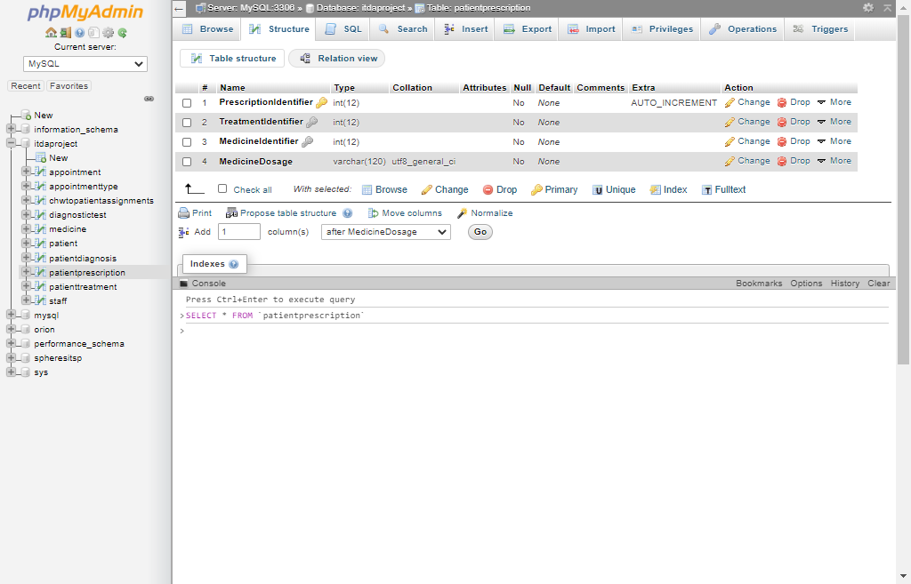

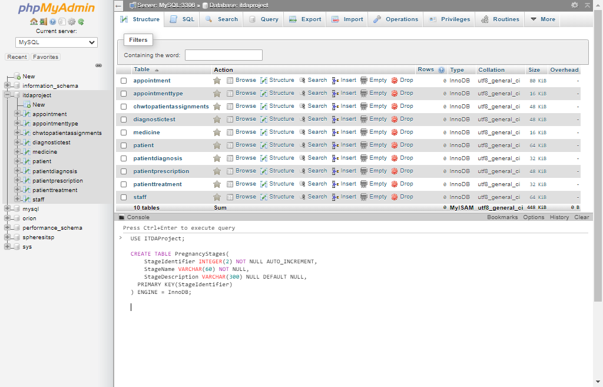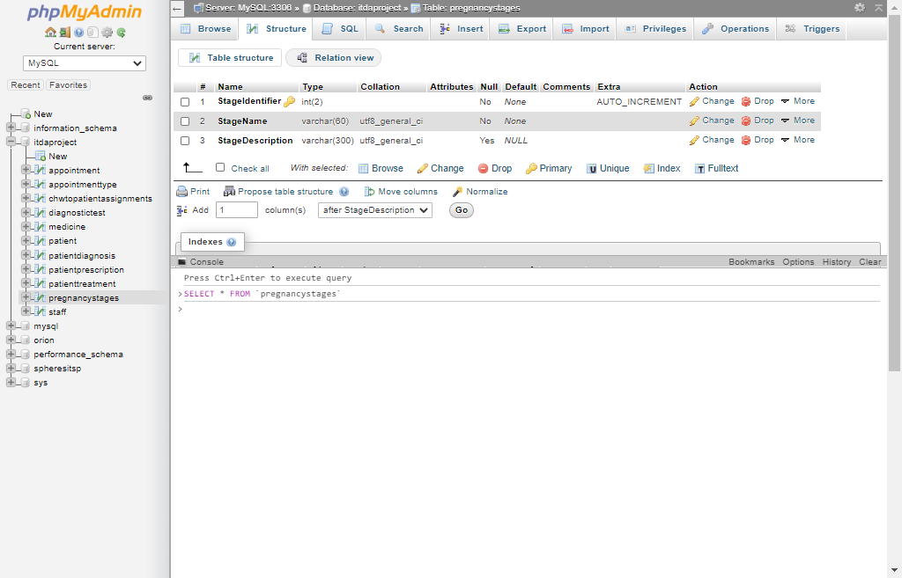

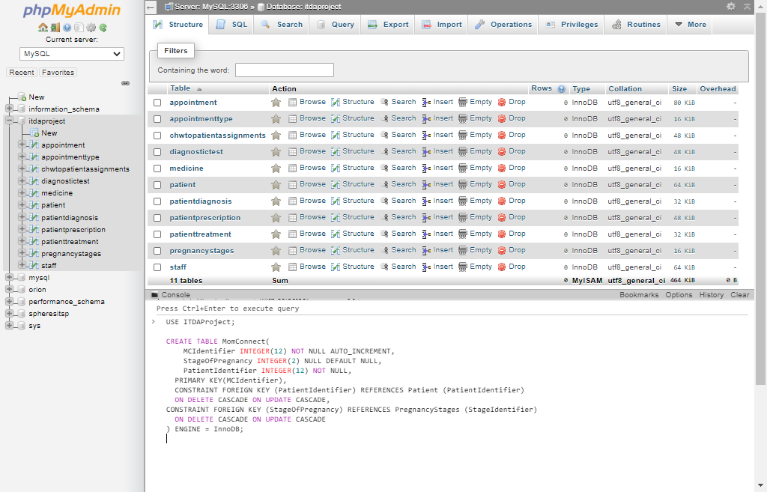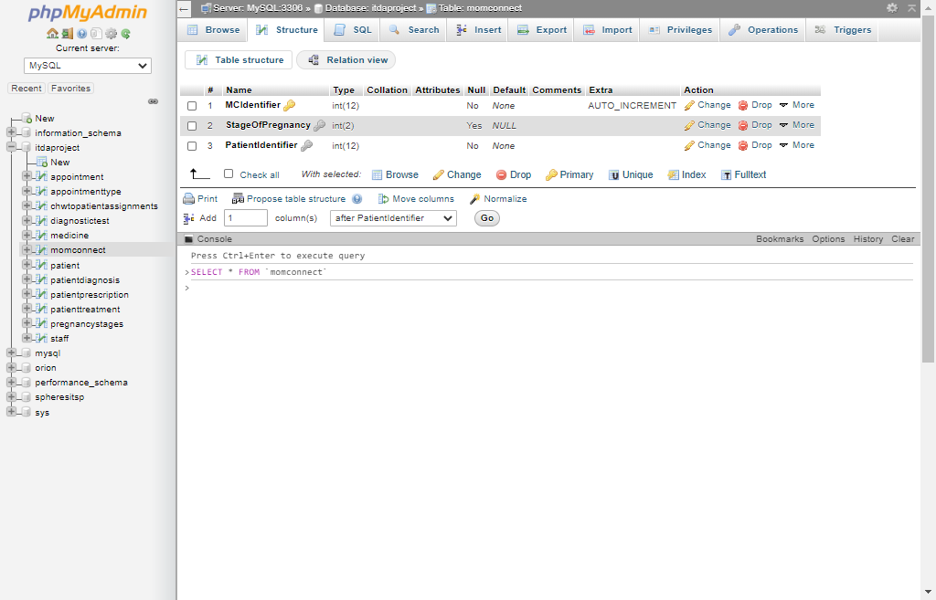

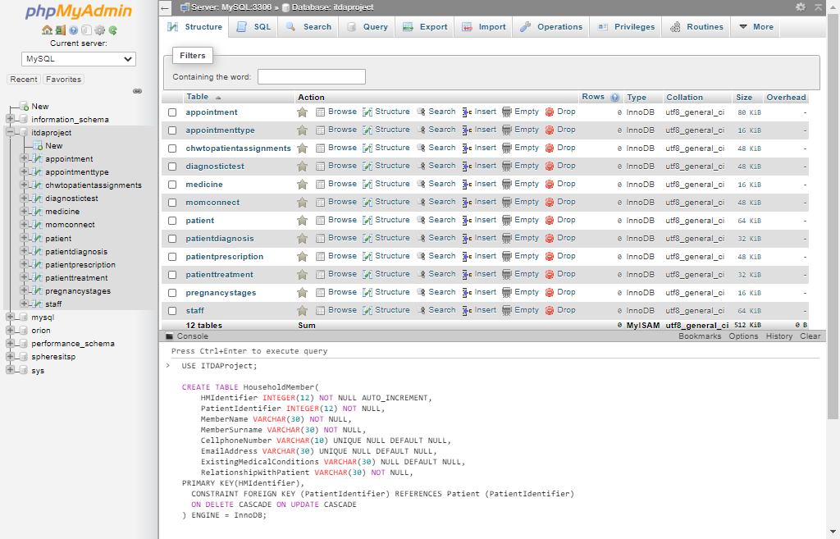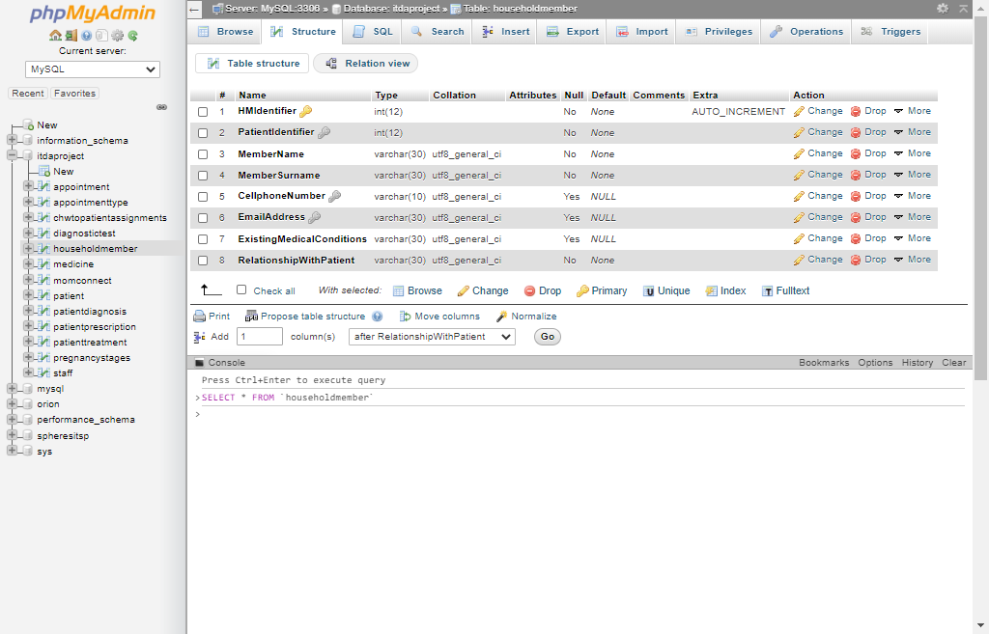

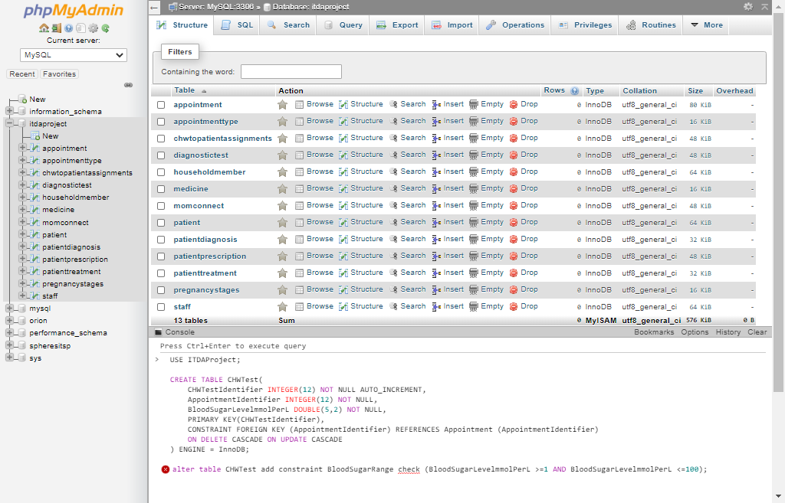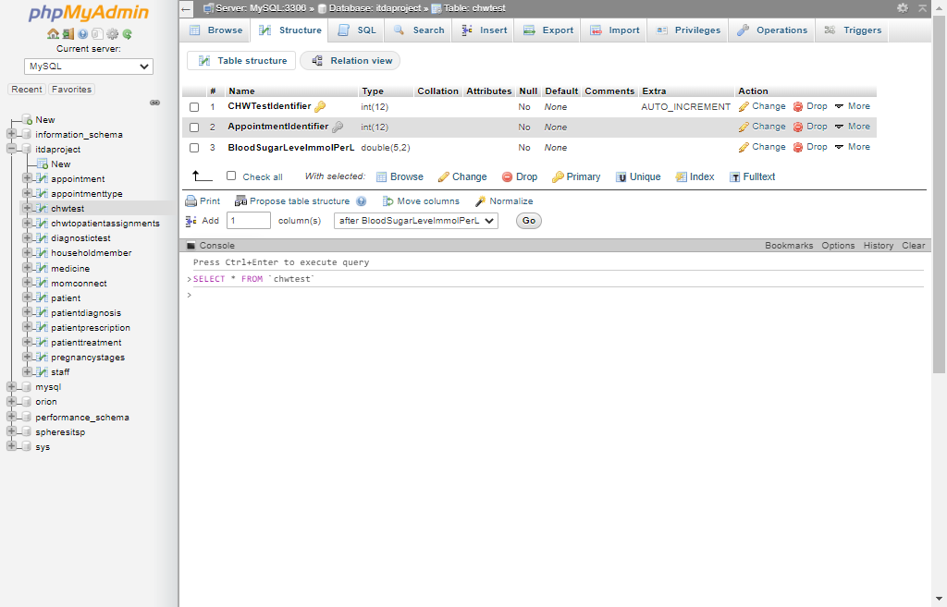

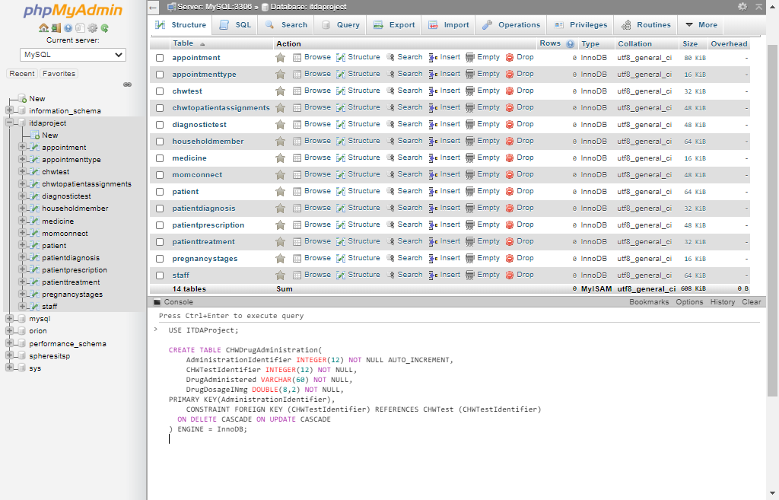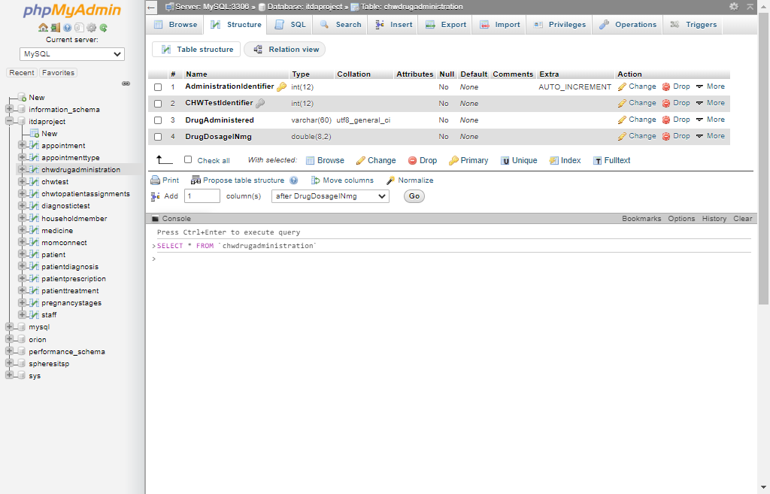

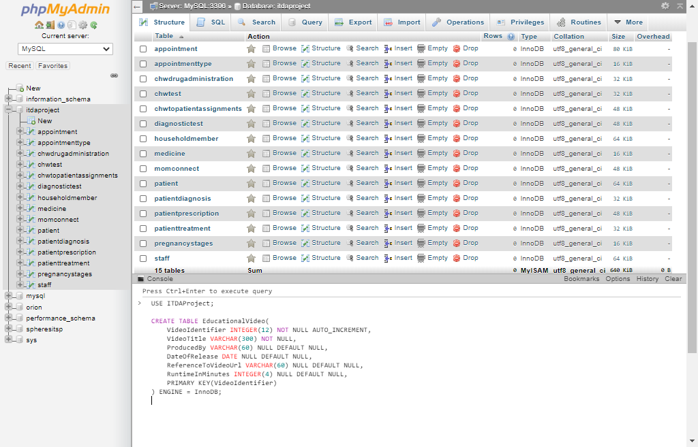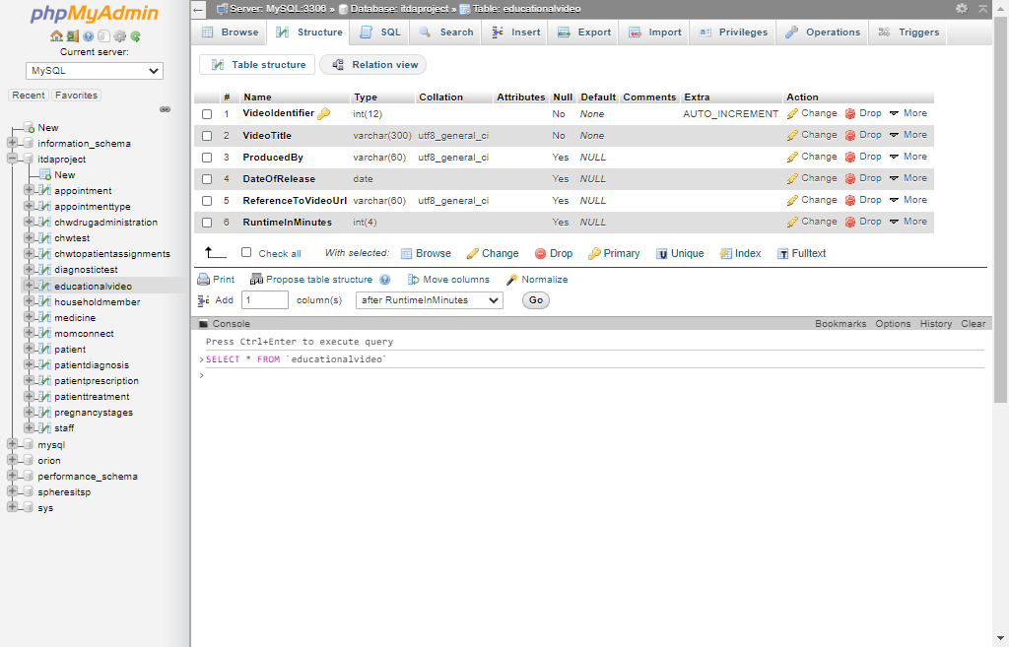

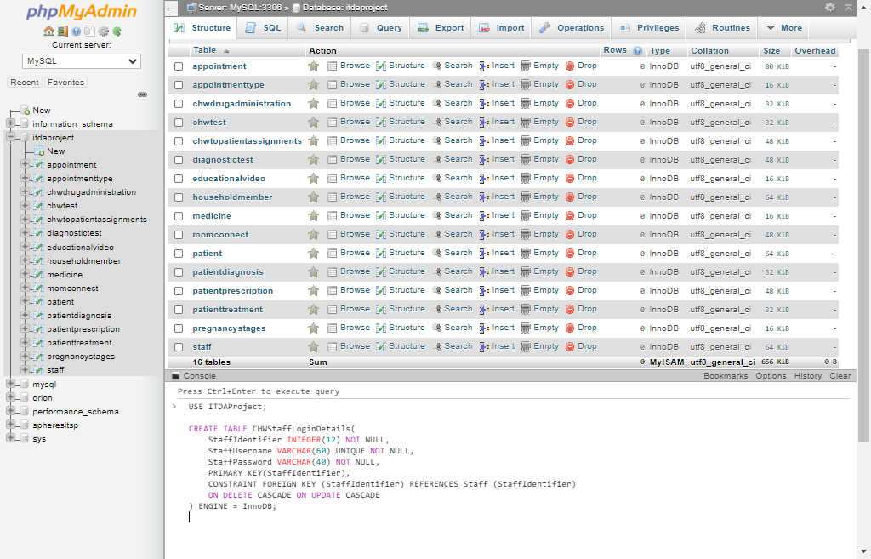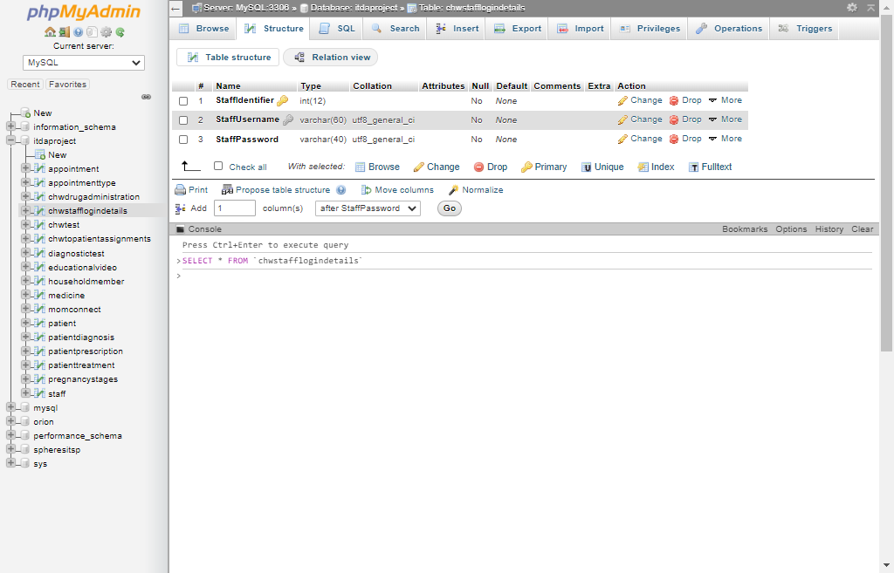

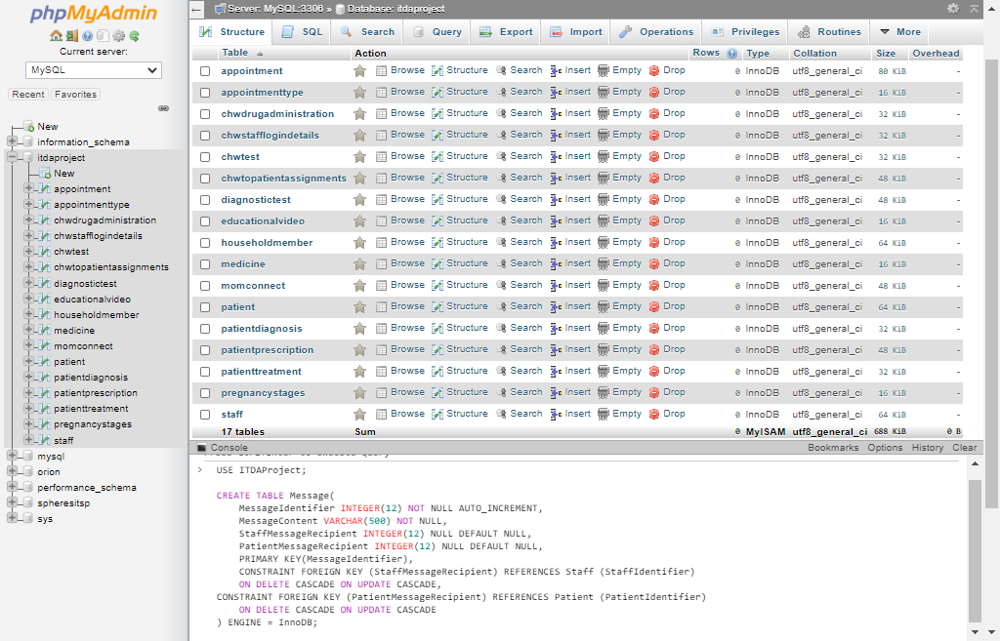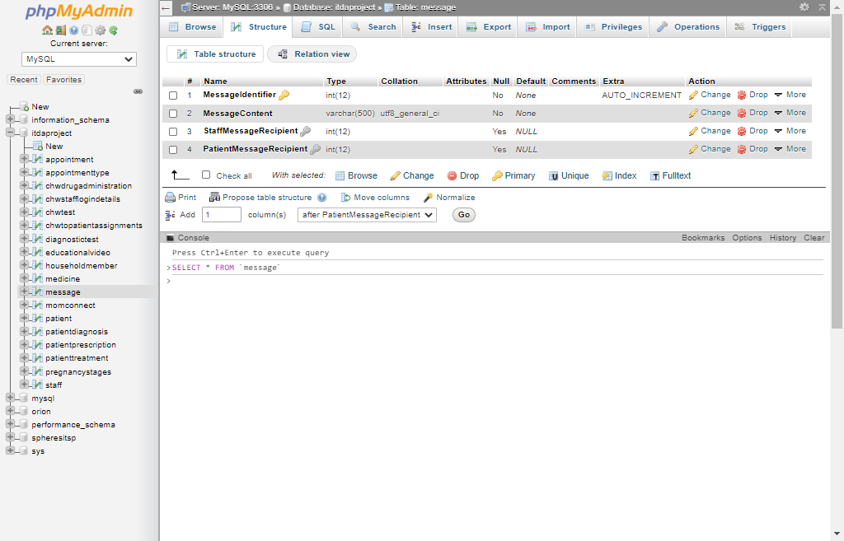

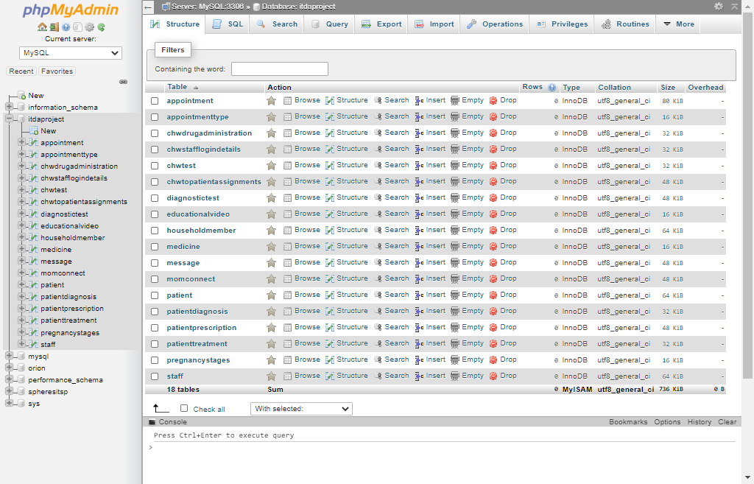

## 3.2

The following Screenshots display the database’s base relations being filled with some pseudo data in MySQL:

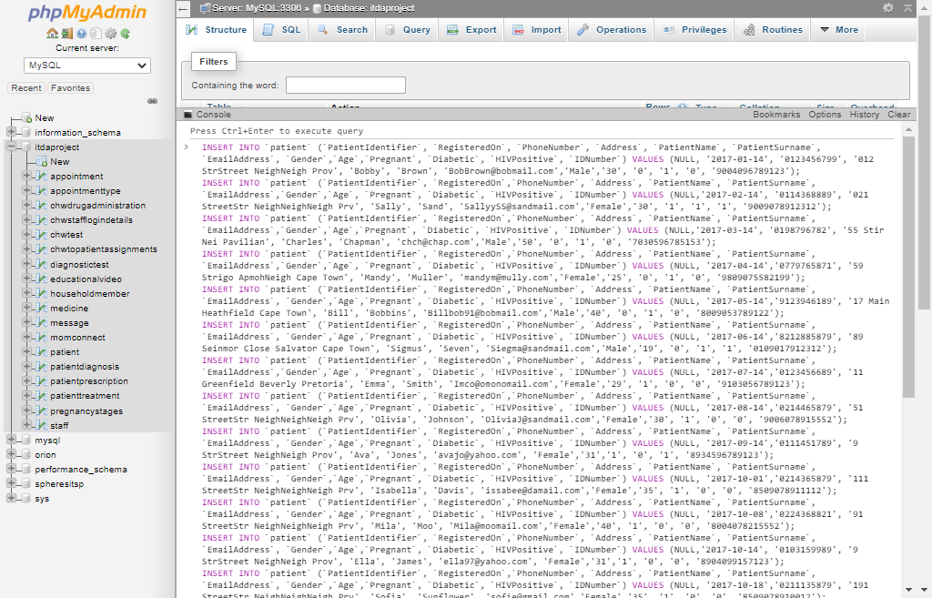 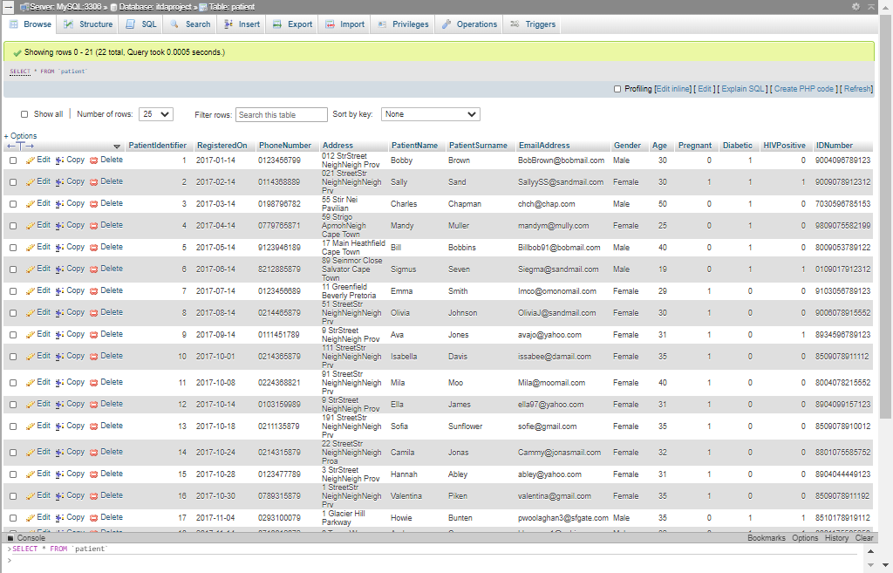

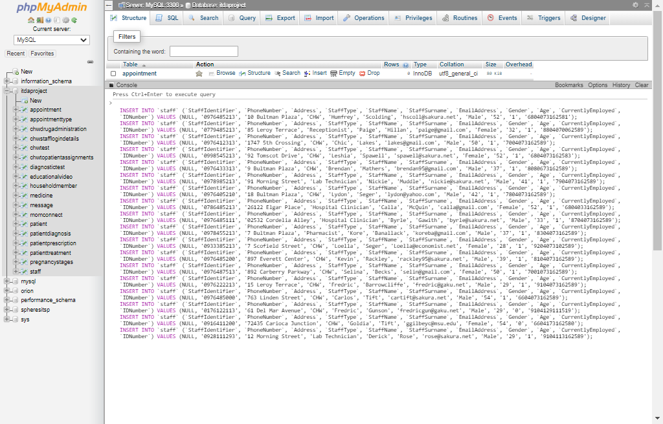 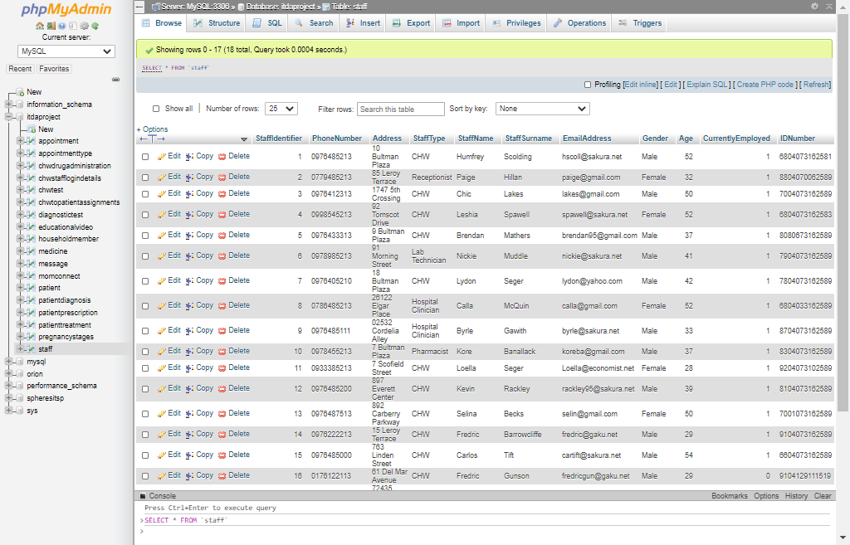

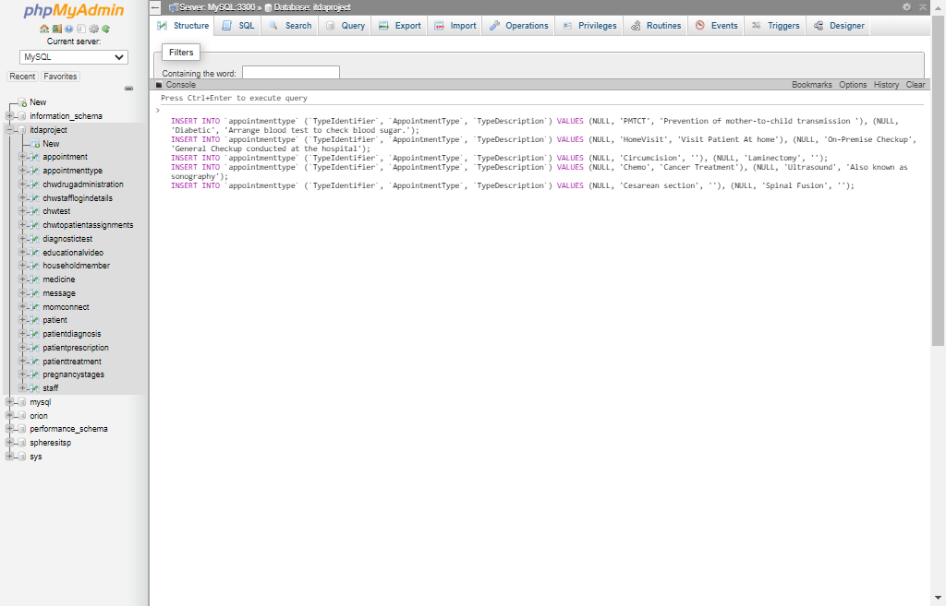 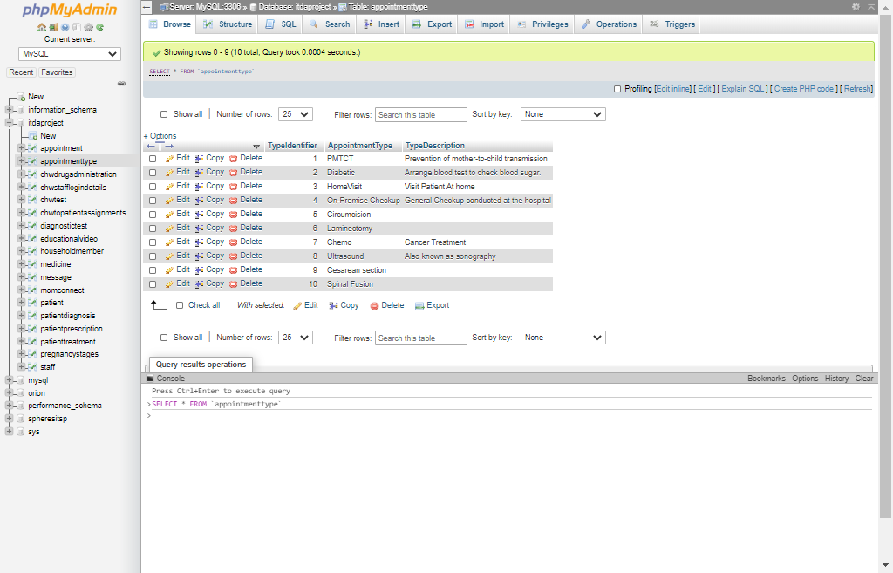

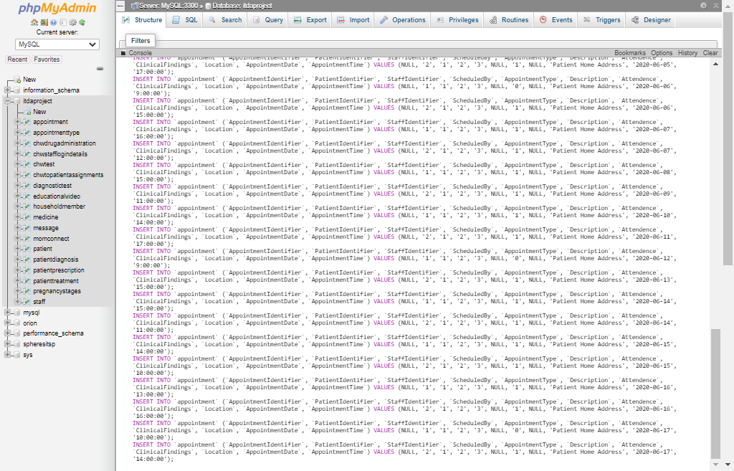 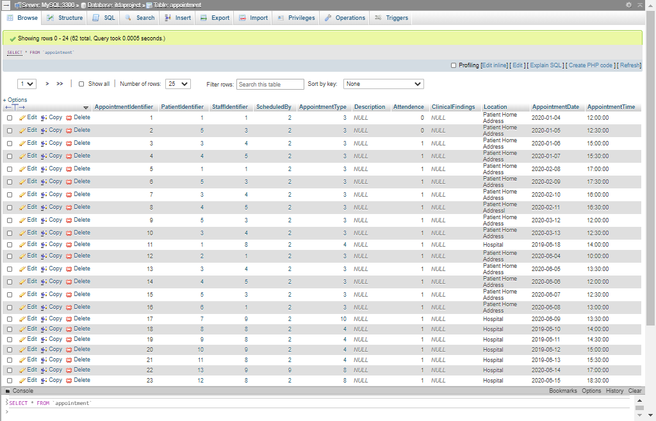

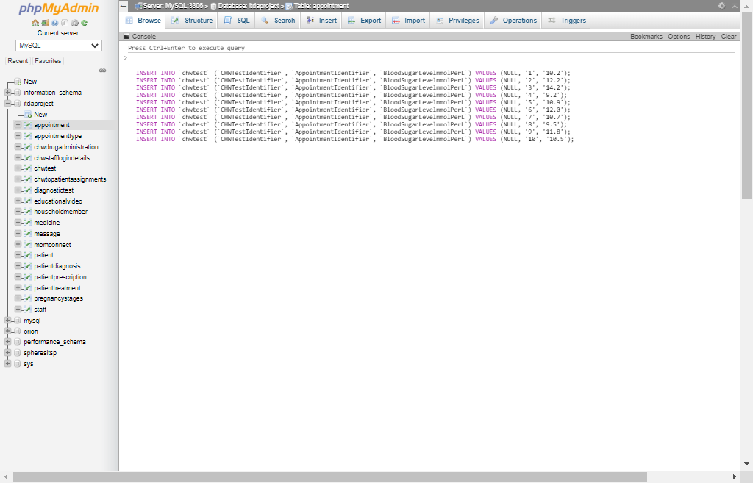 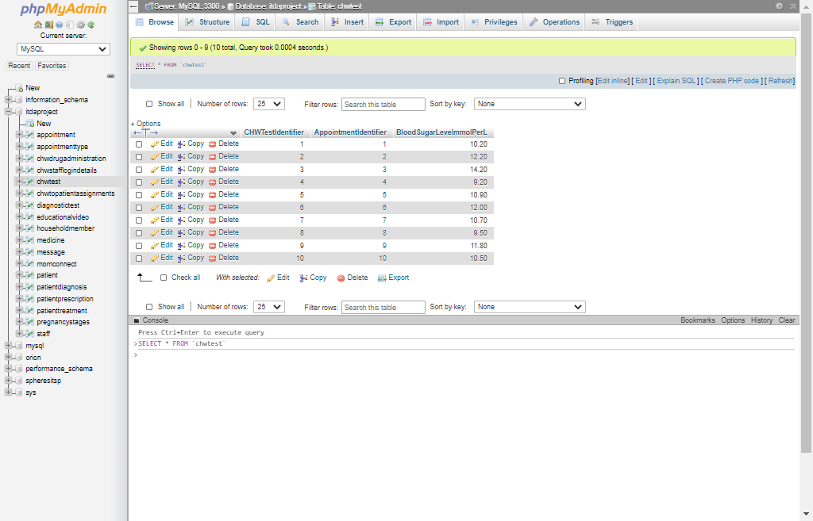

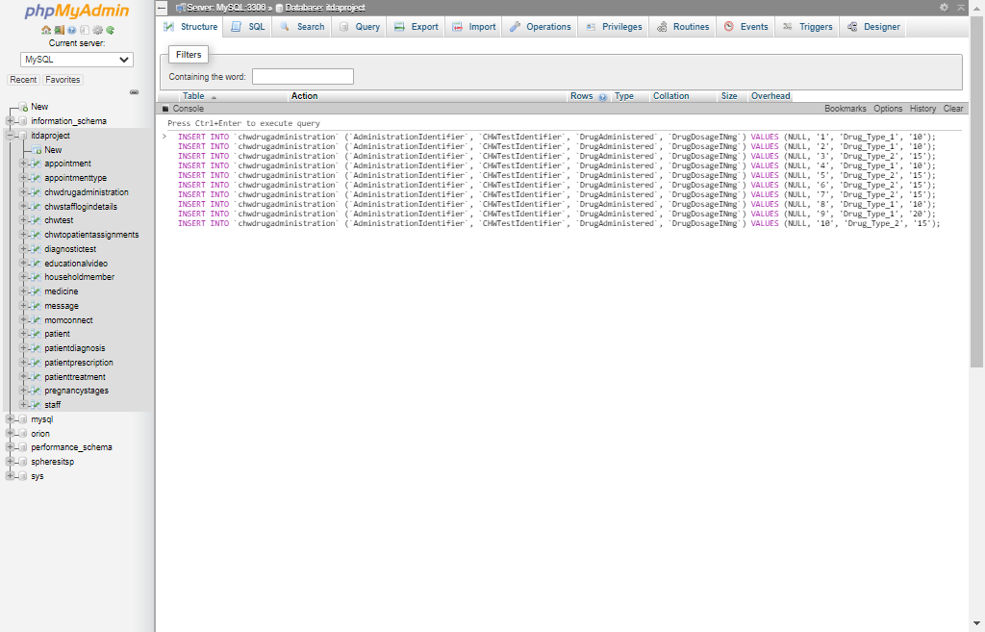 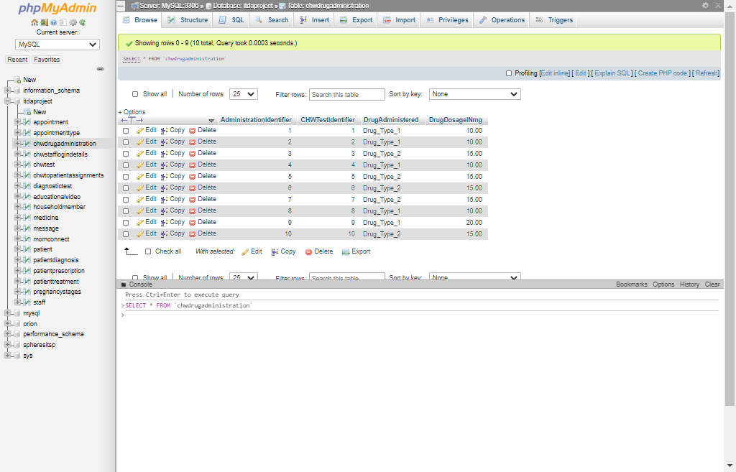

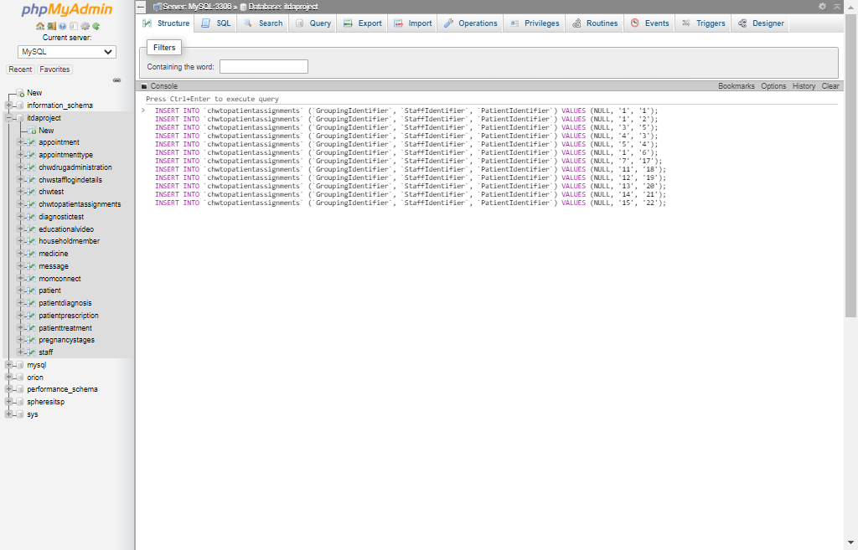 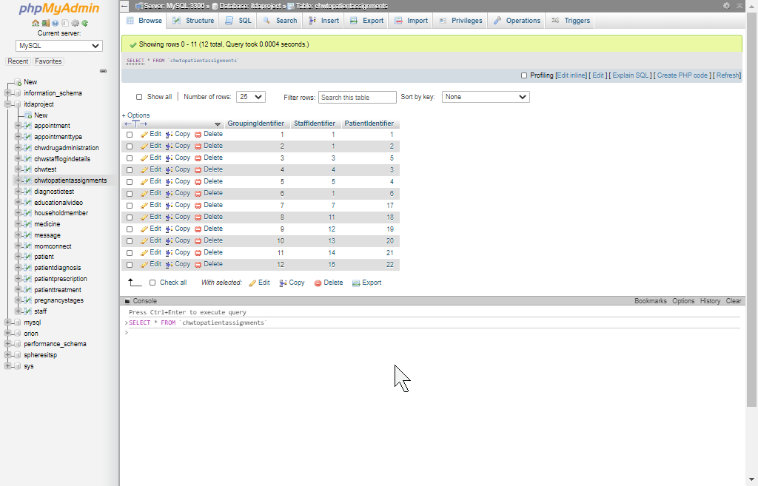

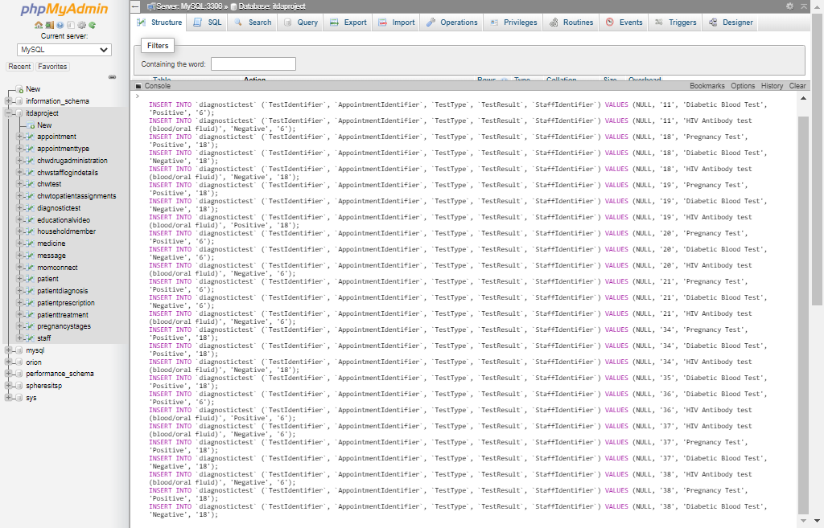 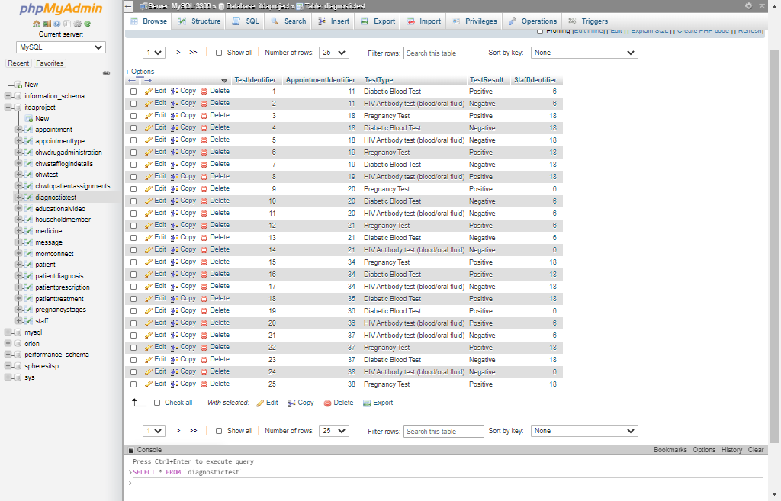

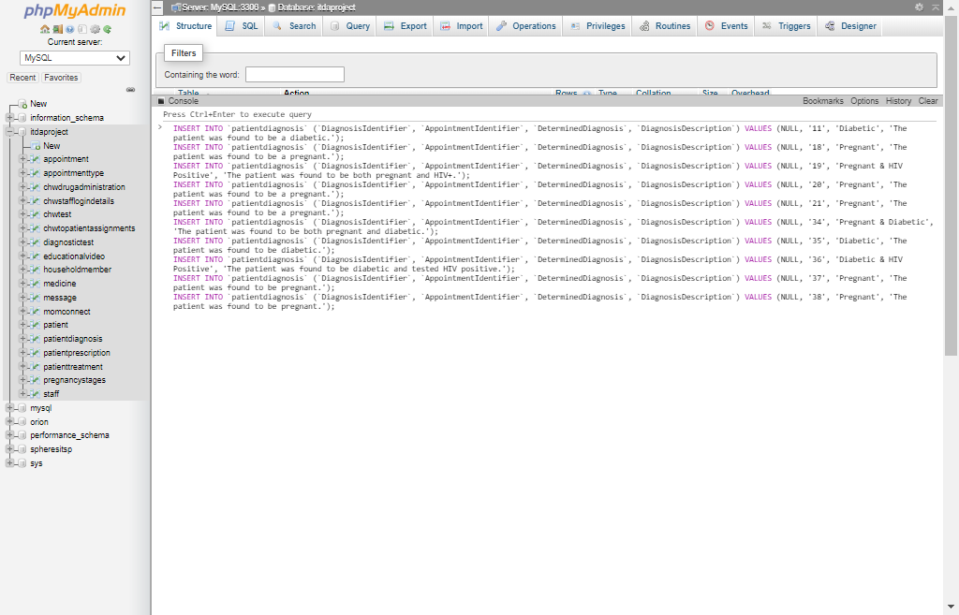 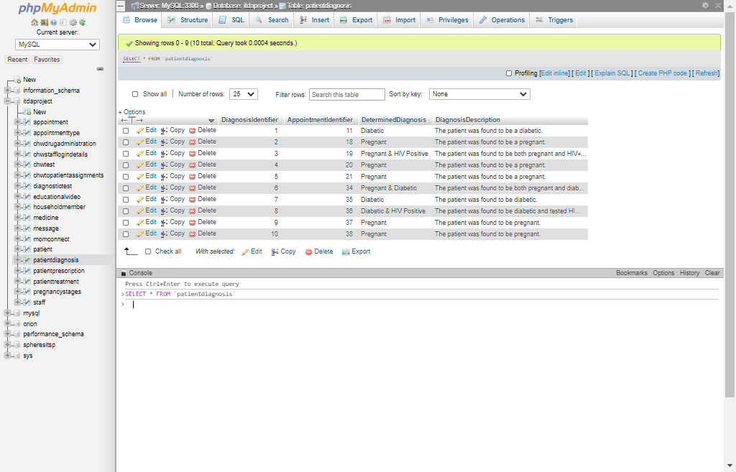

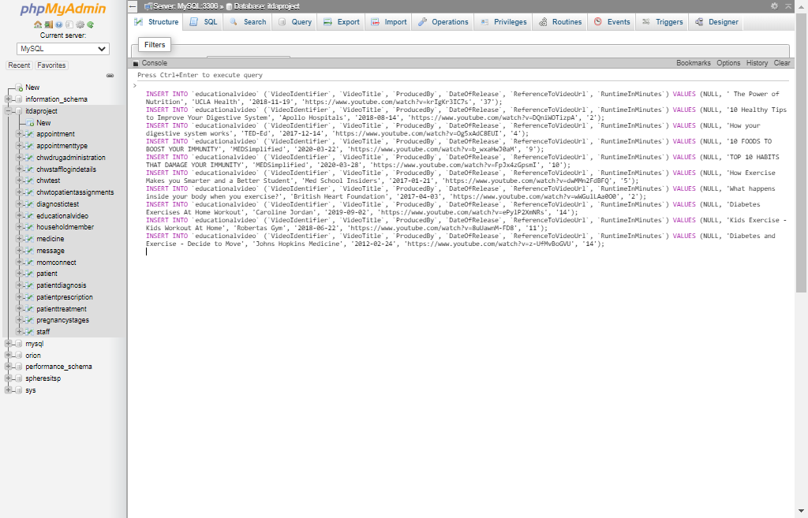 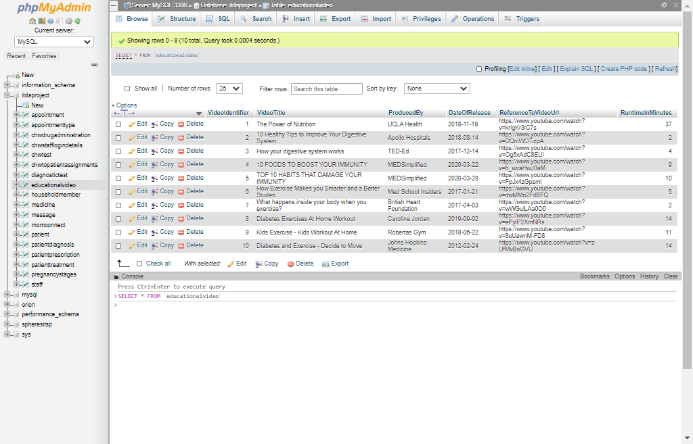

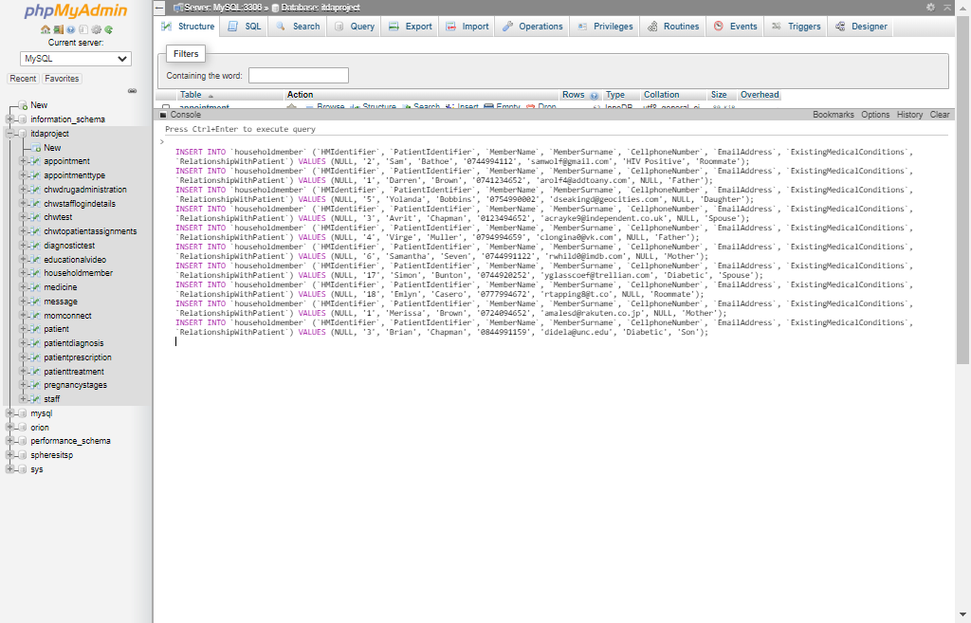 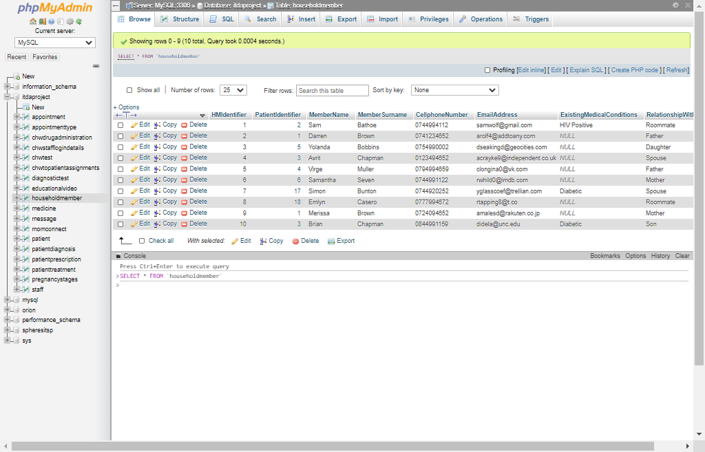

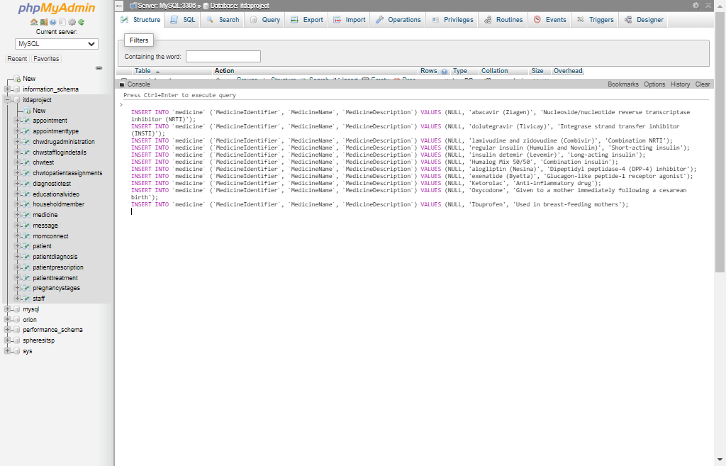 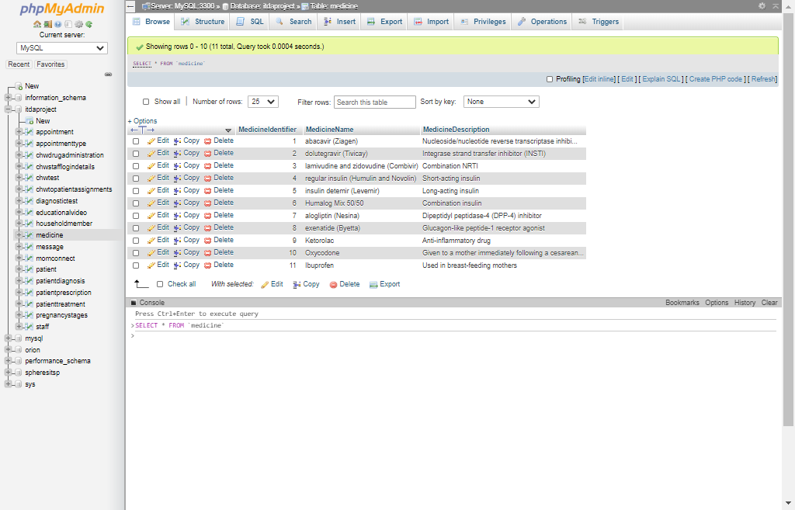

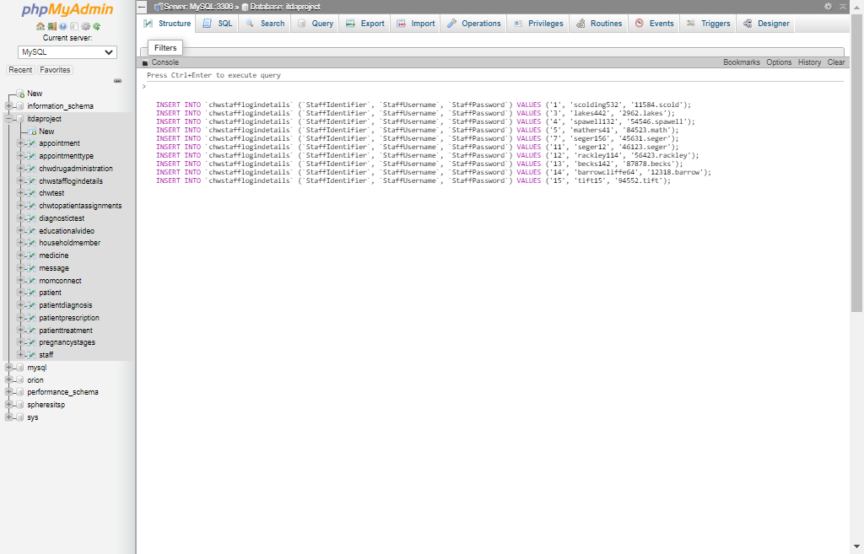 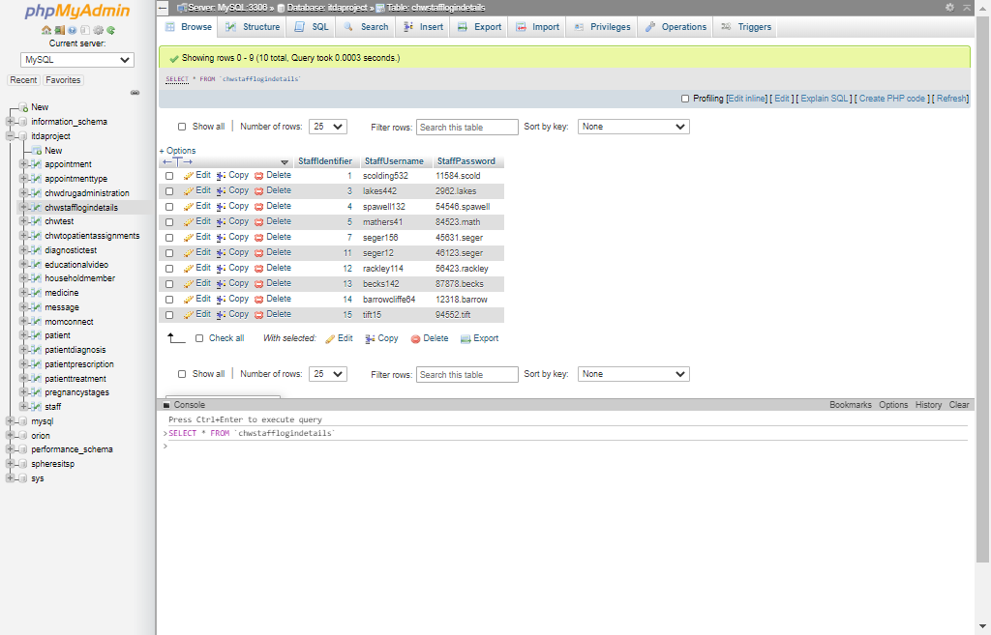

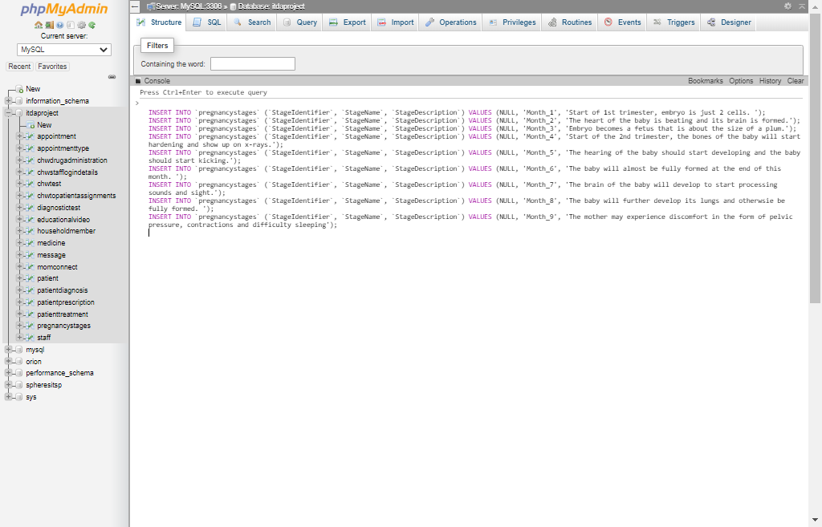 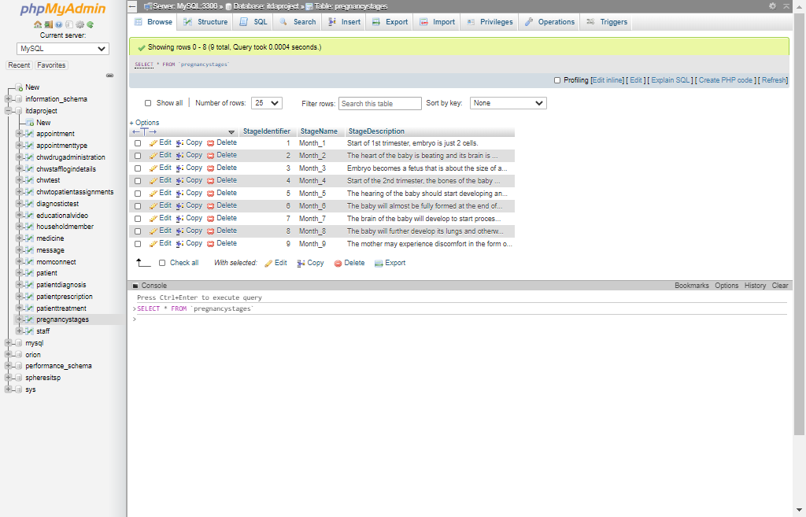

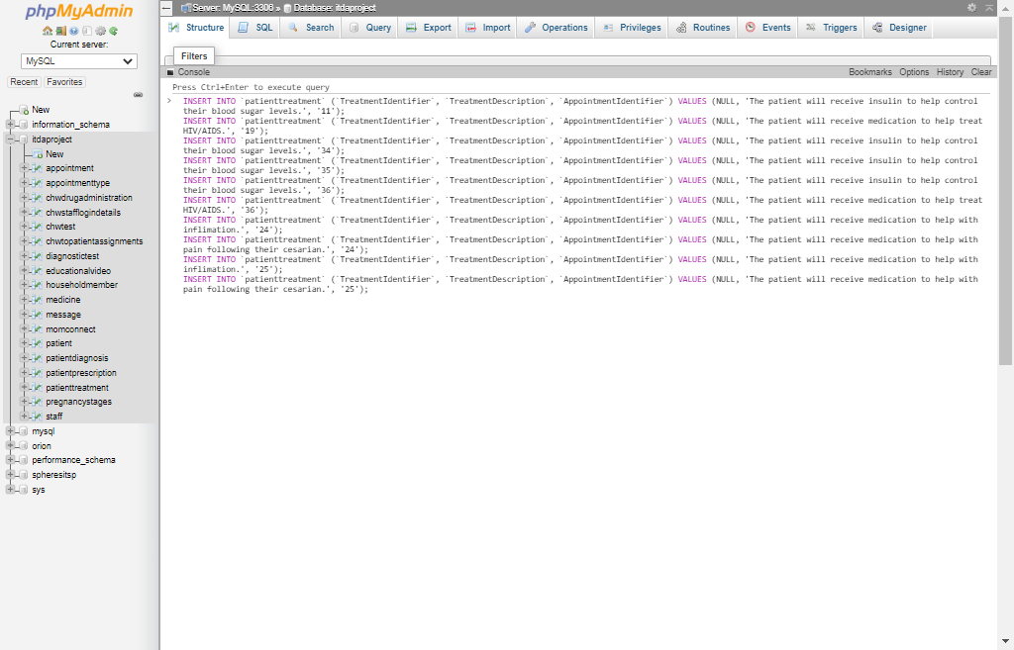 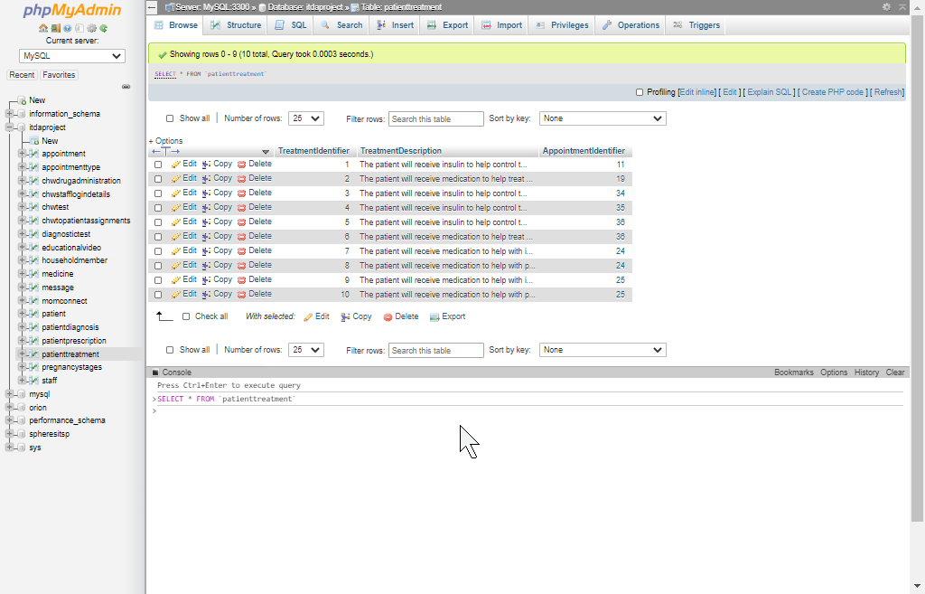

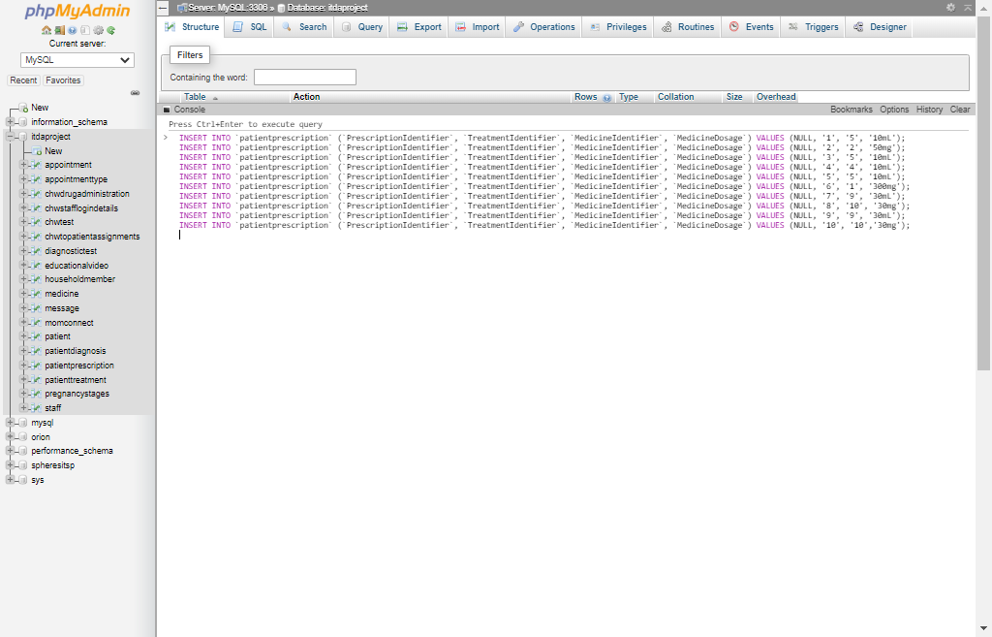 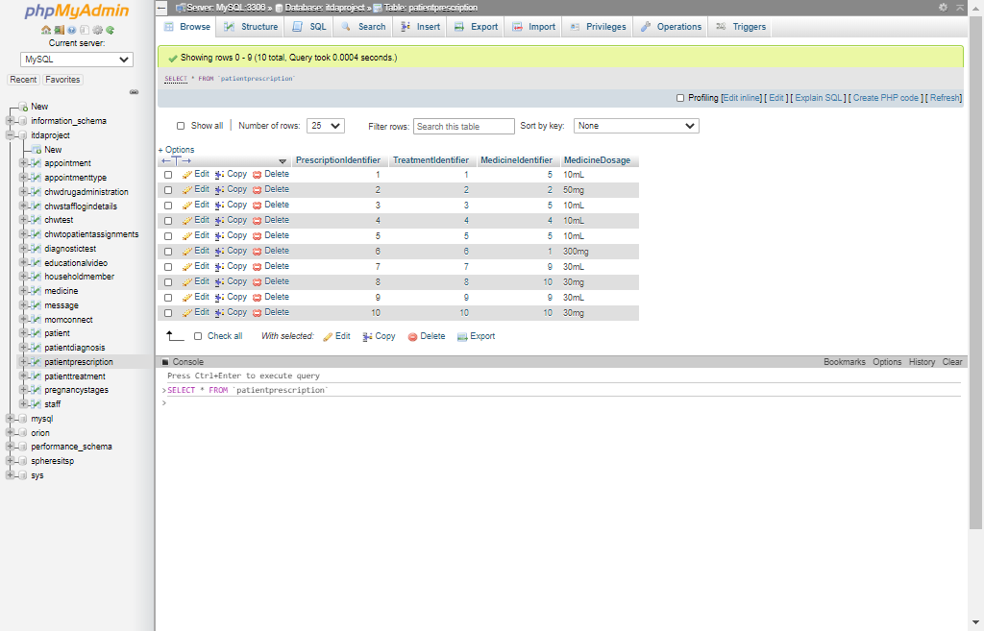

**Both `message` and `momconnect` are entities created with the intent of automatically being filled with data as the consequence of triggers being invoked on other entities in the database. Not all of the triggers necessary to achieve this autonomous feat have been created though as this would go beyond the project’s scope communicated through Question 4’s requirements.**

**Though screenshots in Question 4 will portray some data automatically being added to the `momconnect` and `message` entity, the following pseudo data is also added to the `message` entity:**

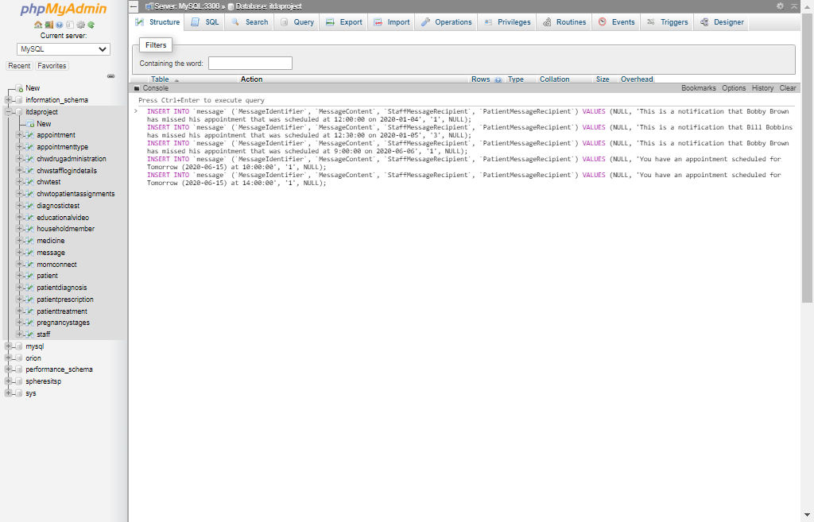 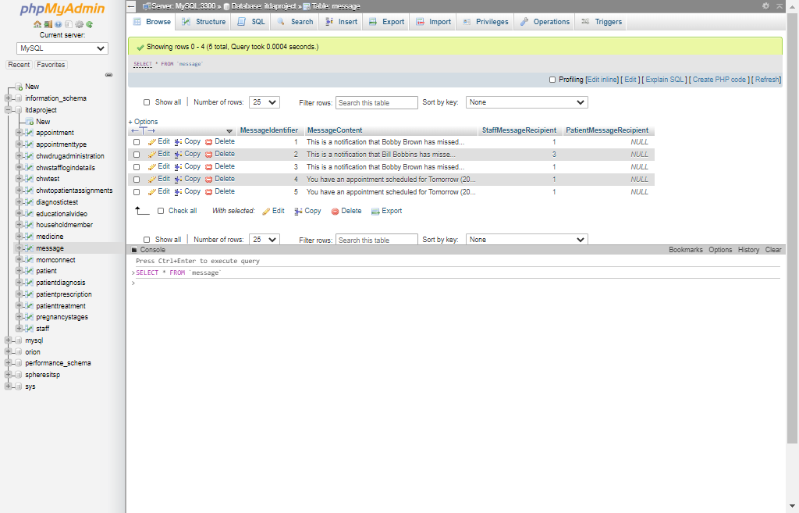

## 3.3

See question 3.1 wherein all the integrity constraints identified earlier in this document is declared alongside their respective entities.

## 3.4

The following Screenshots display the creation of views in MySQL according to those portrayed in the global data model of Question 2.4:

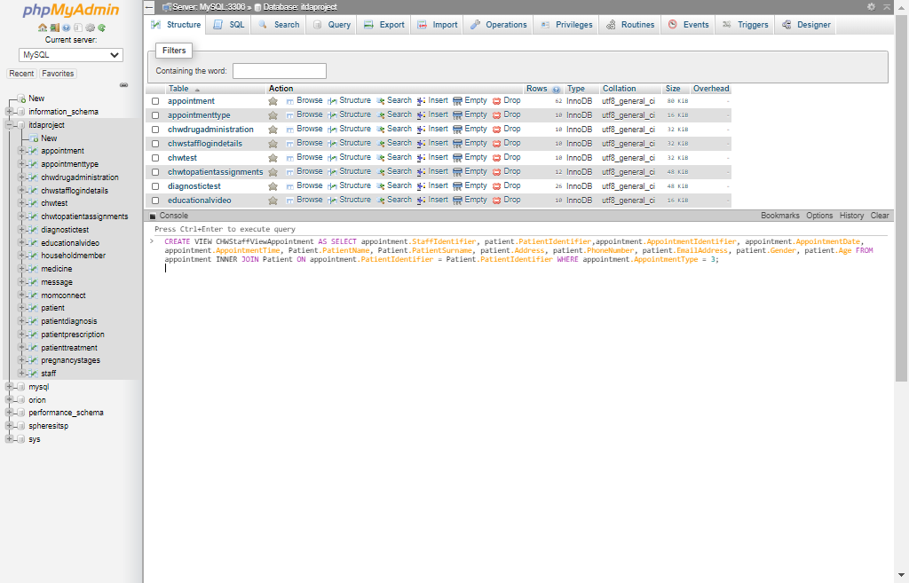 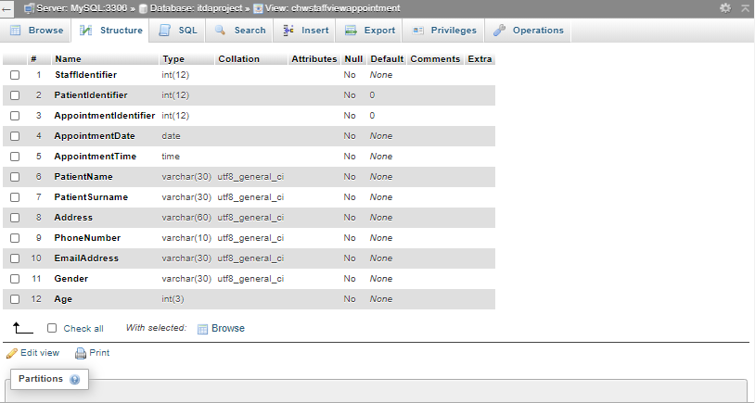

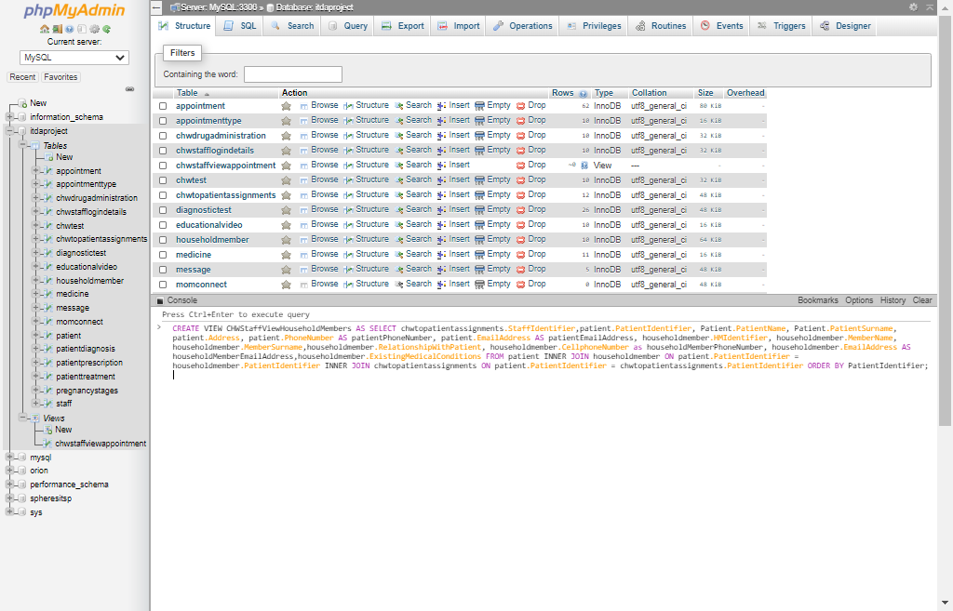 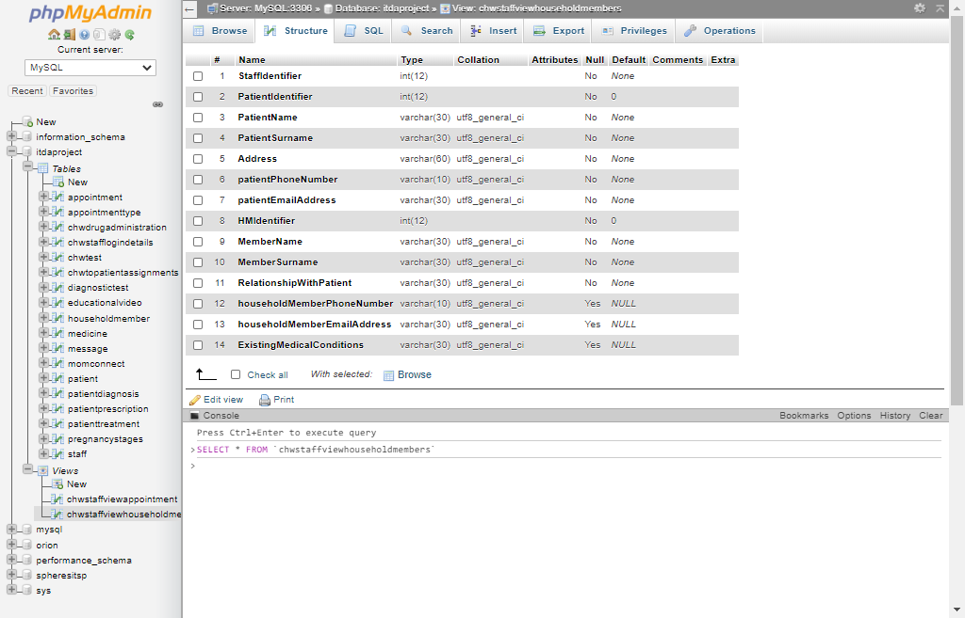

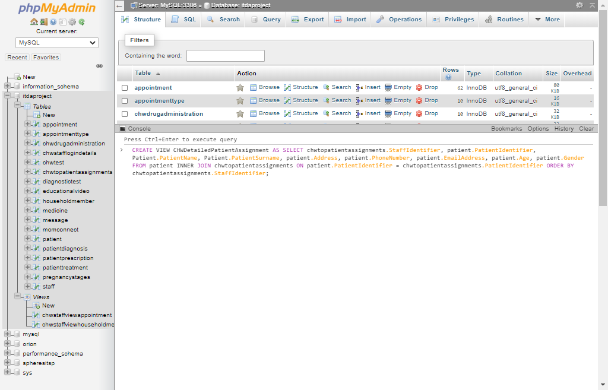 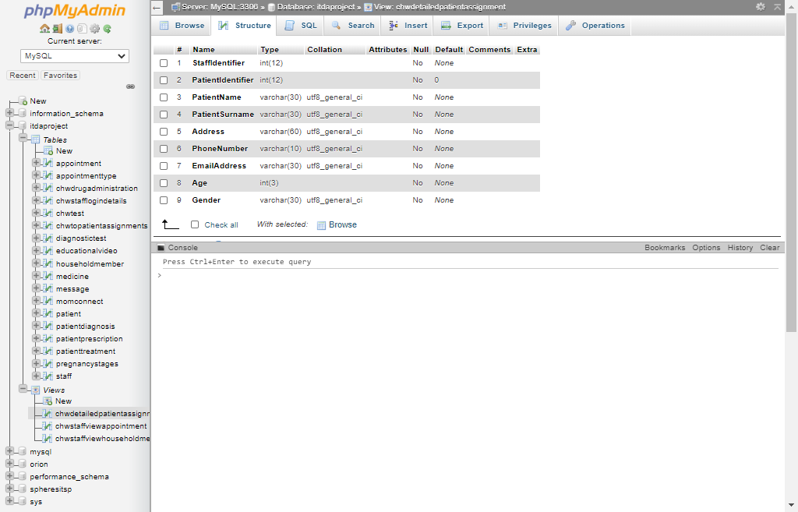

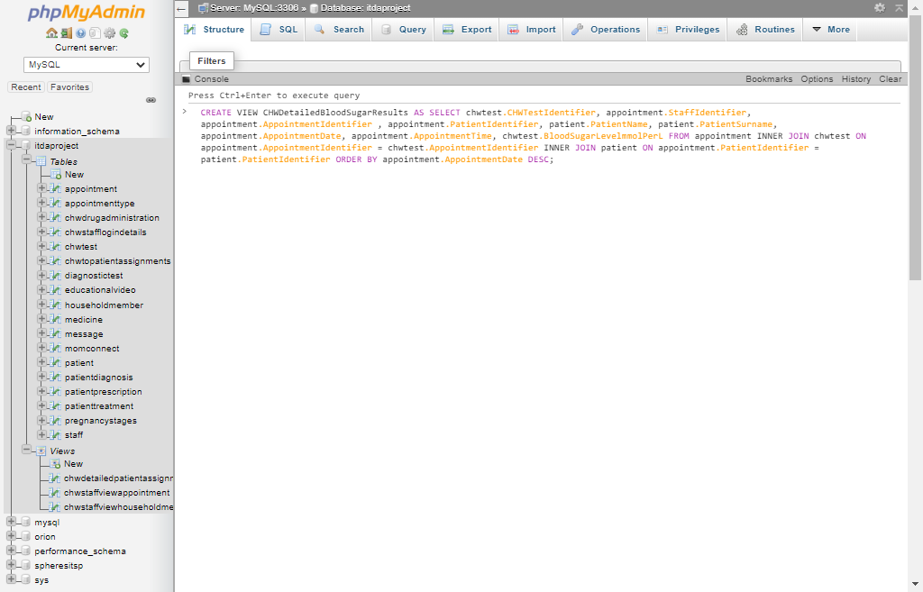 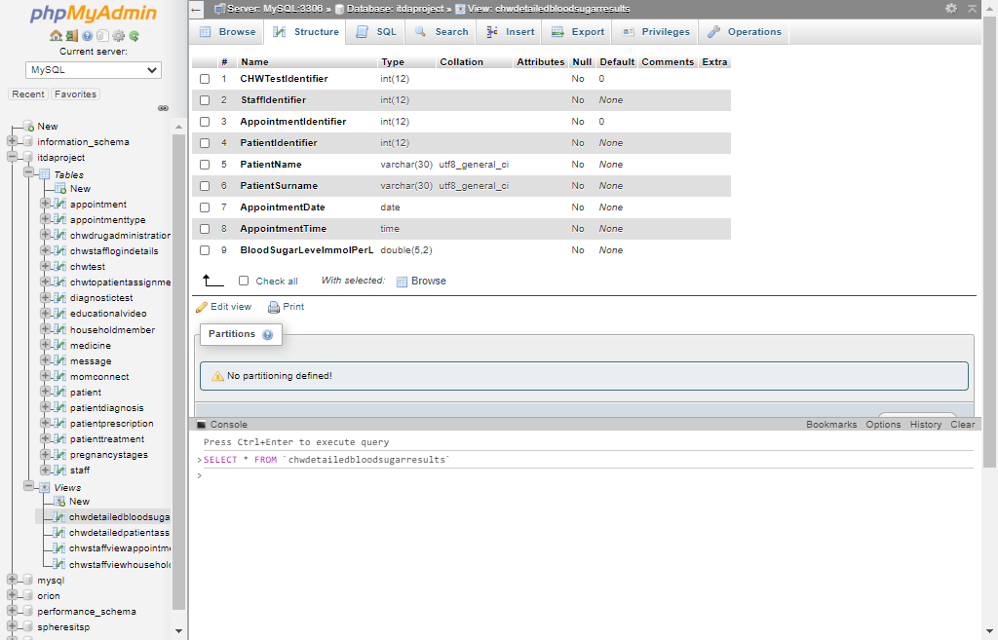

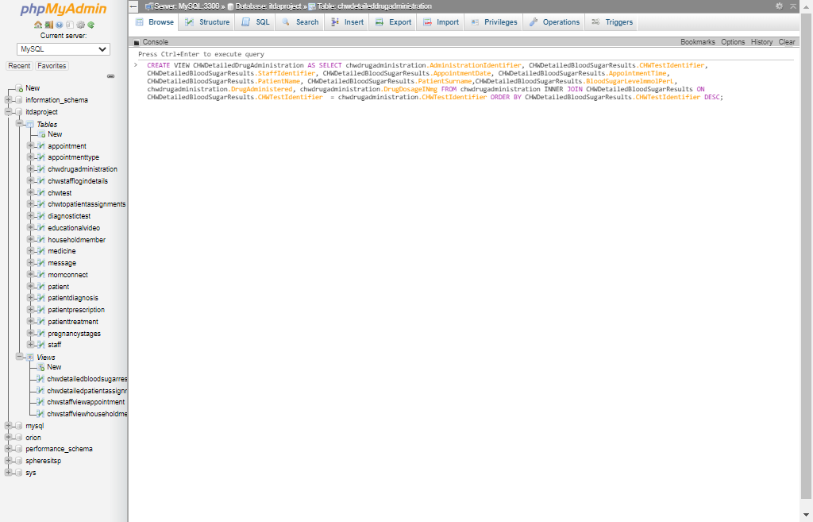 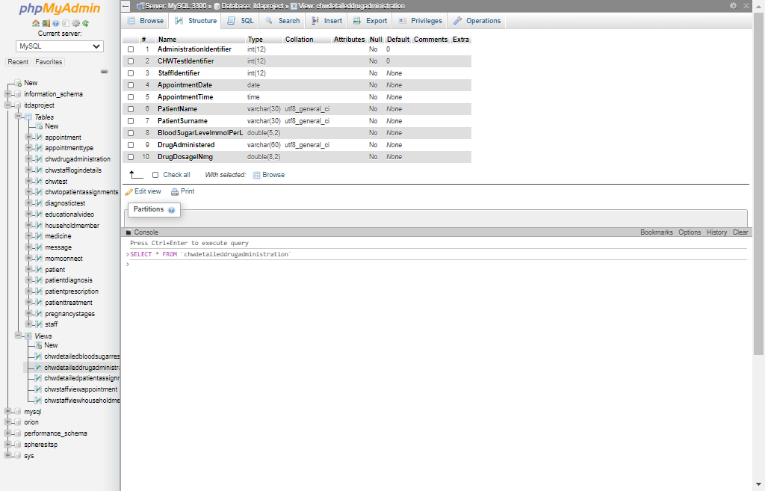

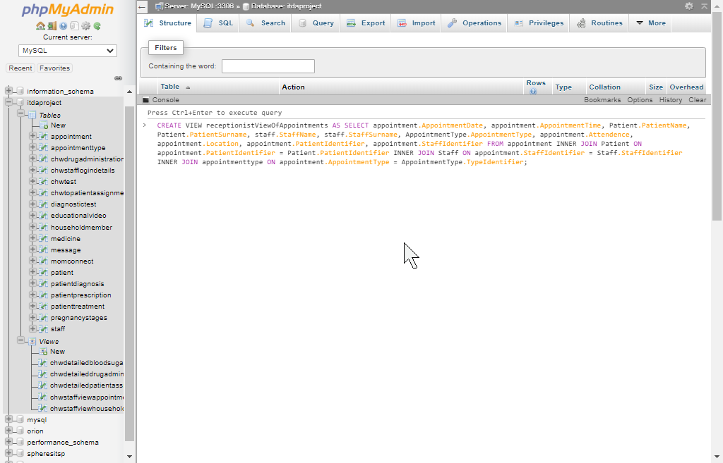 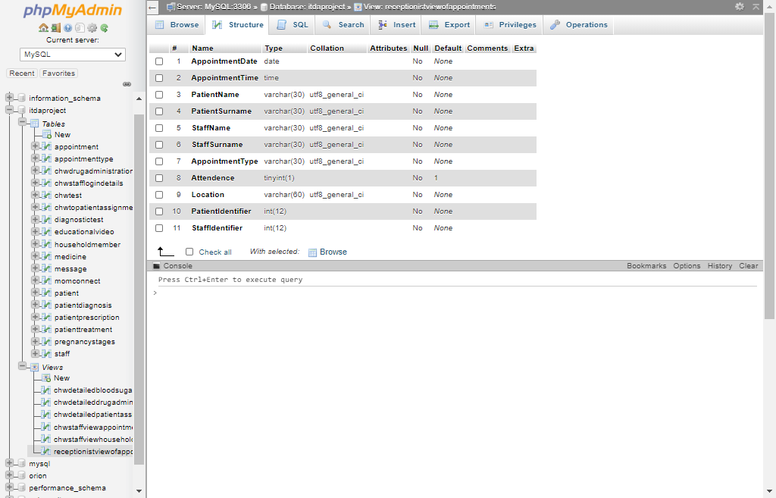

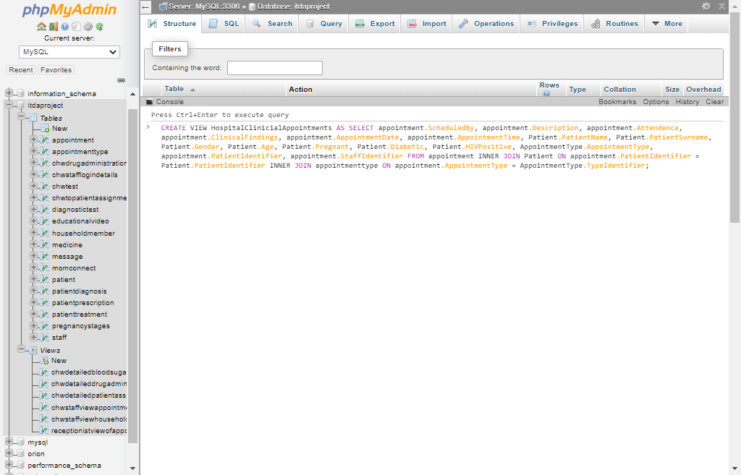 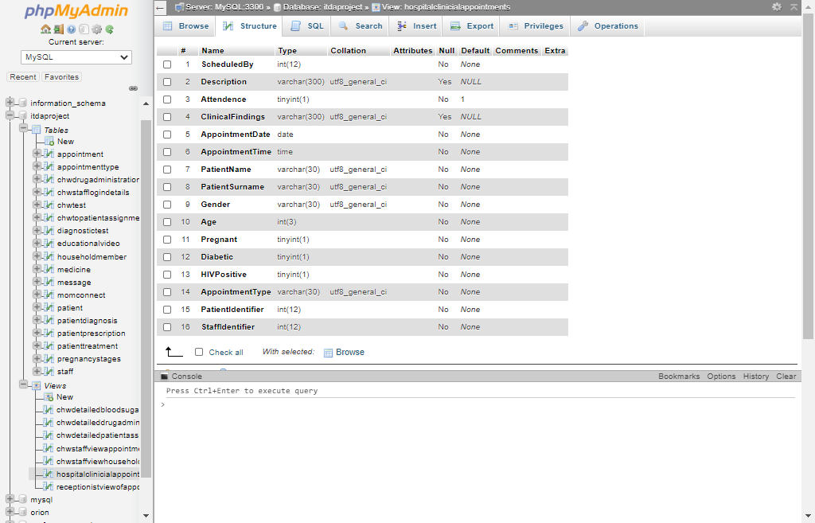

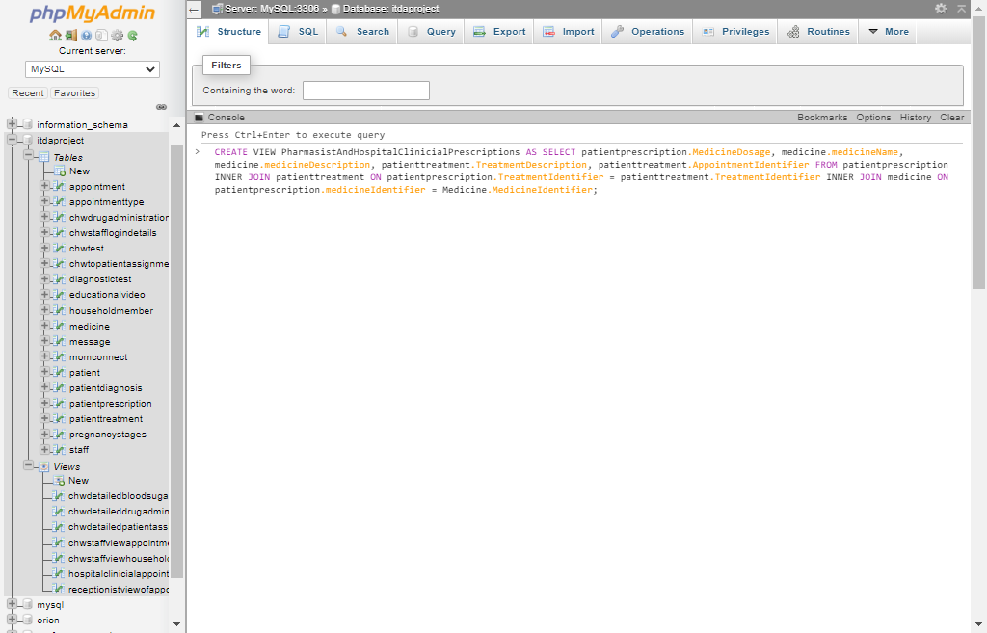 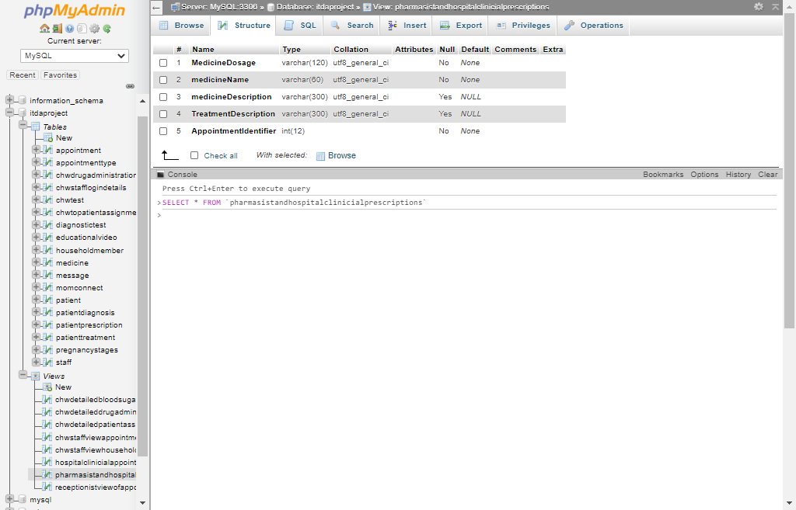

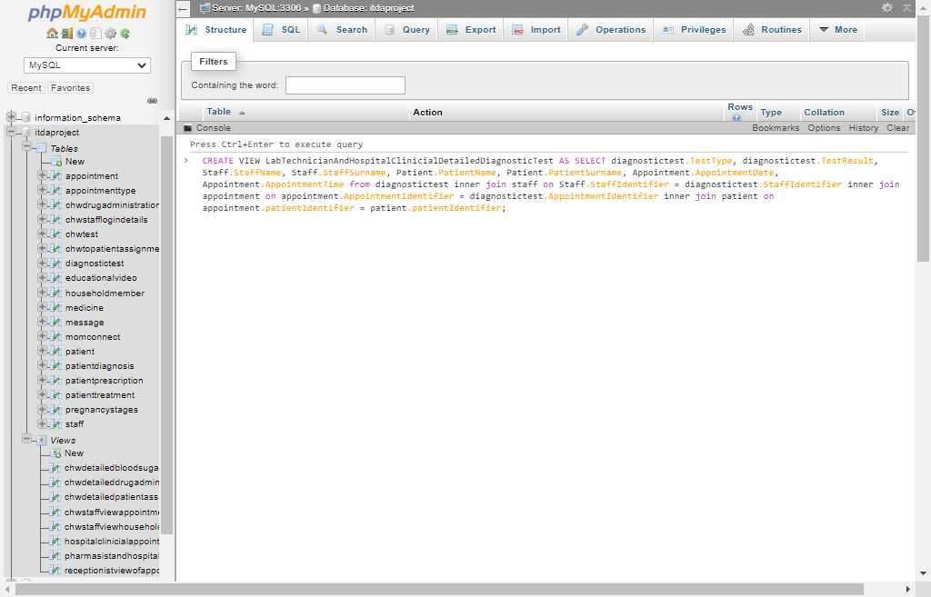 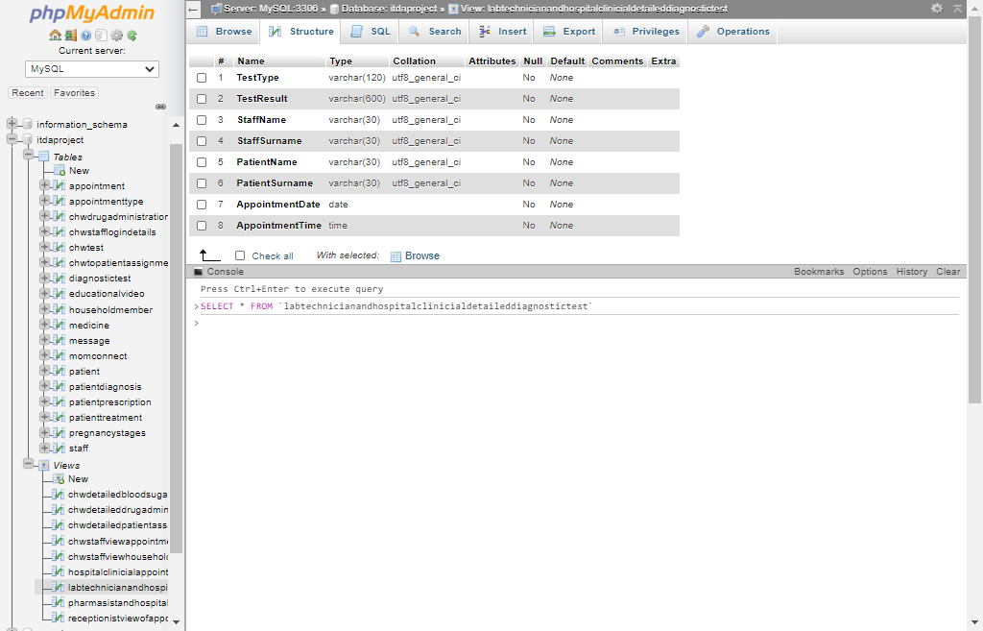

## 3.5

The following screenshots display users being created and privileges being granted them (Note that the absence of “REVOKE” statements is intentional as only the necessary privileges were awarded each user, meaning that no “GRANT ALL” statements were used):

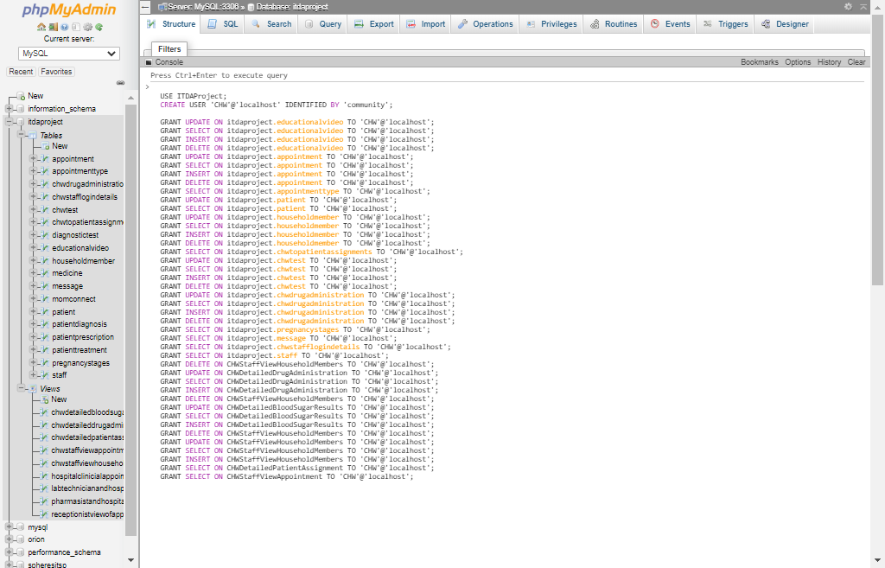 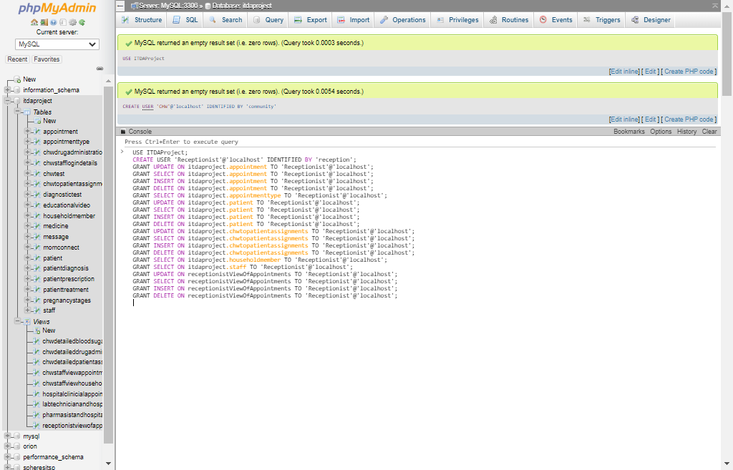 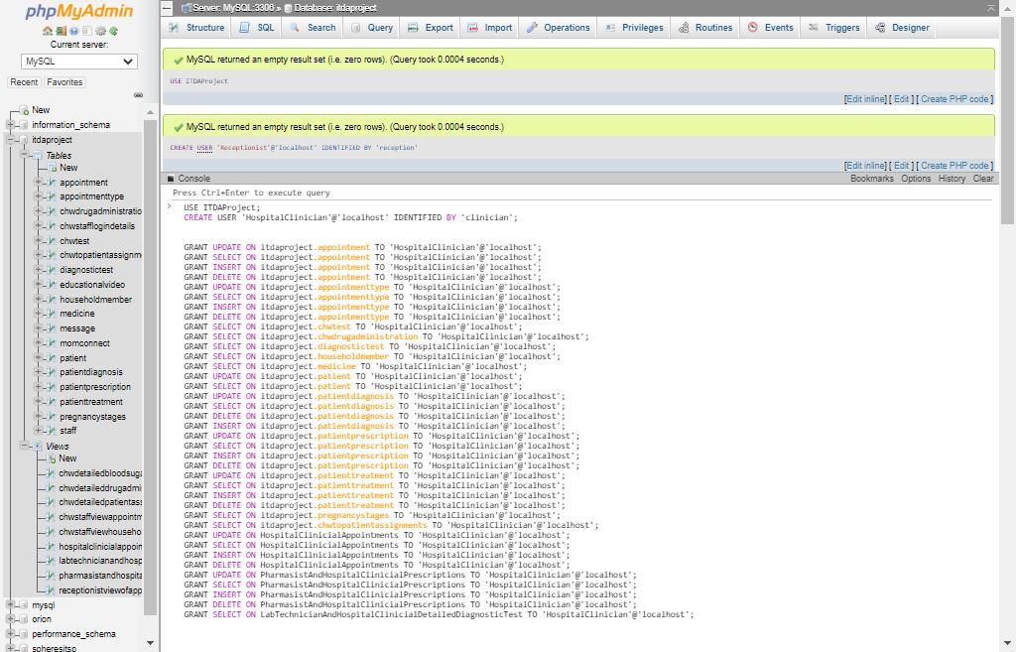 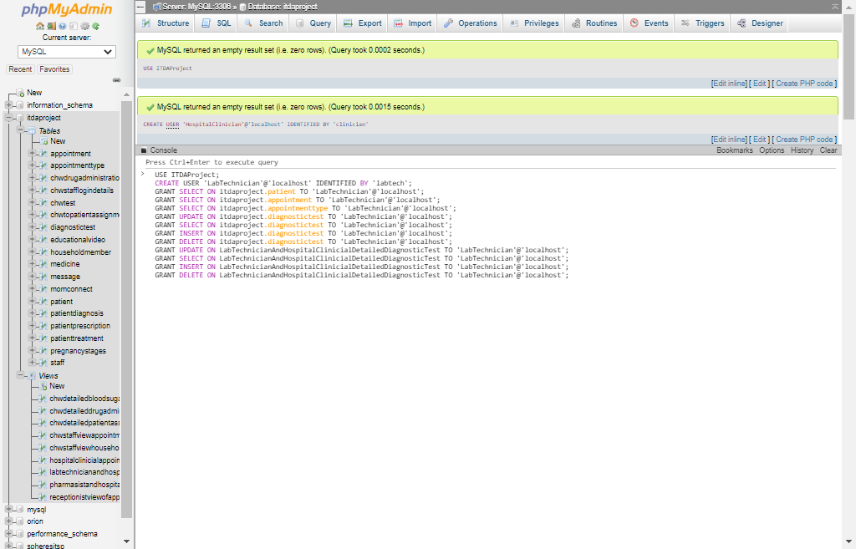 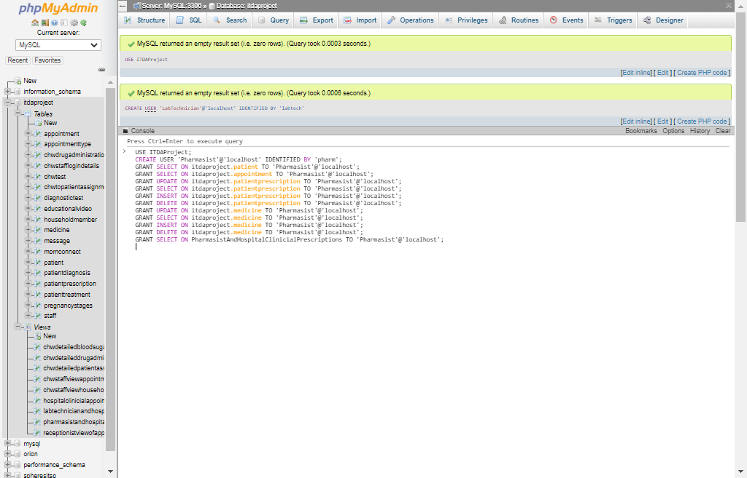

# Question 4

## 4.1

The following screenshots display three cursors, each contained within the body of a stored procedure. Select statements are used to illustrate the fashion in which each cursor accesses the rows of their respected query’s result (one at a time):

The following stored procedure shows the total amount of appointments a community healthcare worker had yesterday and then uses a cursor to display information pertaining to each of yesterday’s appointments (one at a time):

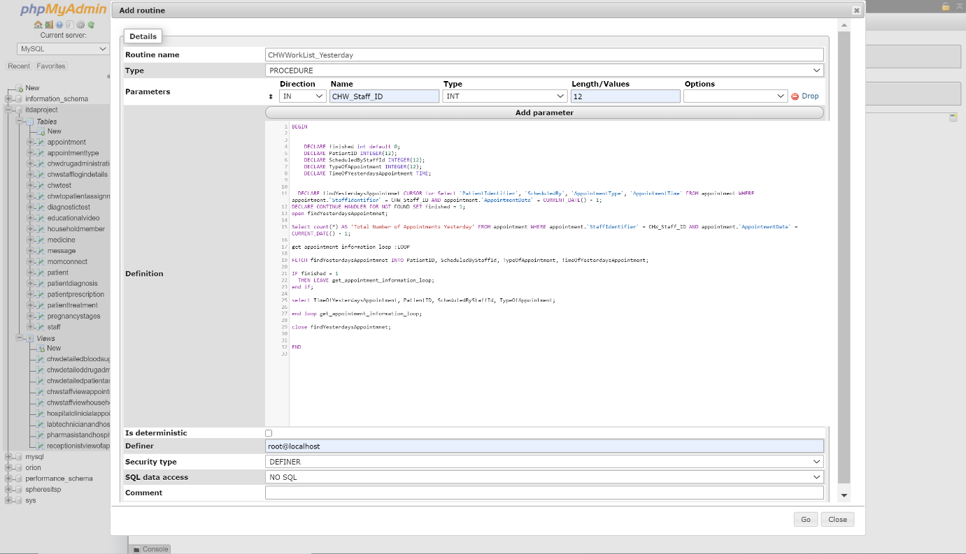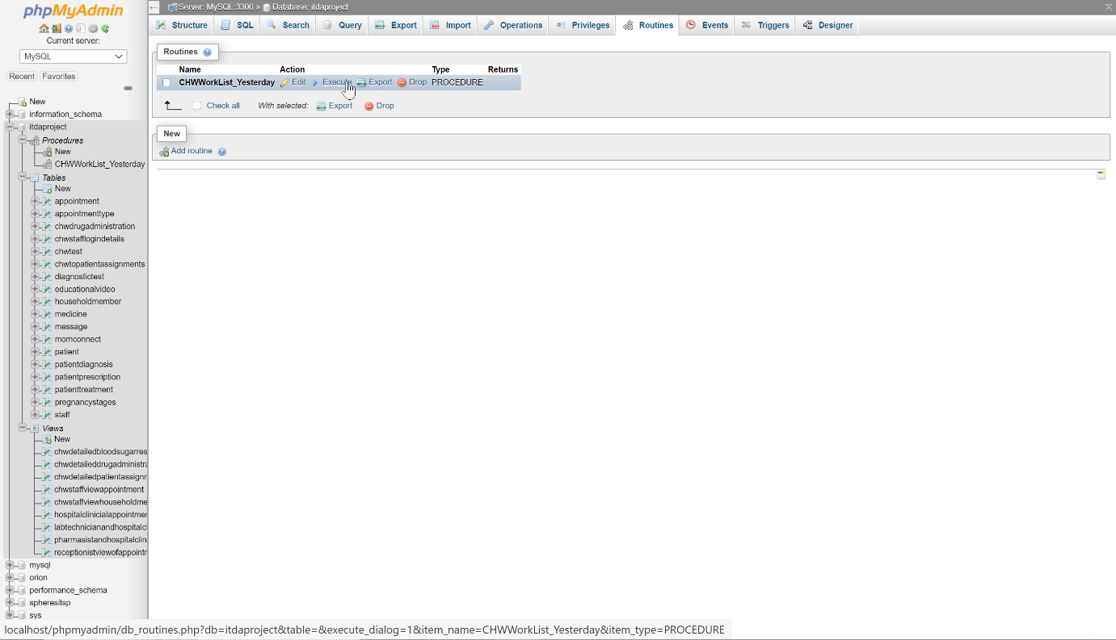

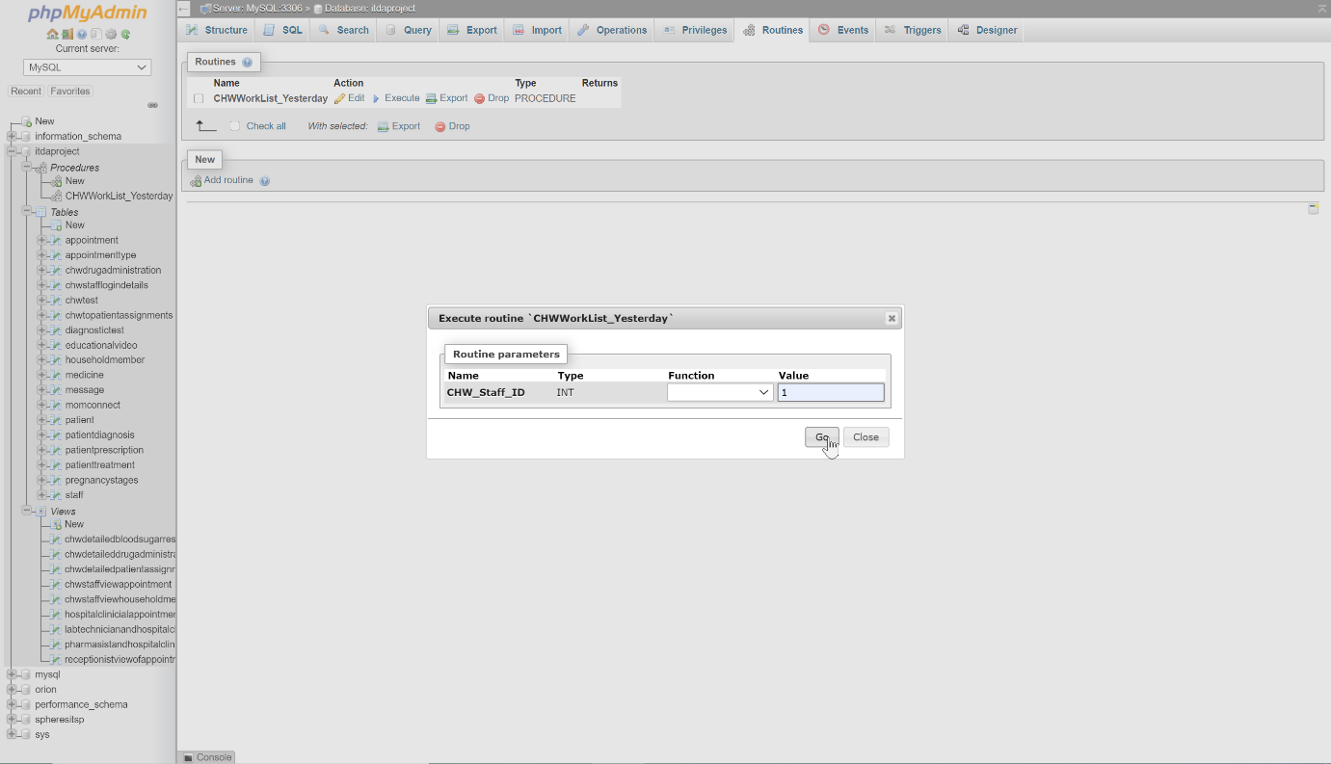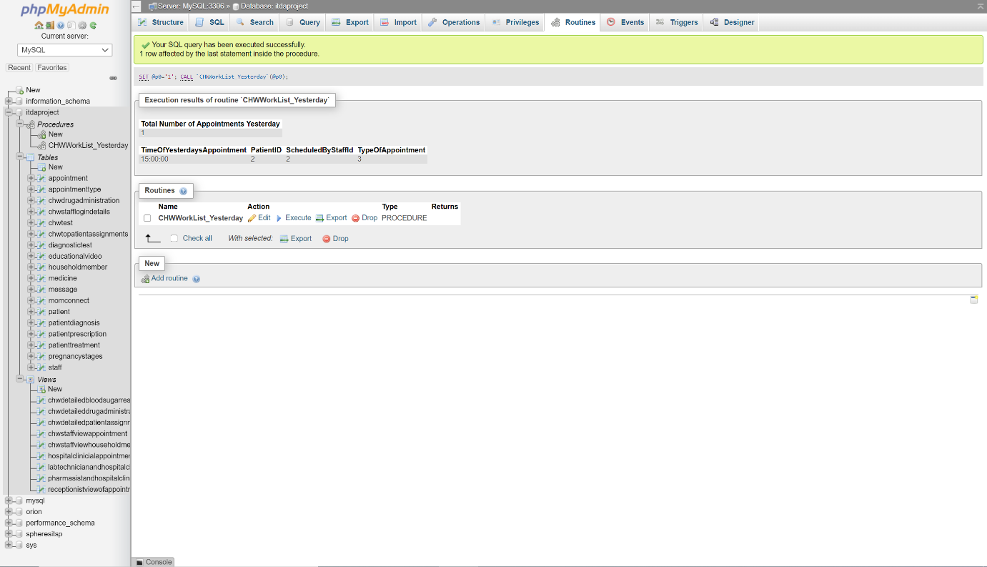

The following stored procedure shows the total amount of appointments a community healthcare worker has scheduled for today and then uses a cursor to display information pertaining to each of today’s appointments (one at a time):

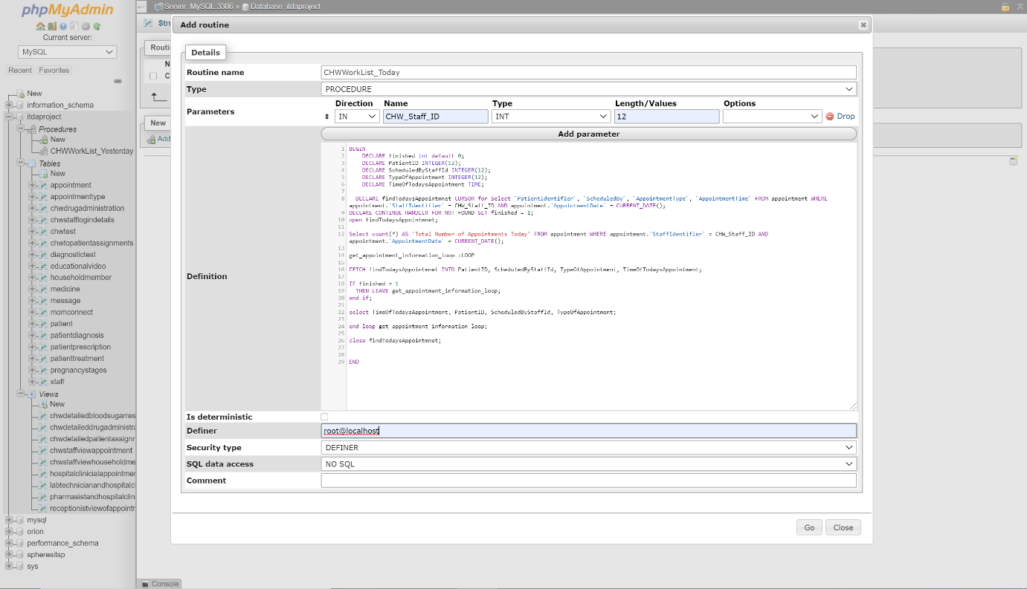 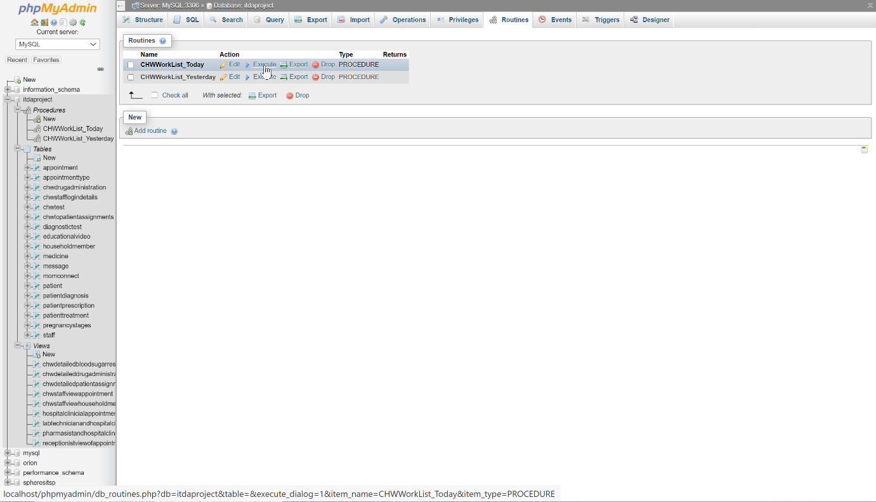 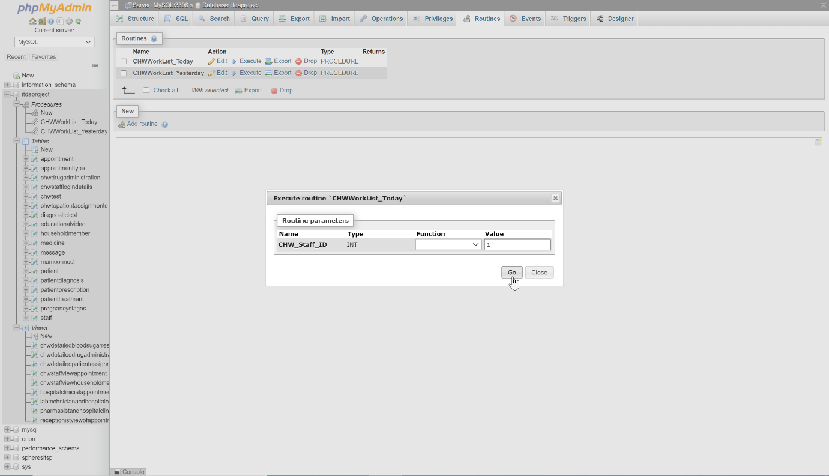 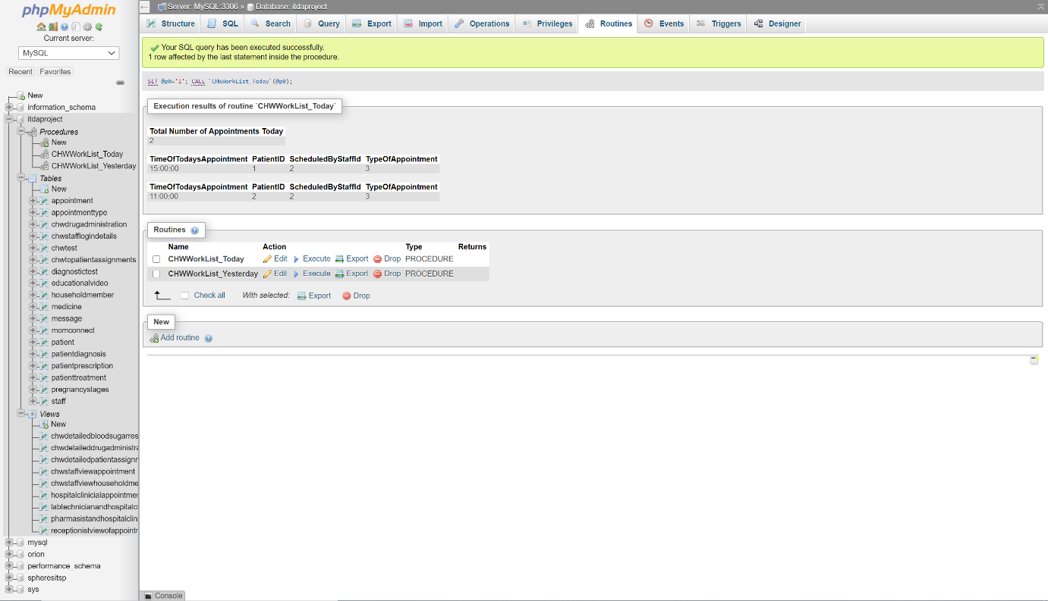

The following stored procedure shows the total amount of appointments a community healthcare worker has scheduled for tomorrow and then uses a cursor to display information pertaining to each of tomorrow’s appointments (one at a time):

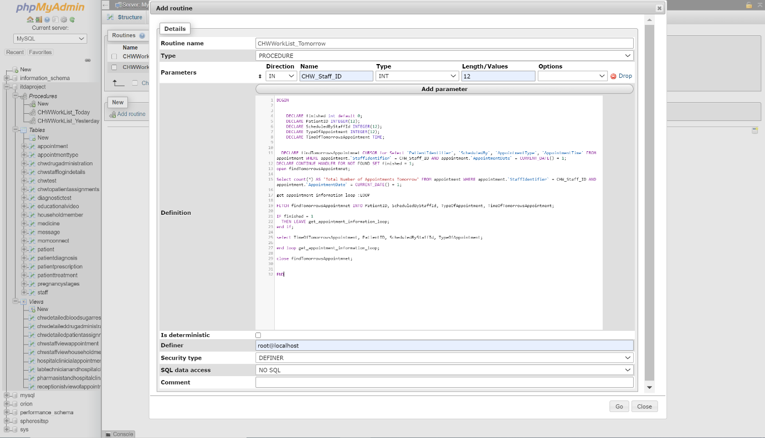 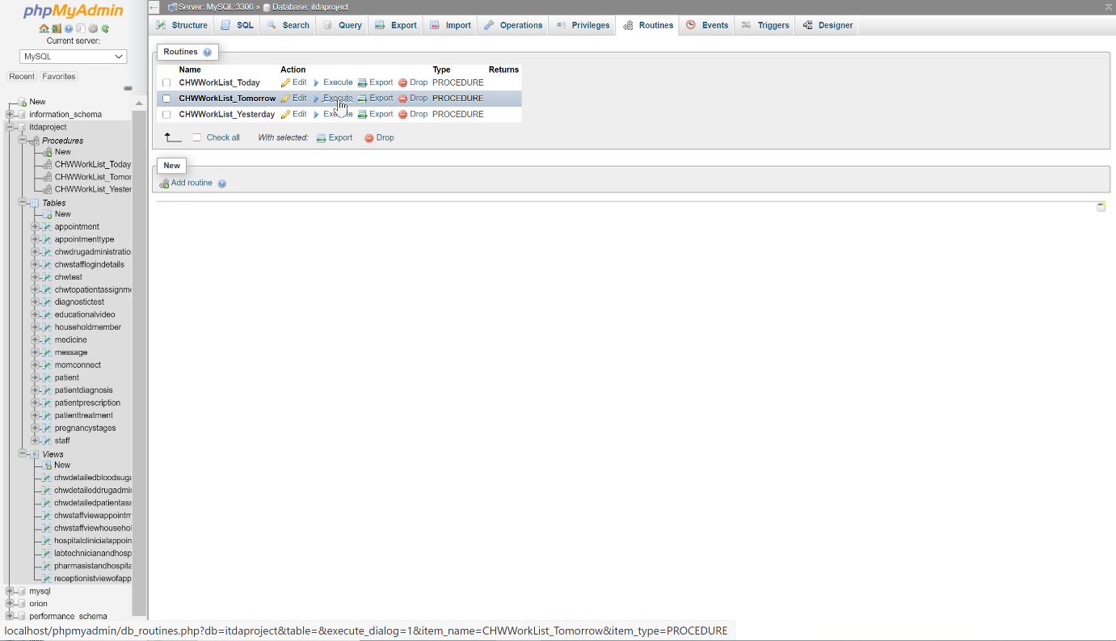 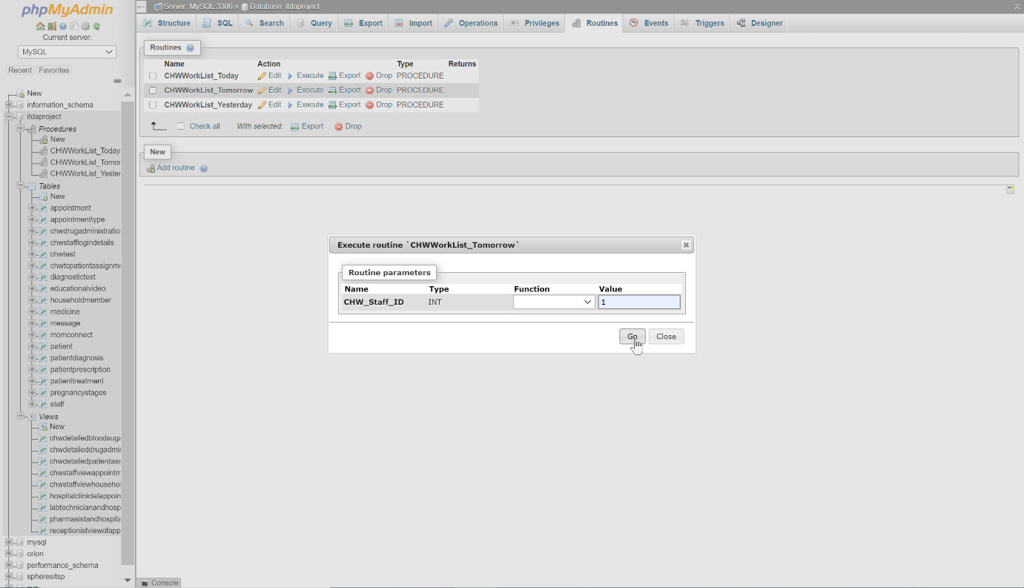 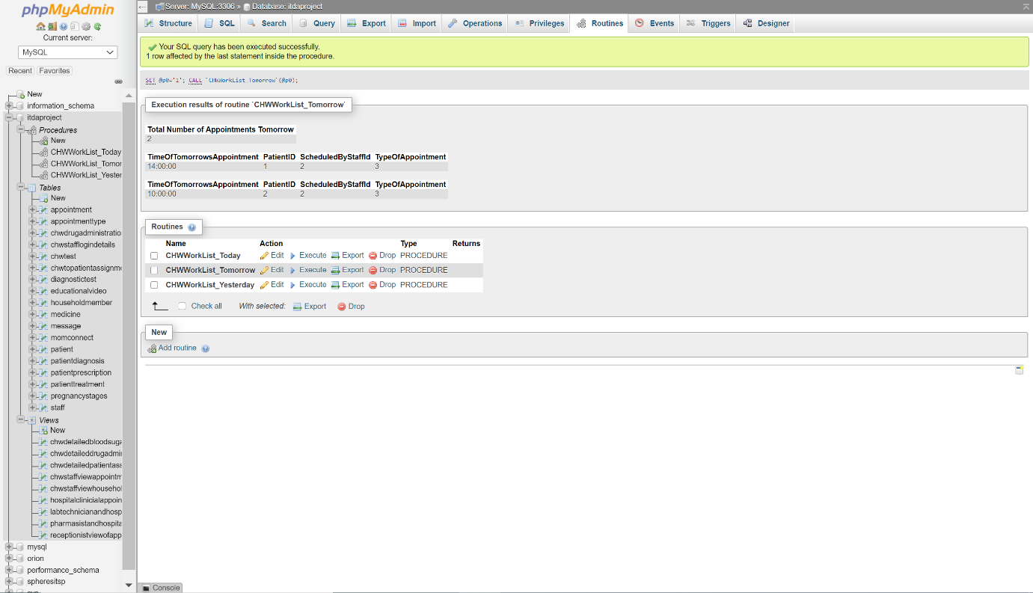

## 4.2

In addition to the three stored procedures displayed in Question 4.1 the following screenshots display two more stored procedures, both fetching the information associated to a patient based either on the full name or the ID number provided:

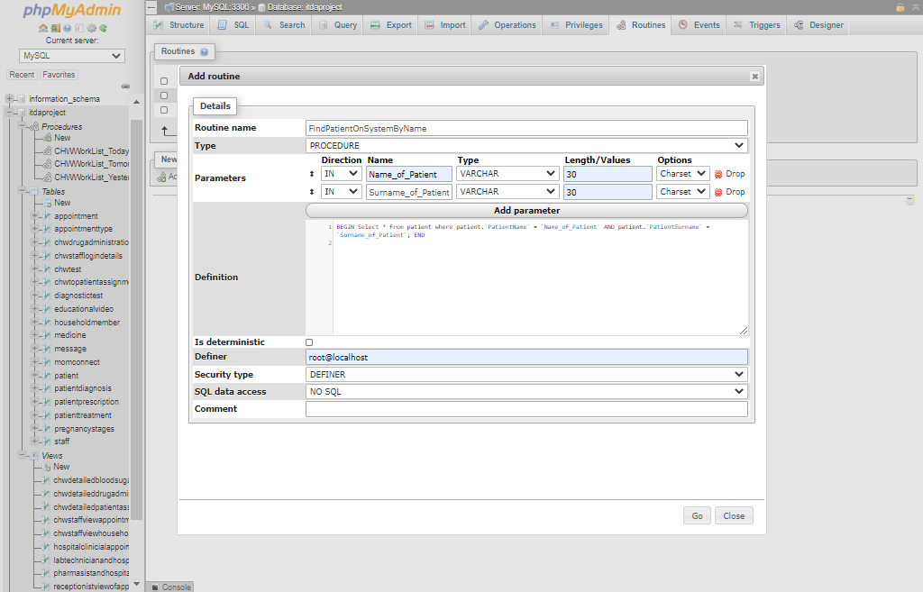 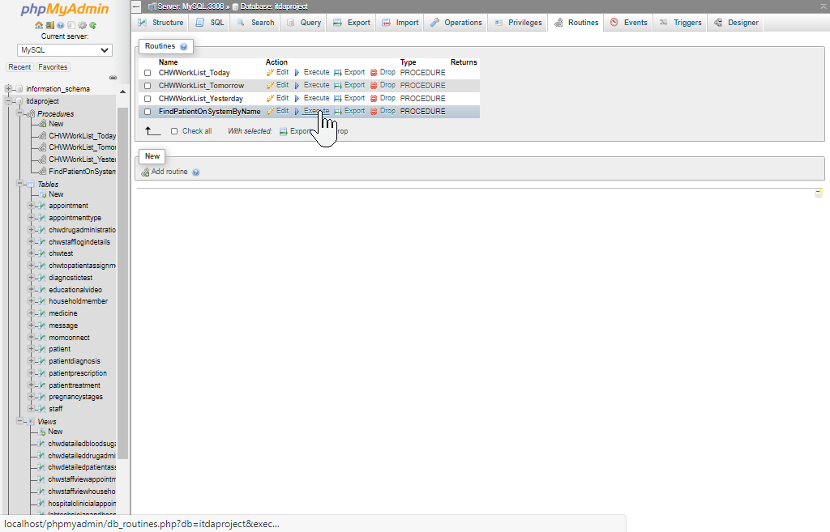 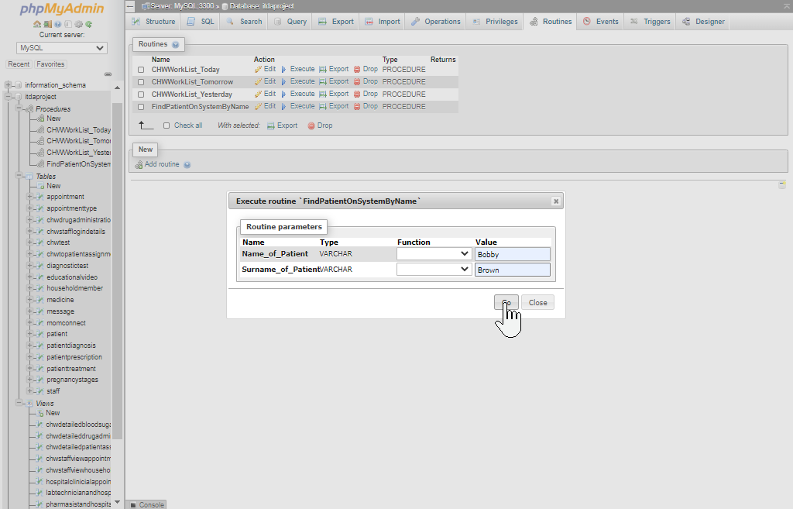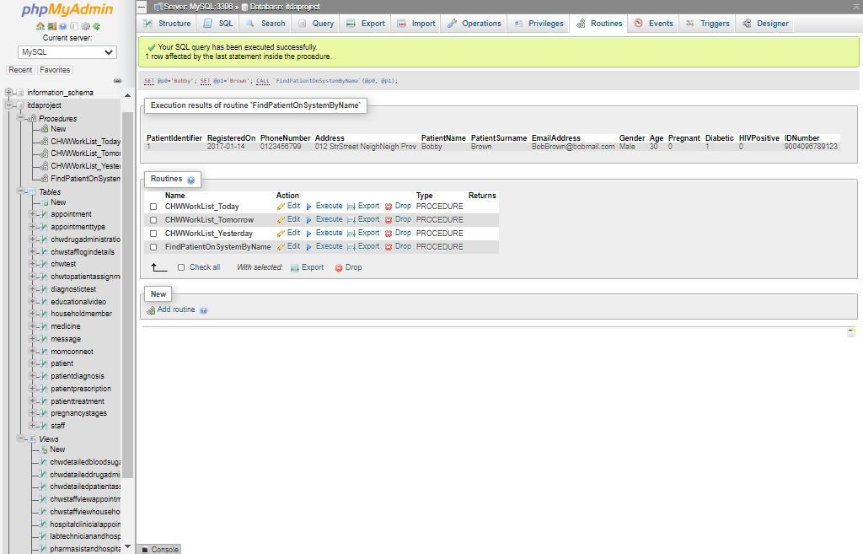

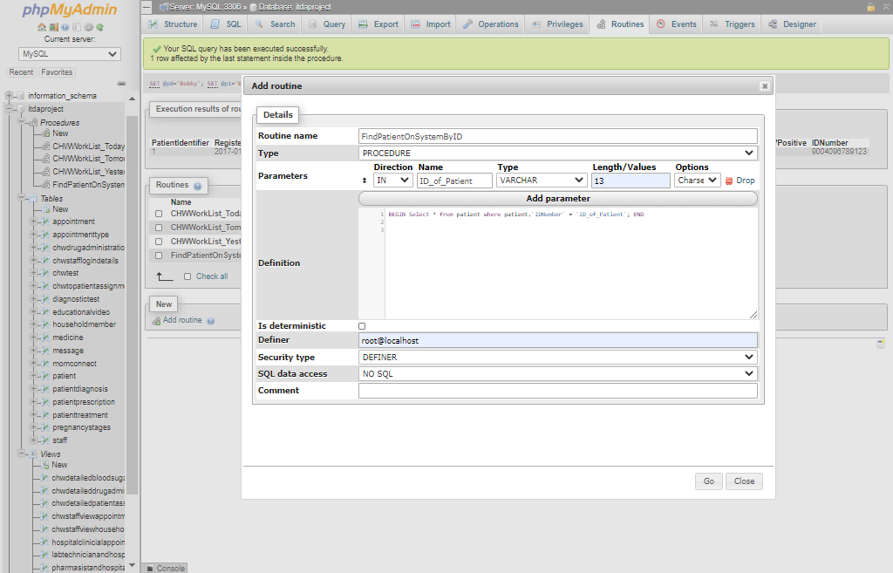 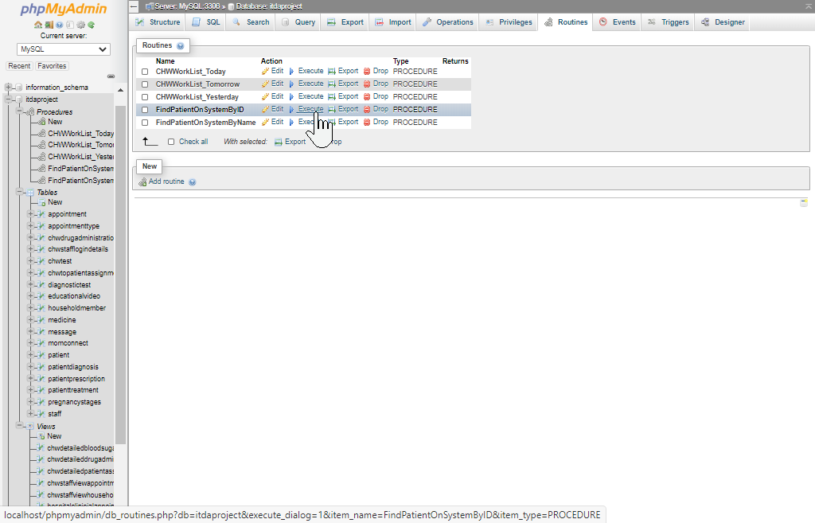 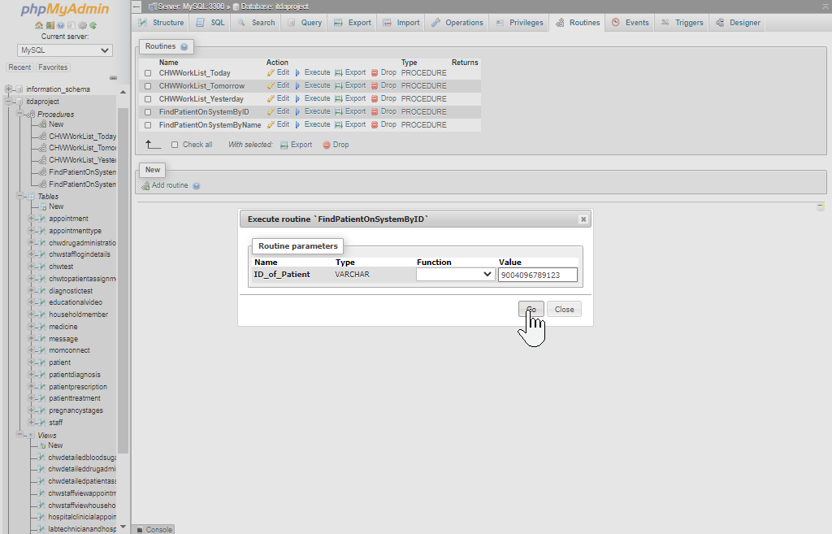 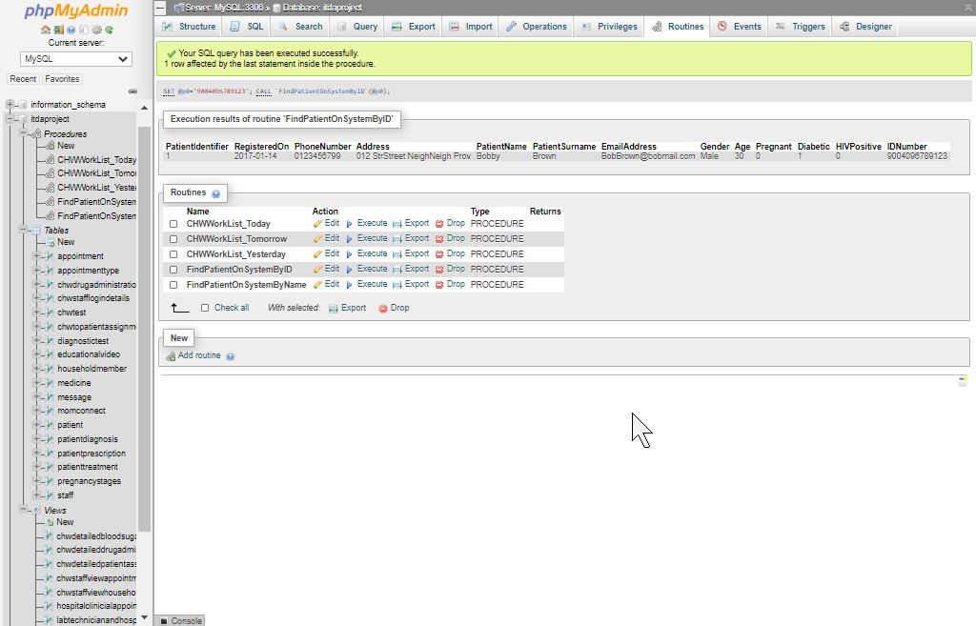

Both of these stored procedures allow the user to check whether a patient is registered on the system which is a basic yet reoccurring task that would warrant the creation of a reusable stored procedure for its simplification. Checking whether a user is on the system before attempting to add them will also be a good practice for end-users as it would prevent attempts at duplicate entries being submitted to the patient table, which in turn would render the database more maintainable.

## 4.3

The following screenshots display two functions, both of which will format a message that in turn will be sent to patients under certain conditions. The functions are intended to be used alongside triggers that will detect the appropriate time for them to be called upon. These triggers and their resulting output will be will be displayed in question 4.5.

The following function formats a message to notify a patient that they have been added to the MomConnect system:

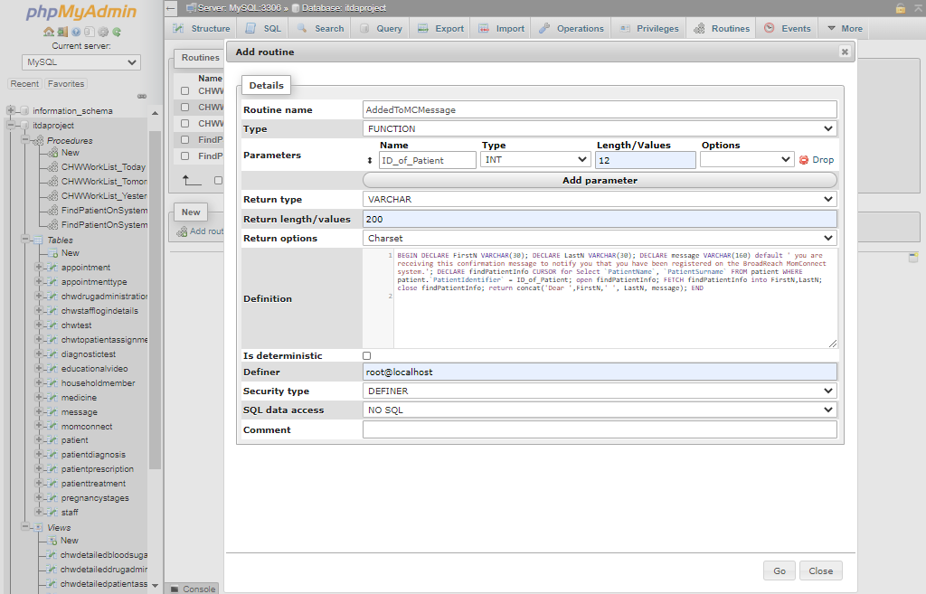 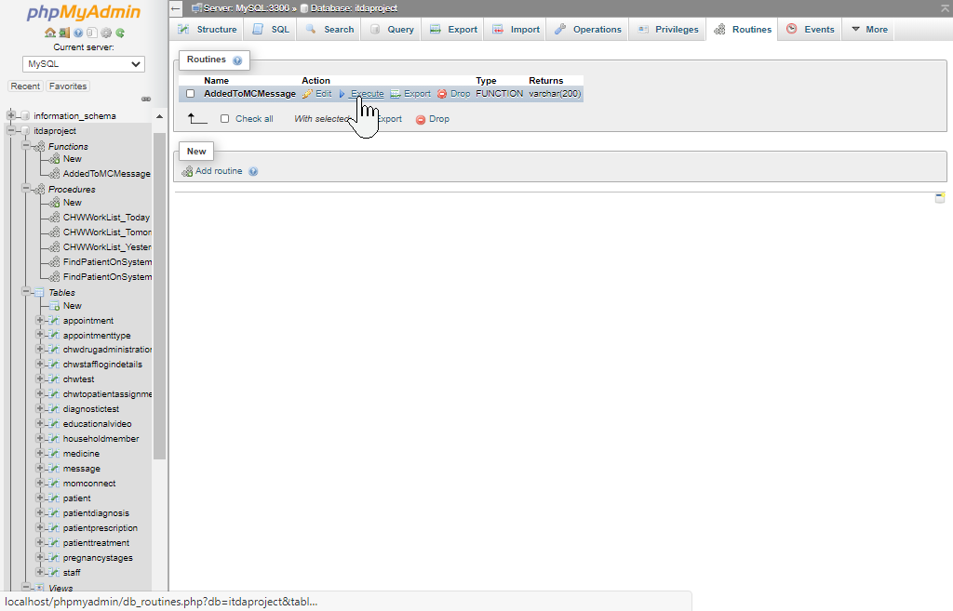 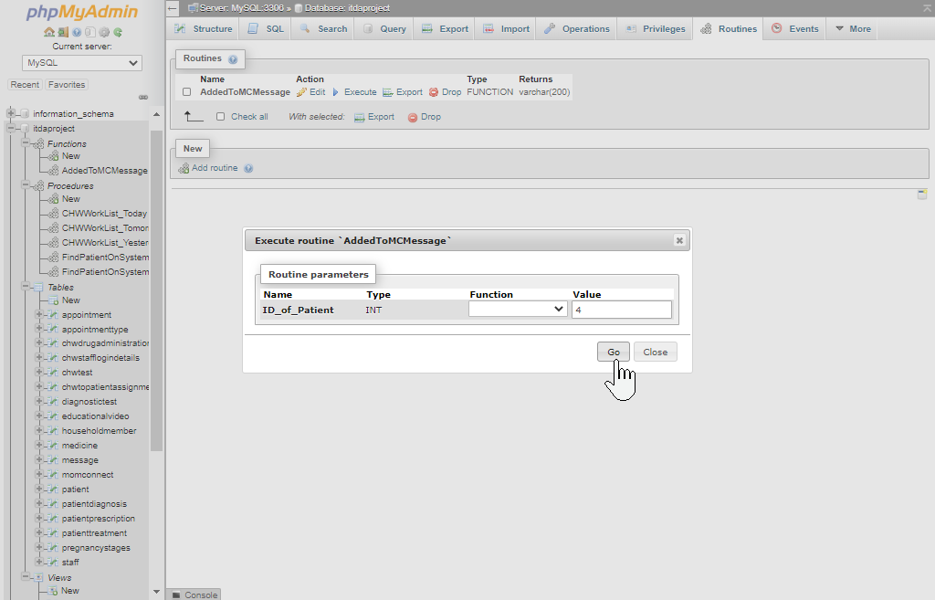 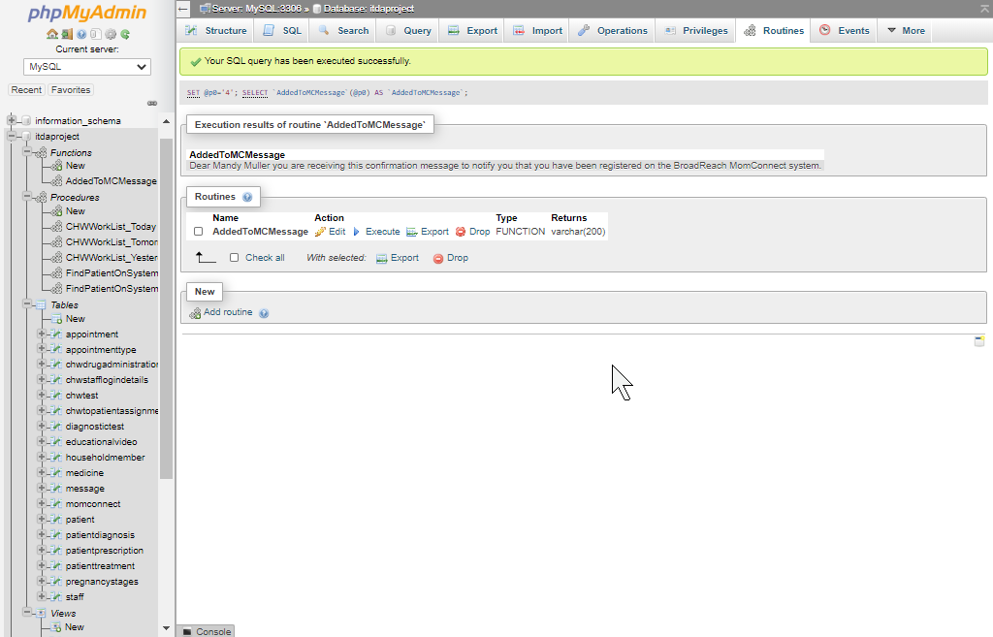

The following function formats a message to notify a patient that their appointment has been confirmed and is thus booked on the system:

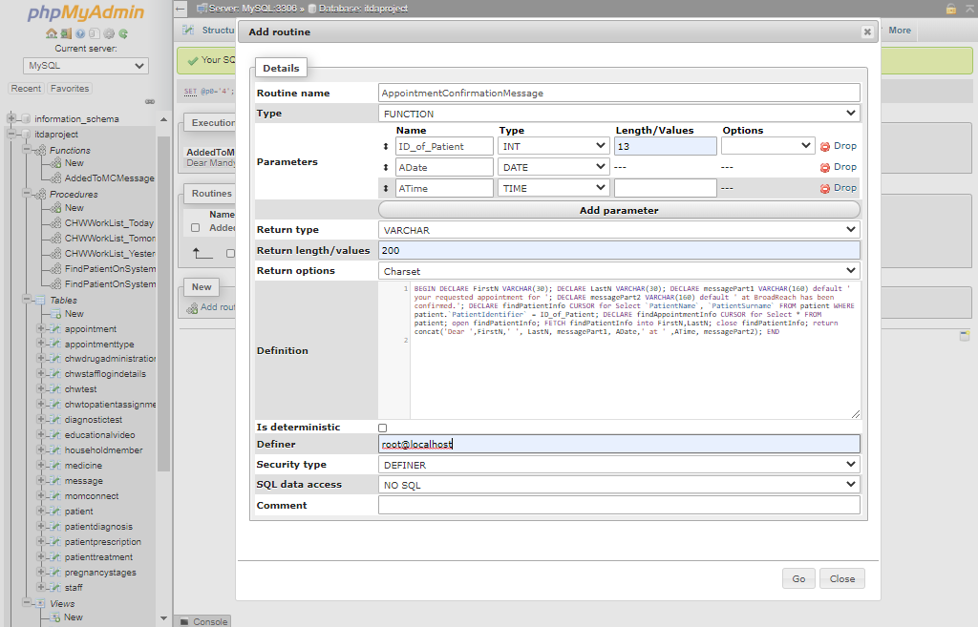 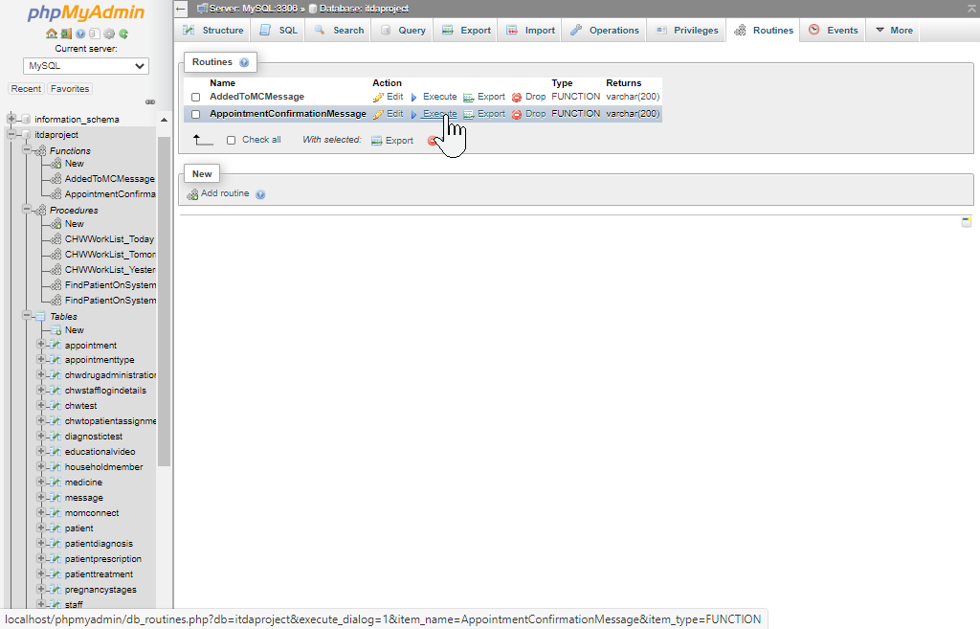 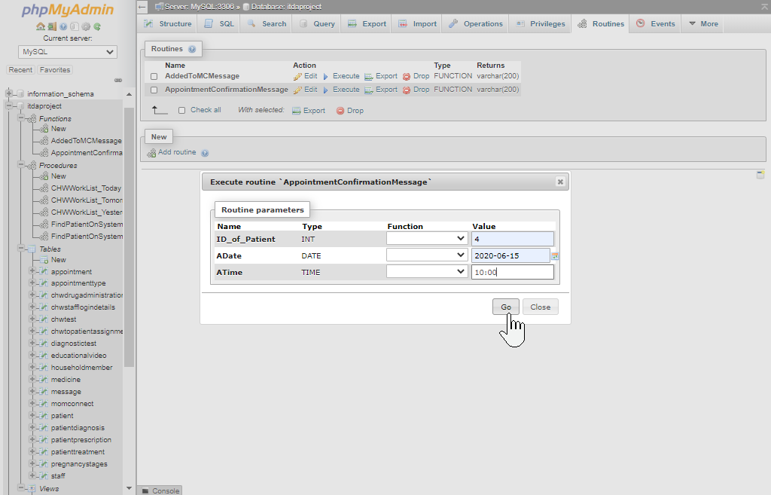 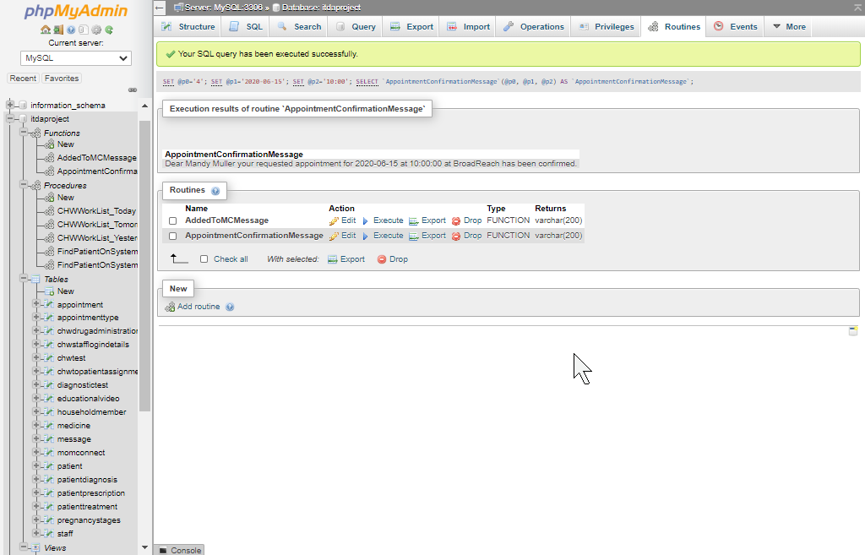

## 4.4

The following screenshots and descriptions all document the integration of the following 5 triggers into the database:

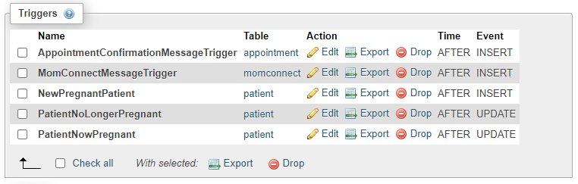

The following trigger detects when a patient in the database is updated and indicated to be pregnant where they previously weren’t, after which they will be added to the momconnect table (thereby being added to the momconnect system):

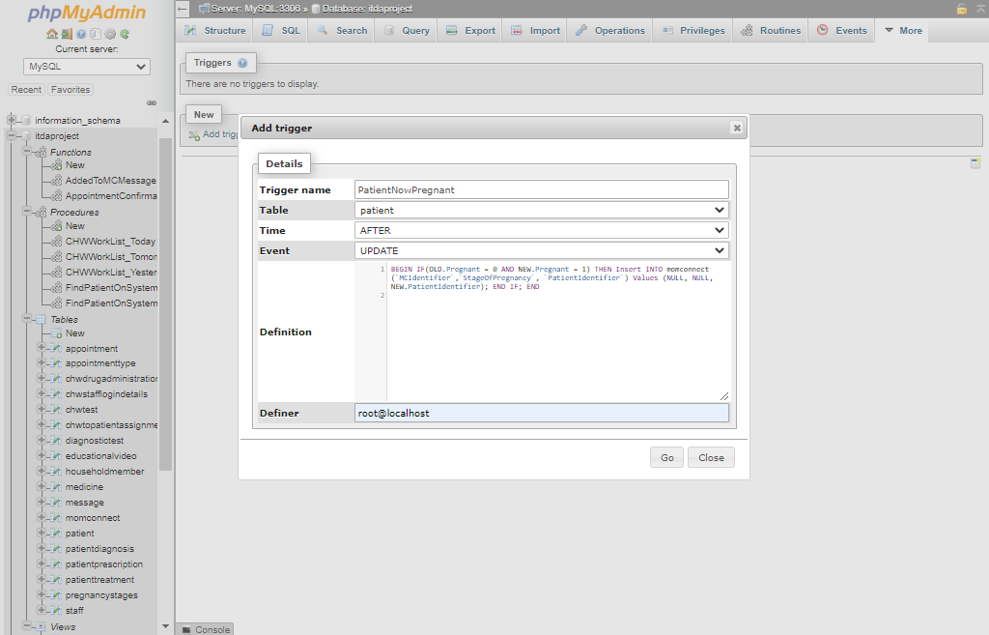 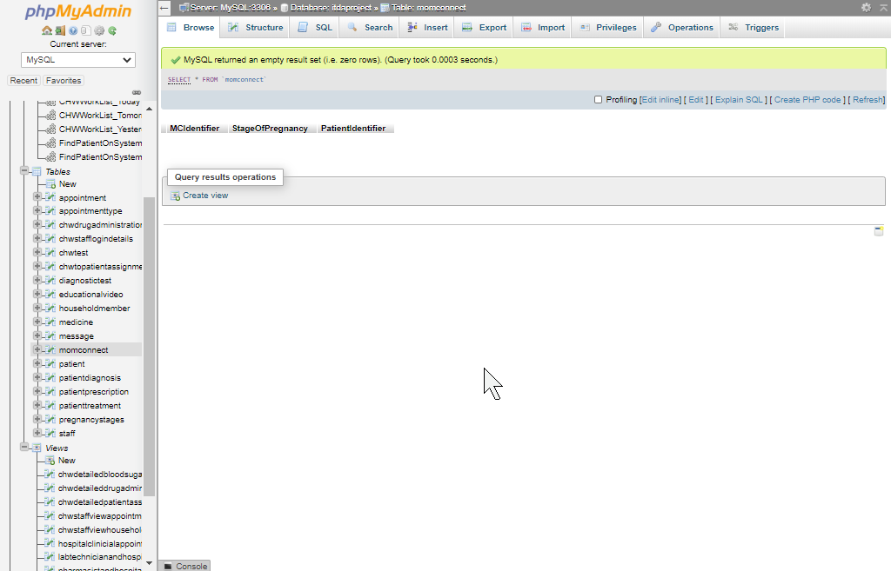 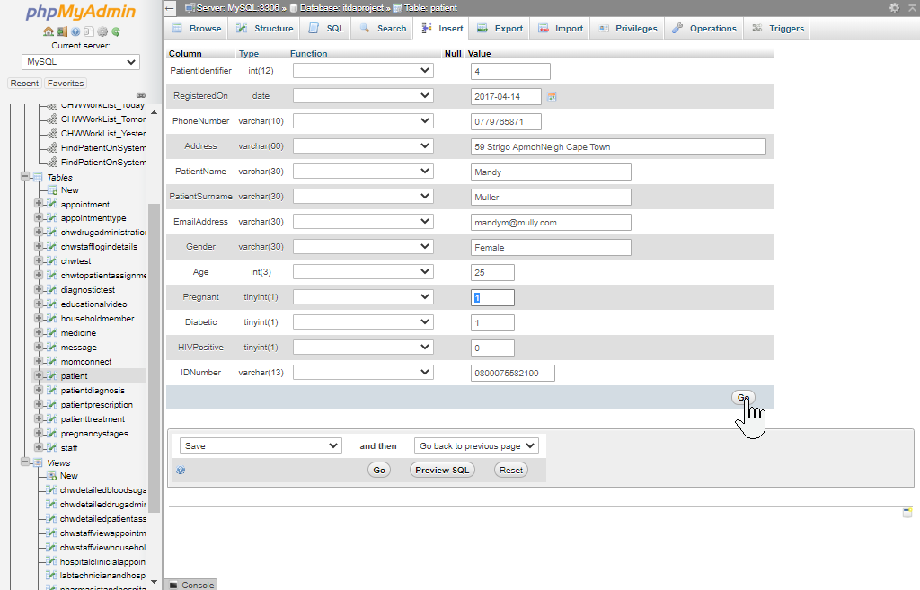 

The image above displays how the patient automatically got added to the momconnect system, after which their StageOfPregnancy information can manually be updated.

The following trigger will work in a similar fashion to the previous one though it will be triggered upon the insertion of a pregnant patient into the system (verse the updating of a previously non-pregnant patient):

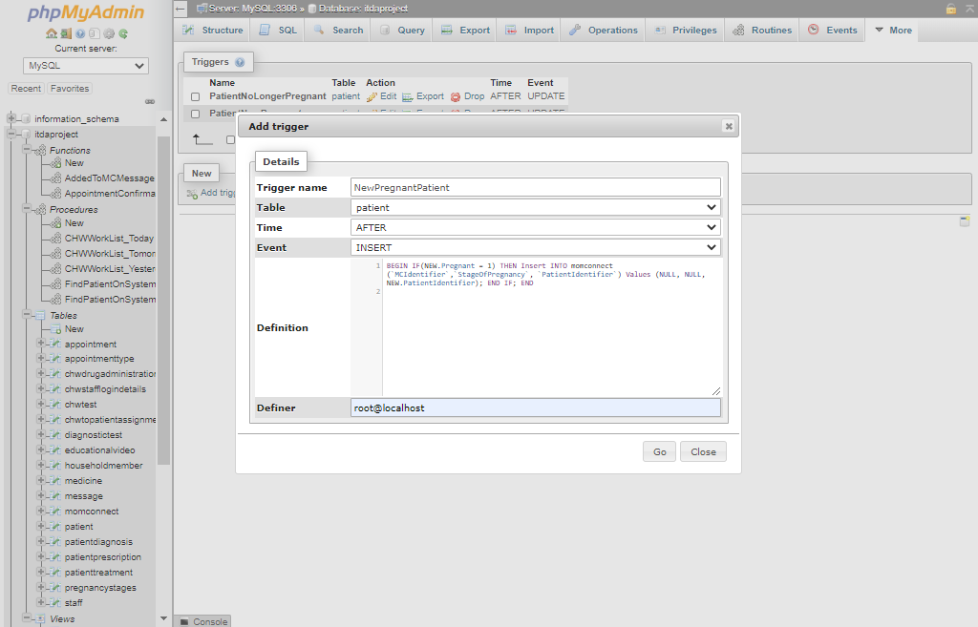

The following trigger detects when a patient in the database is updated and indicated to no longer be pregnant where they previously were, after which they will be removed from the momconnect table (thereby being removed from the momconnect system):

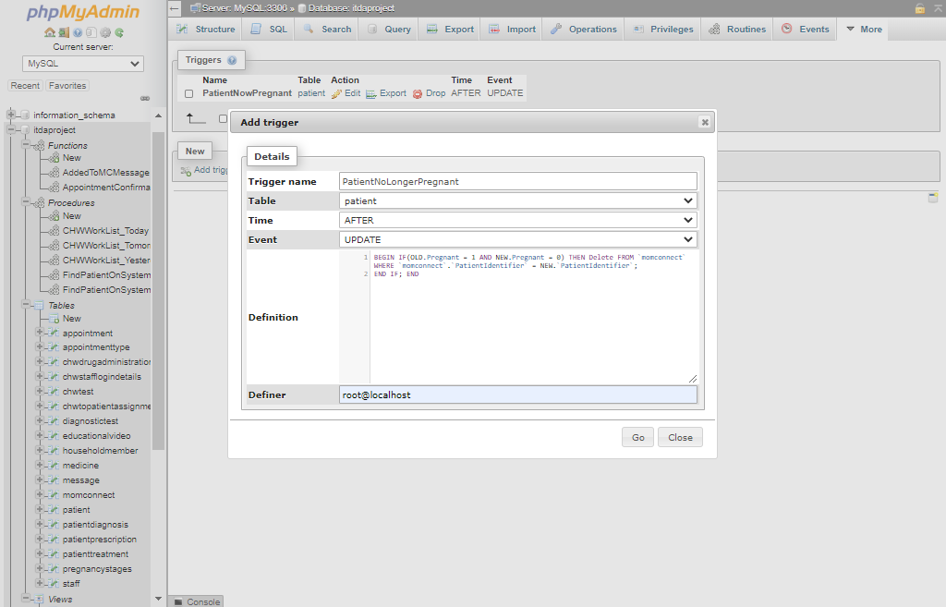

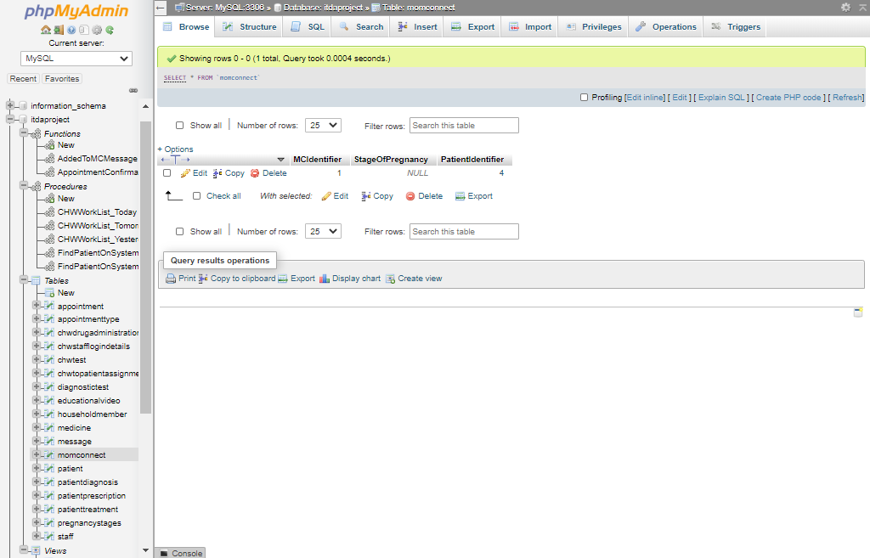 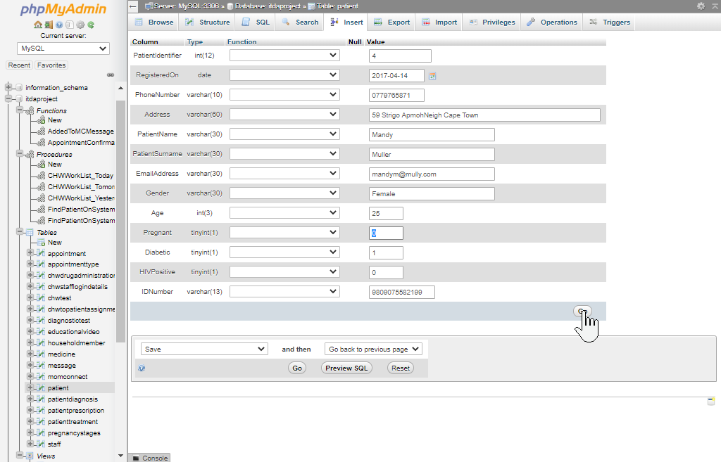 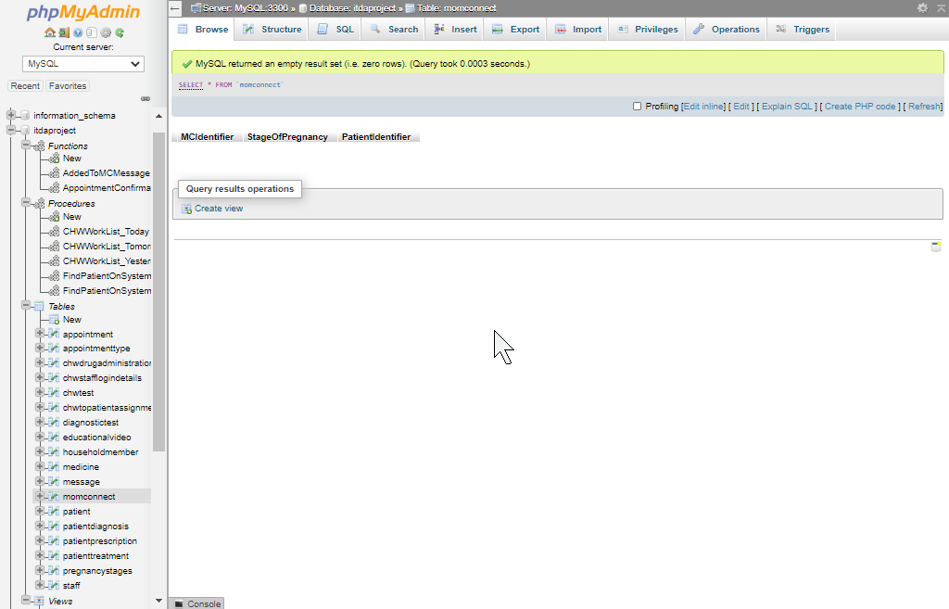

T

The screenshot above displays the patient (with PatientIdentifier=4) being removed from the momconnect table after having been deemed no longer pregnant.

The following trigger will call upon the AddedToMCMessage() function previously created in order to automatically create a notification message when a patient is added to the momconnect system:

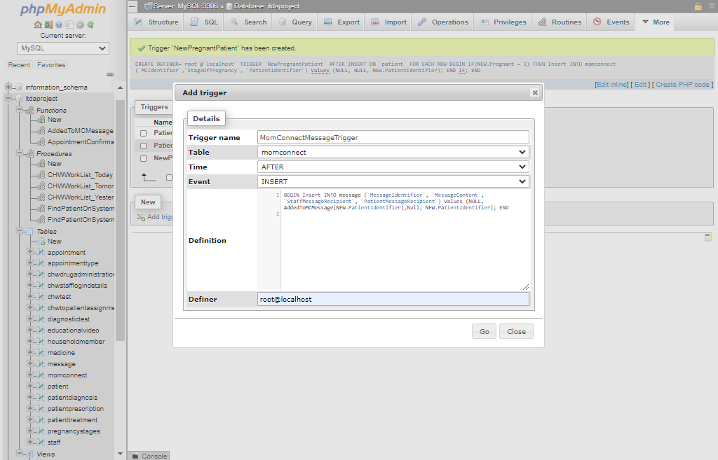 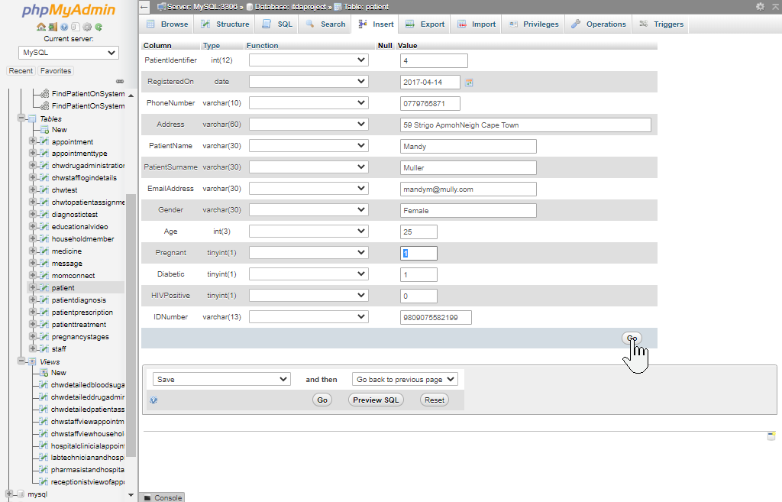

We

We already have a trigger that will add the patient to the momconnect table once they are updated to a pregnant status - the update statement will thus in turn also cause our newly created trigger to create a notification message for the pregnant patient:

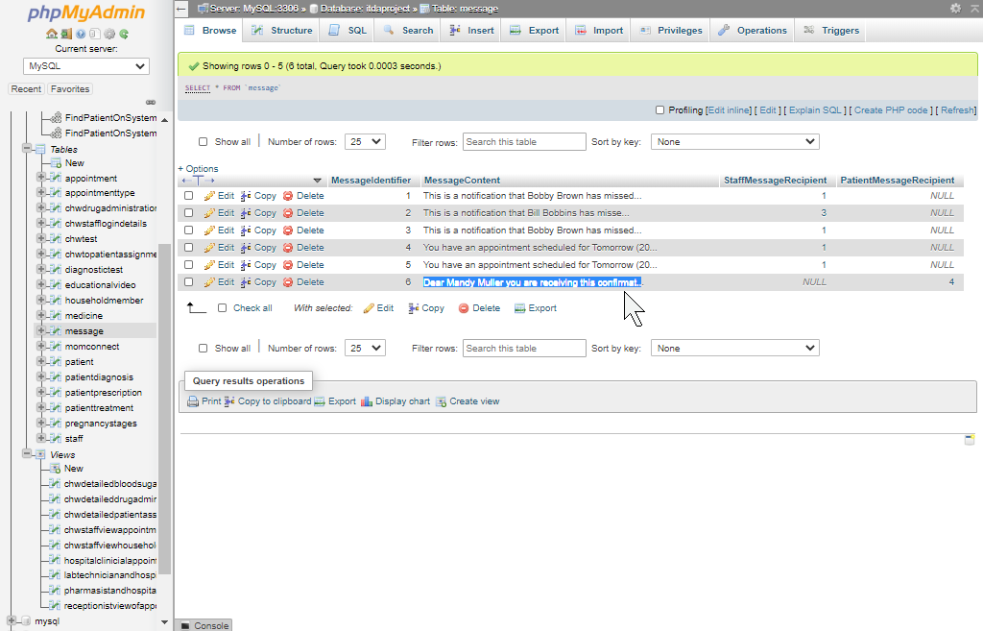

The following trigger will call upon the AppointmentConfirmationMessage() function previously created in order to automatically create a notification message when a patient’s appointment has been added to the system and has thus been confirmed:

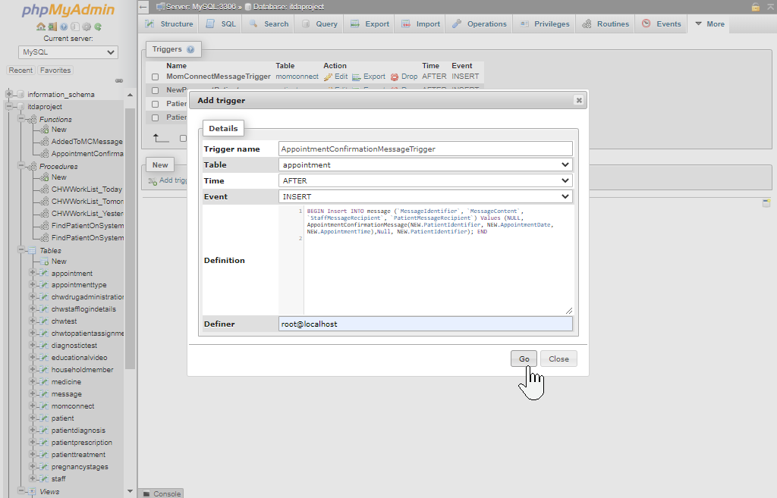

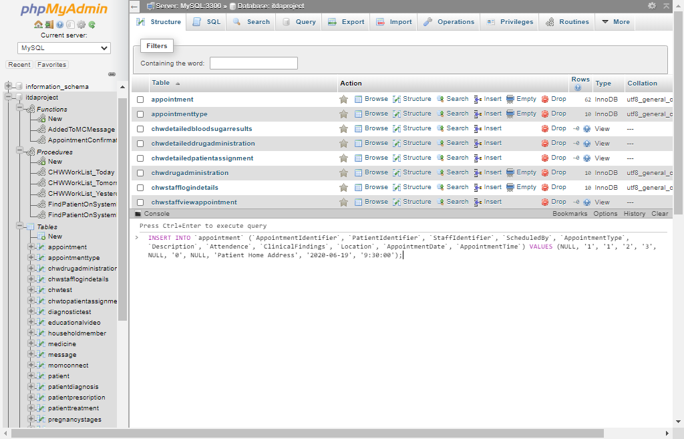

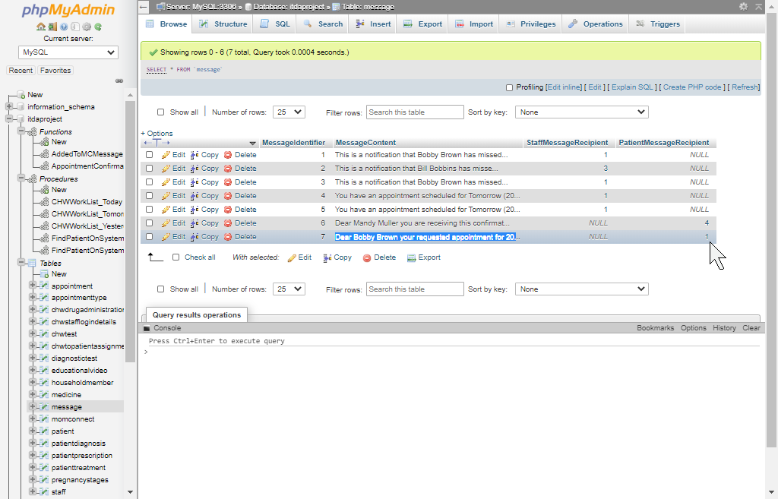

# Question 5

In order to display the interface I created for Question 5 I will first present a walkthrough of the system’s interface and functionality where after samples of the interface’s underlying code will be provided with some context.

## Interface Walkthrough

I decided to create an interface catering to the needs of community healthcare workers interacting with the database via the `CHW` user’s privileges defined in Question 3.5. Any non-logged in user will be required to log in via the following page before further utilize the interface:

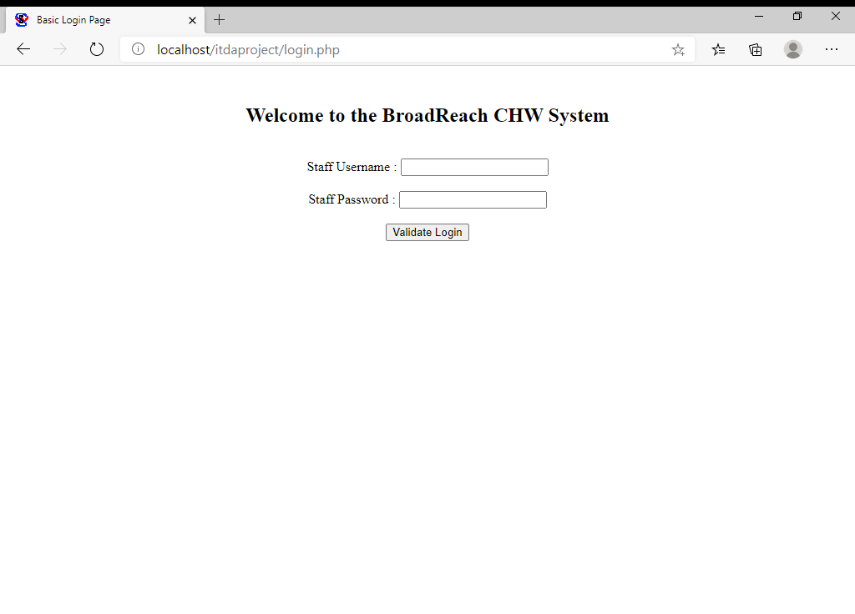

The username and password entered by the user will be validated against the information stored in the [chwstafflogindetails](http://localhost/phpmyadmin/sql.php?db=itdaproject&table=chwstafflogindetails) table. In the case of an incorrect username and password being entered the invalid information inserted by the user will be displayed back to them as shown below (I am aware that revealing a password in plaintext on the user’s screen, whether incorrect or not, is not common practice but included the functionality for demonstration-purposes):

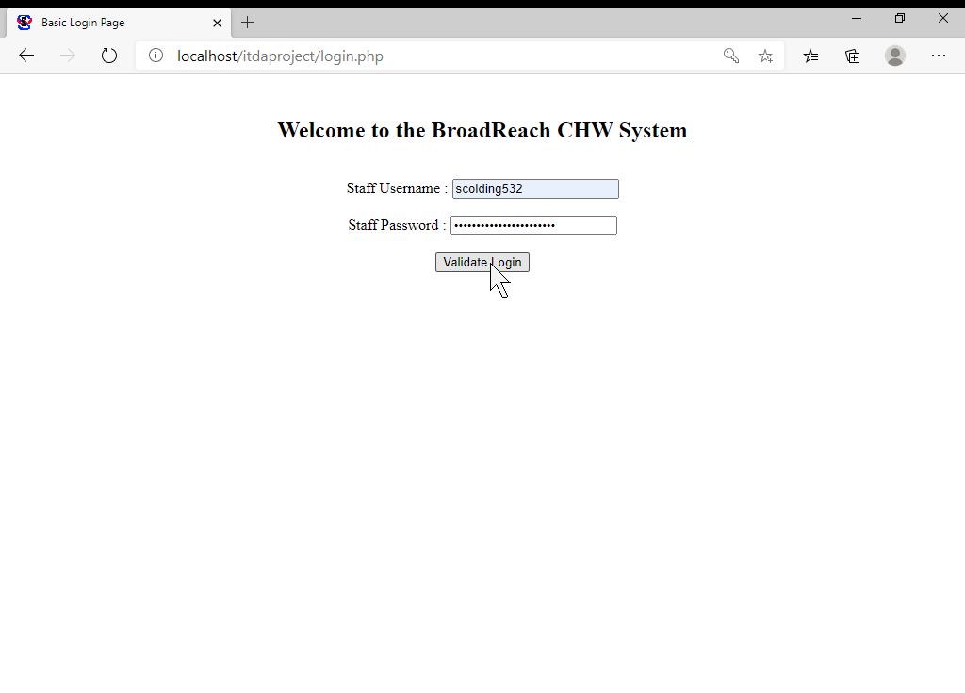

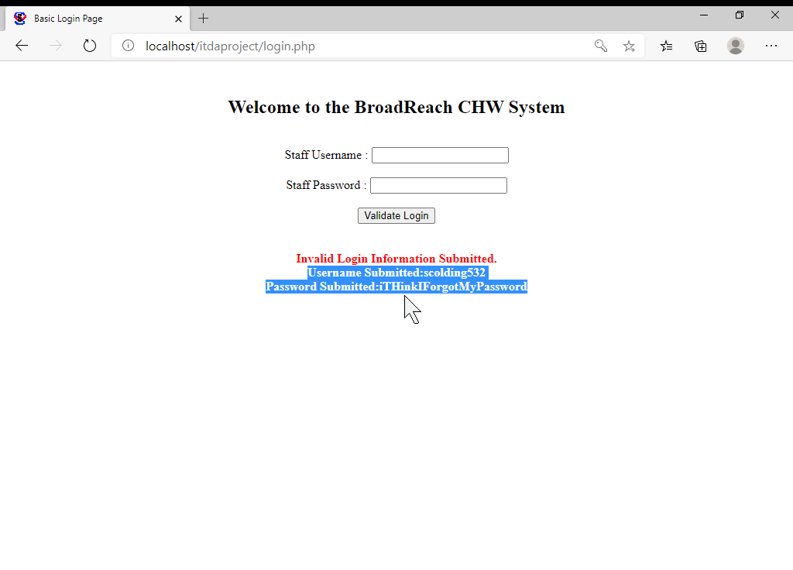

In the case of a valid username and password being entered the user will be directed to the Home page that welcomes the community healthcare worker by their full name, as displayed below:

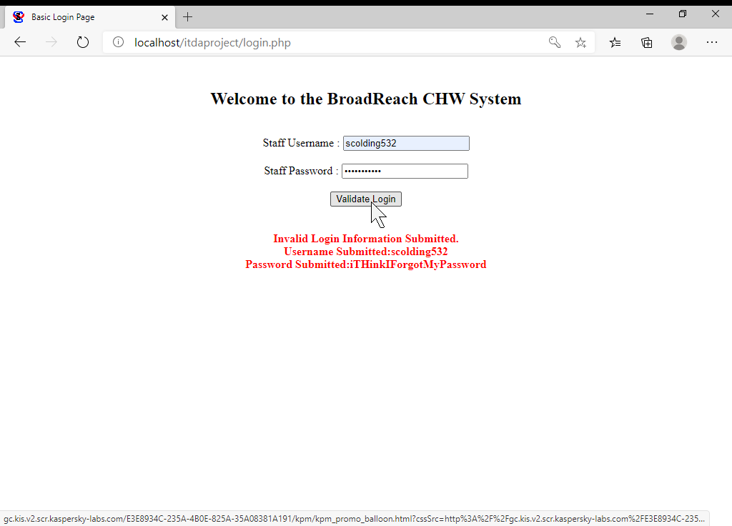

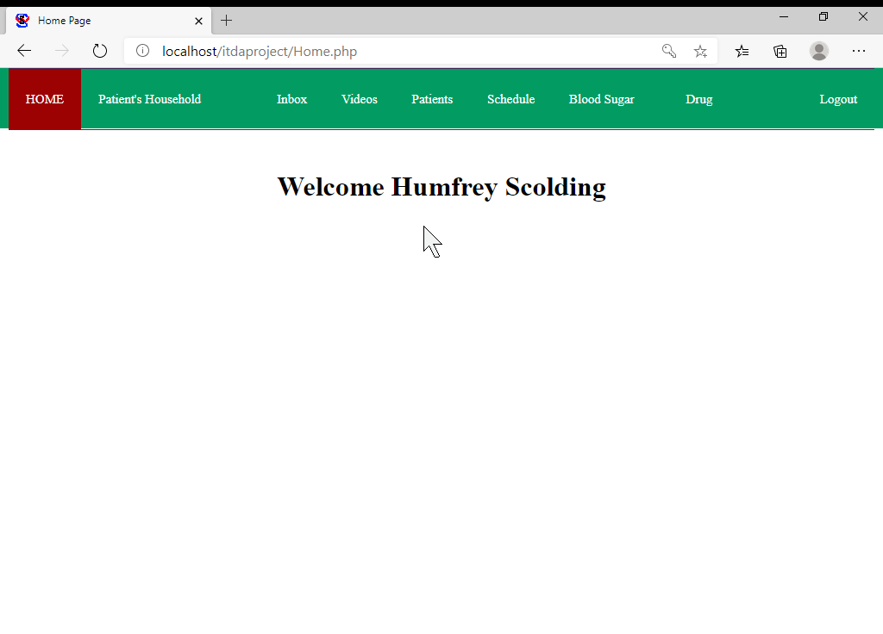

The Navigation bar displayed at the top of the home page is persistently implemented across the other pages of the interface. From the Home page we will navigate to the “Patient’s Household” tab that allows the community healthcare worker to manage information pertaining to the household members of patients they have been assigned to.

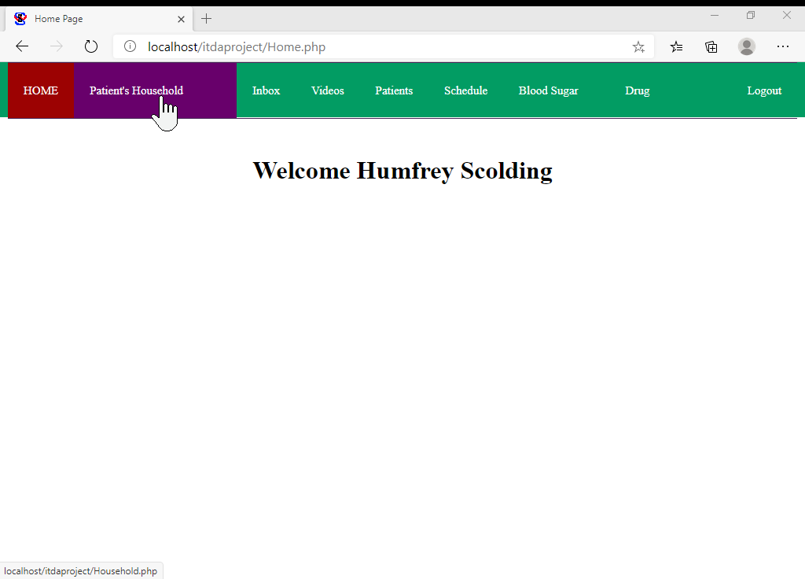

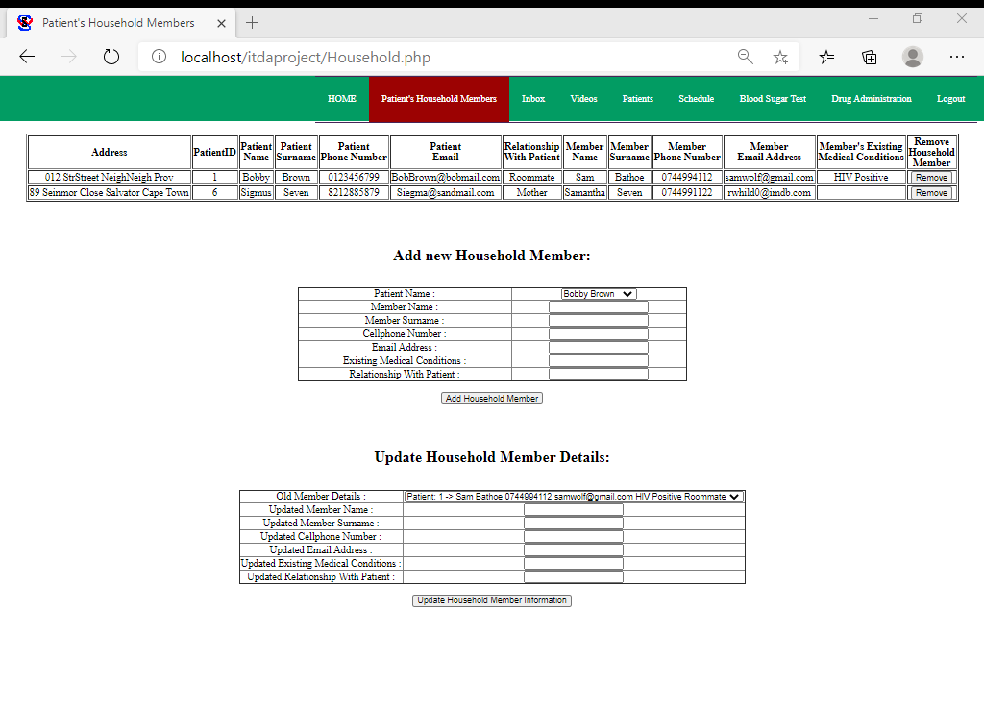

Let’s assume the community healthcare worker wishes to add a new household Member, from the dropdown menu beneath the “Add new Household Member” title they would be able to choose between their assigned patients for the member to whom the new household member is related to:

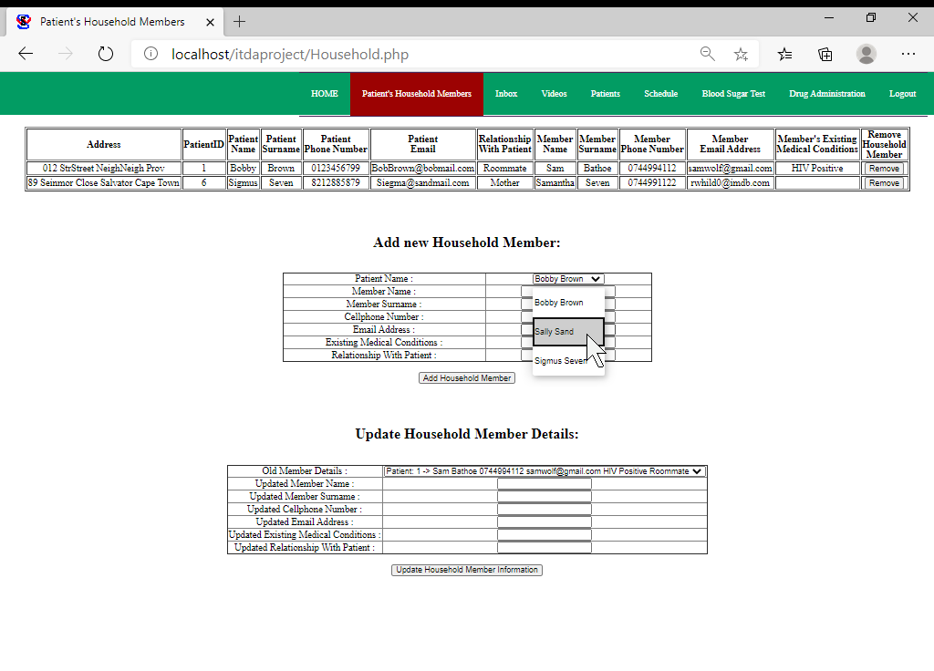

The rest of the information pertaining to the household member would have to be filled in manually as shown below:

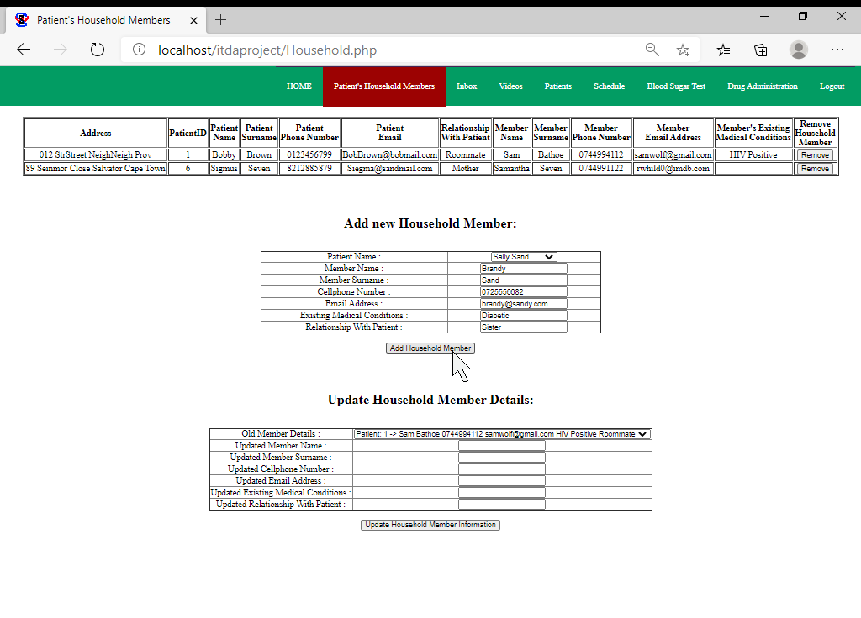

After adding the household member, their information should be displayed in the table at the top of the page (which receives its data from the database that has been inserted into):

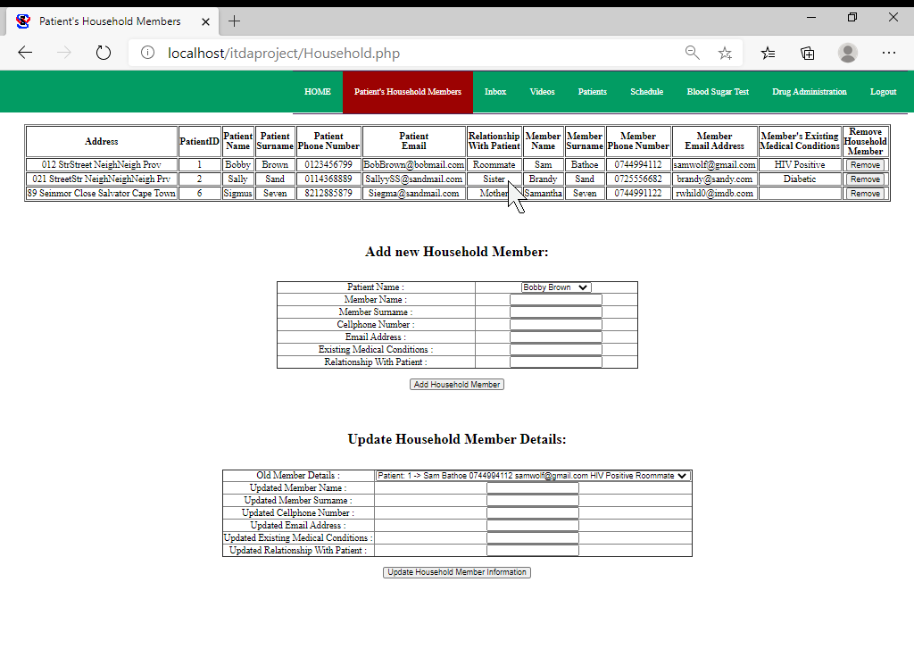

Let’s assume that the details pertaining to the new household member (Brandy) changed and that she got a new email address and phone number – the forms located beneath the “Update Household Member Details” title can be used to update the information of any household member associated to a patient which the currently logged in community healthcare worker has been assigned. The first step to updating Brandy’s information would be to select her currently stored information from the dropdown menu shown below:

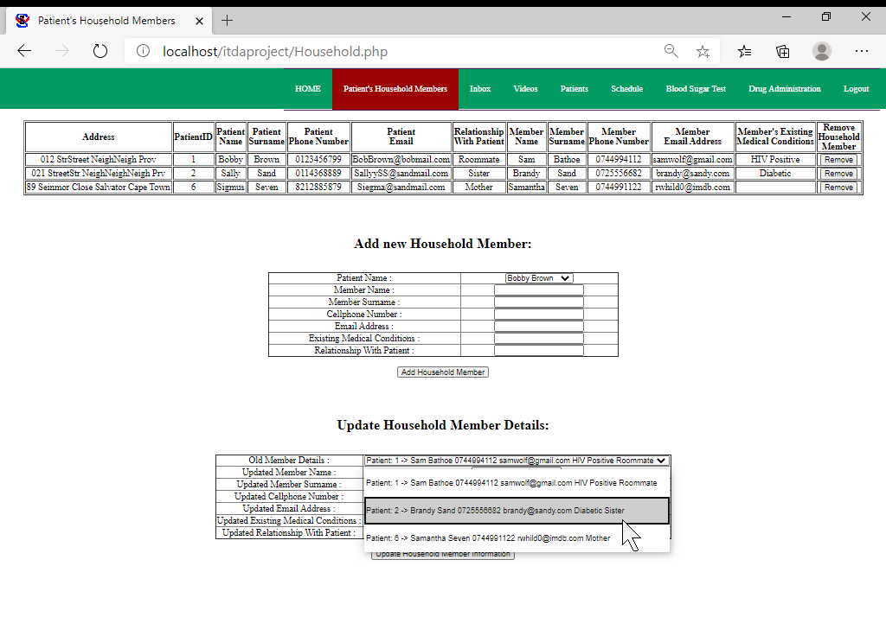

After selecting the outdated household member’s details from the dropdown menu their new information can manually be inserted as depicted below:

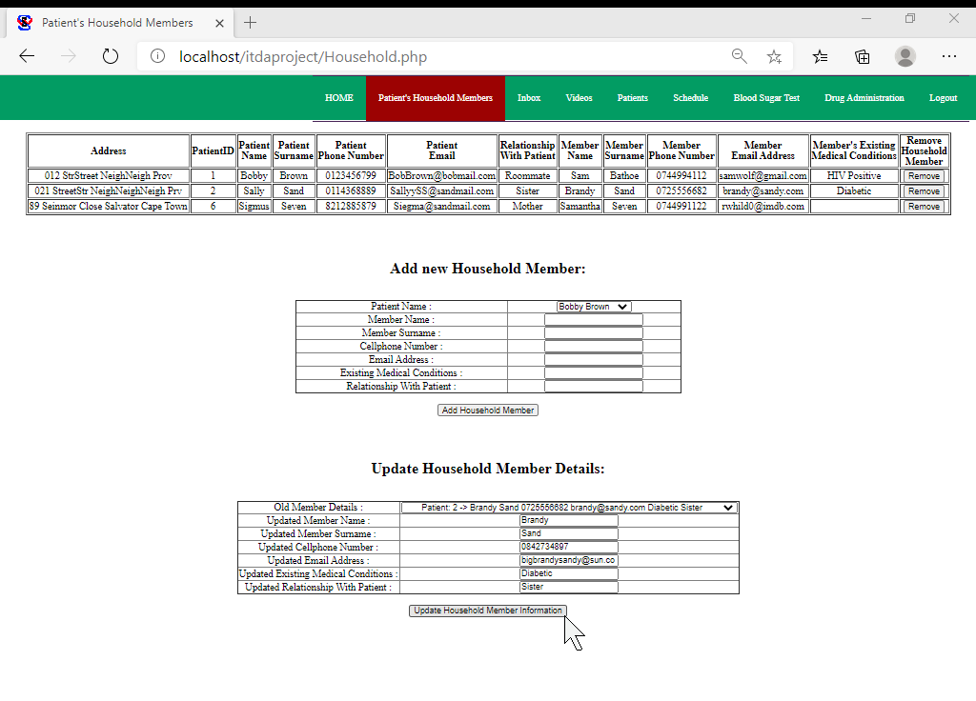

After clicking the “Update Household Member Information” button the household member’s information displayed at the top of the page should reflect the update having been made to the database as shown below:

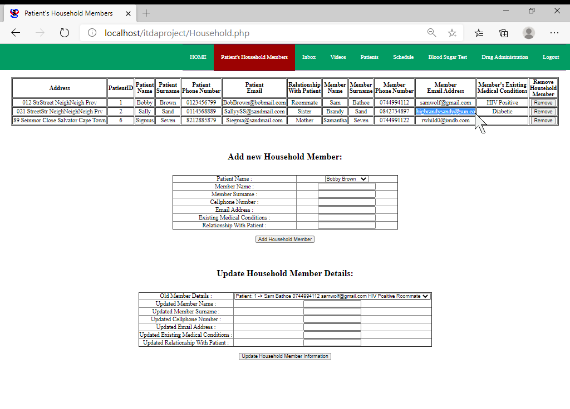

Deleting the information pertaining to a household member is also easily achieved through clicking the “Remove” button next to the household member’s information that should be deleted. This is shown below as the diabetic “Brandy Sand” got removed from the database and consequentially also from the table at the top of the page:

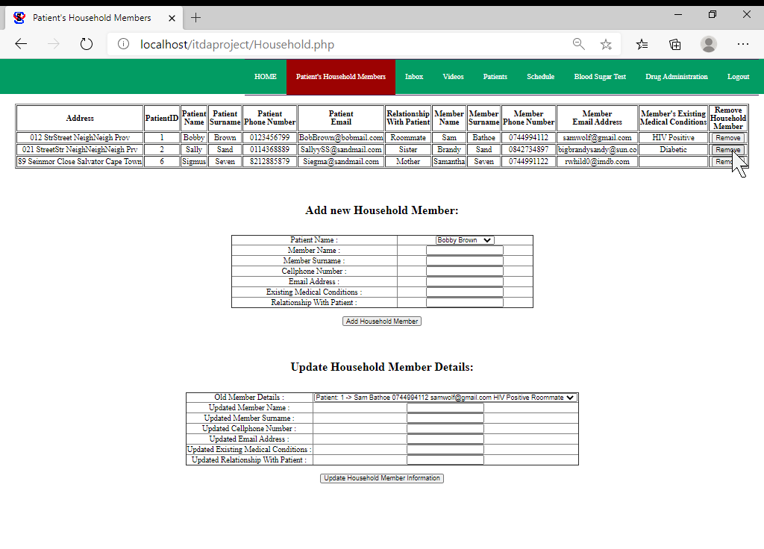

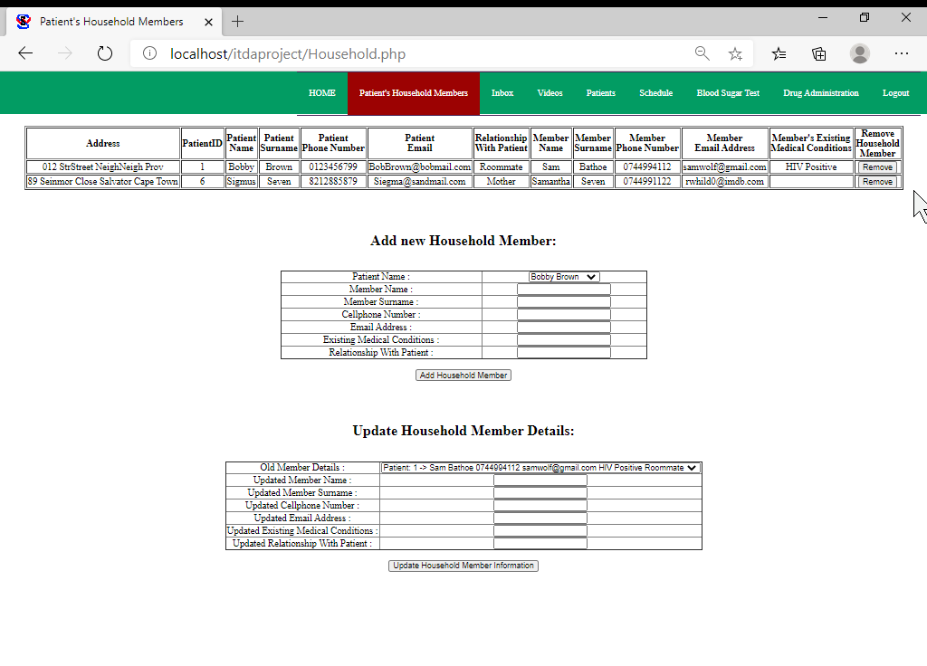

Next we will navigate to the “Inbox” tab that displays messages made out to the logged in community healthcare worker.

Note that this inbox is intended to display messages that were automatically sent as consequences to various triggers having been activated in the database. The fashion in which data can automatically population the fields of the `message` table has briefly been displayed in Question 4.4 where messages notifying patients of their appointments having been confirmed as well as those notifying patients that have been added to the momconnect system were illustrated. Due to the scope of this project however (the fact that Question 4.4 only asks for 2 triggers) pseudo data portraying other types of messages have been manually inserted (as mentioned at the end of Question 3.2). The result of some of those messages having been assigned to the currently logged in community healthcare worker is shown below with the newest messages populating the top of the table:

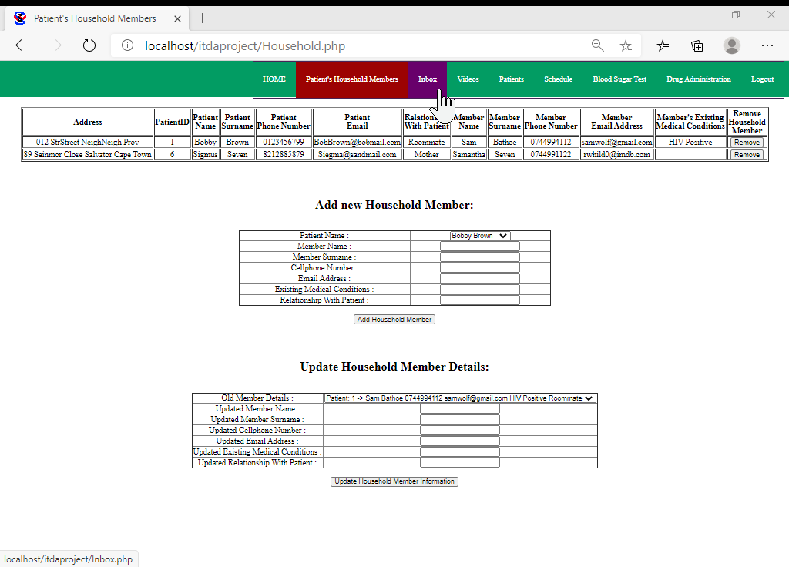

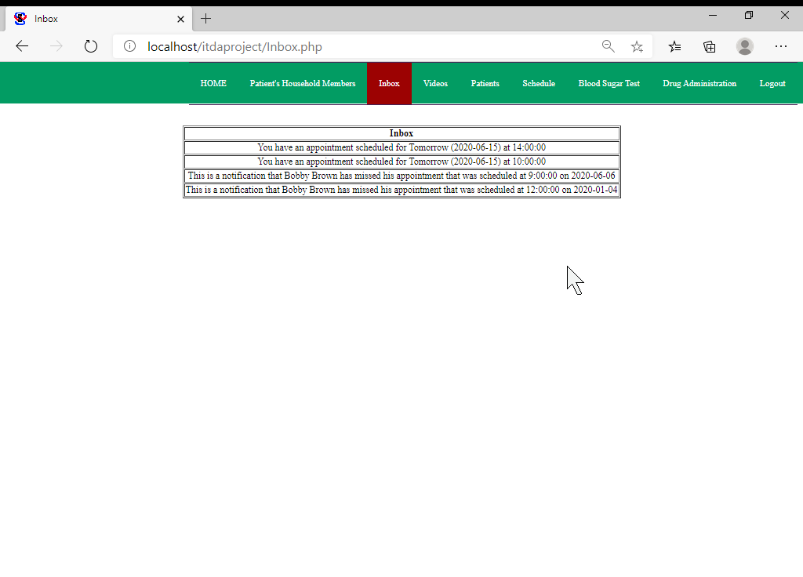

Next we will navigate to the “Videos” tab:

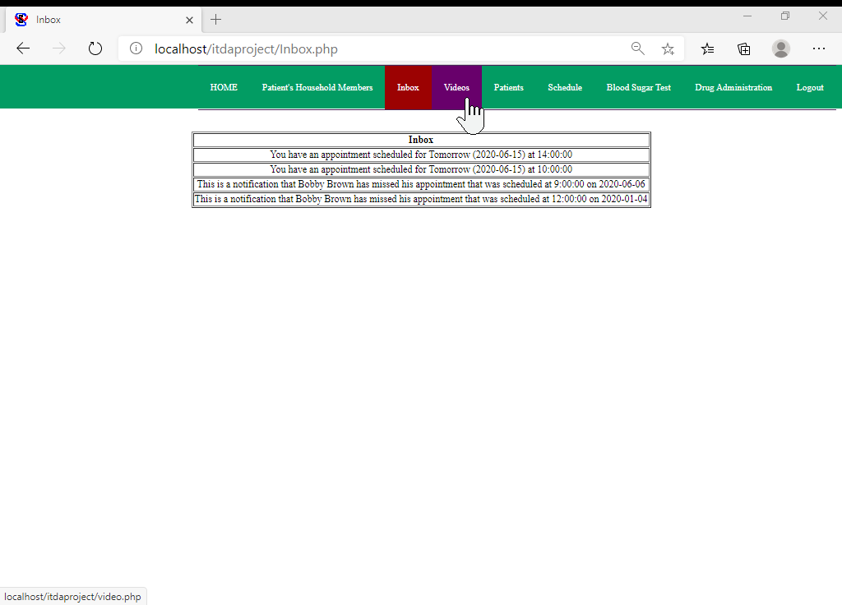

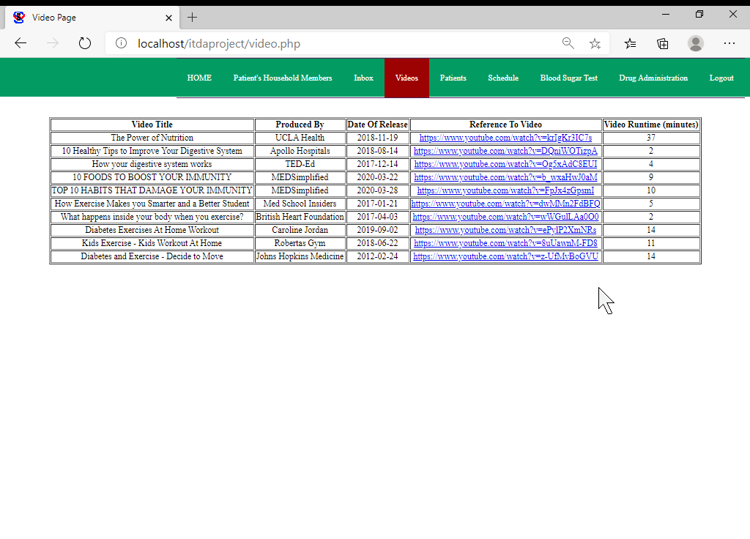

As shown above the `videos` tab of the navigation bar directs the community healthcare worker to information associated to educational videos that are aimed at improving the exercise and diet routines of viewers. This page is intended to aid community healthcare workers that we are told are required to access educational videos on their phone and in turn present them to the families they visit.

Next we will navigate to the “Patients” tab:

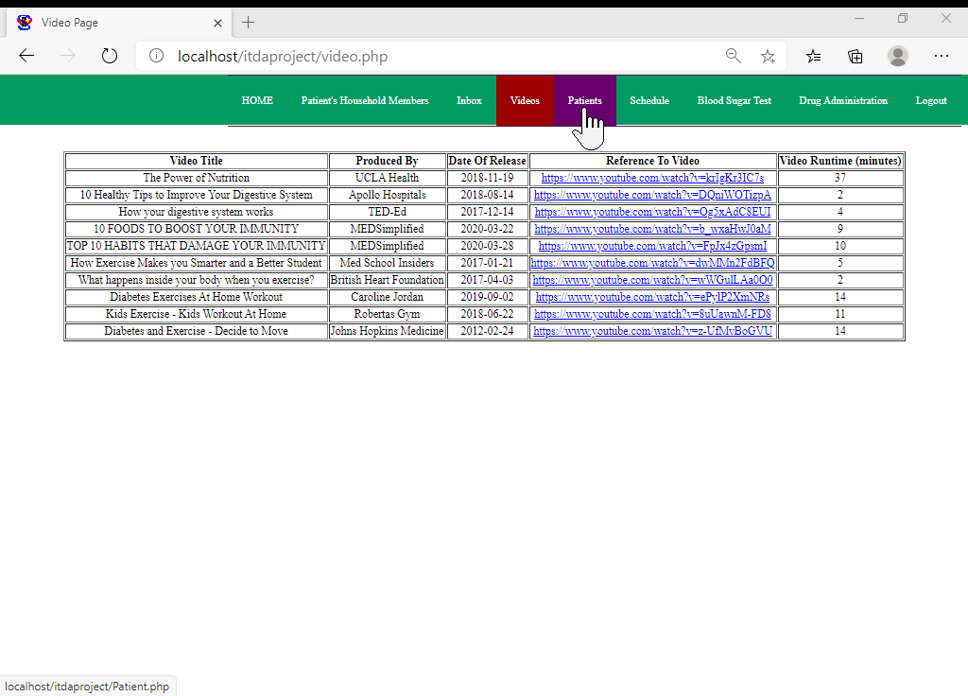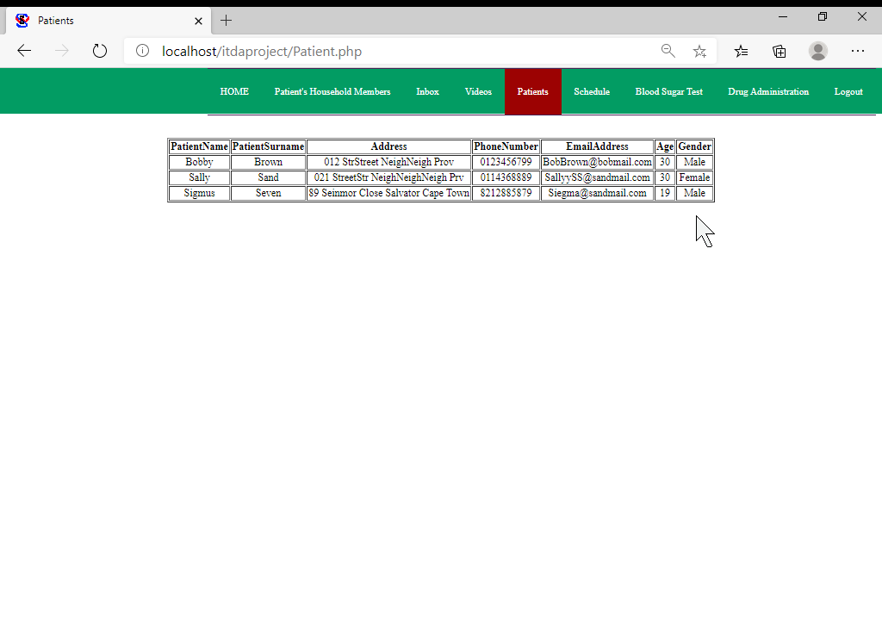

As shown above the `Patients` tab simply redirects the community healthcare worker to information pertaining to the patients they have been assigned to. Next we will navigate to the “Schedule” tab:

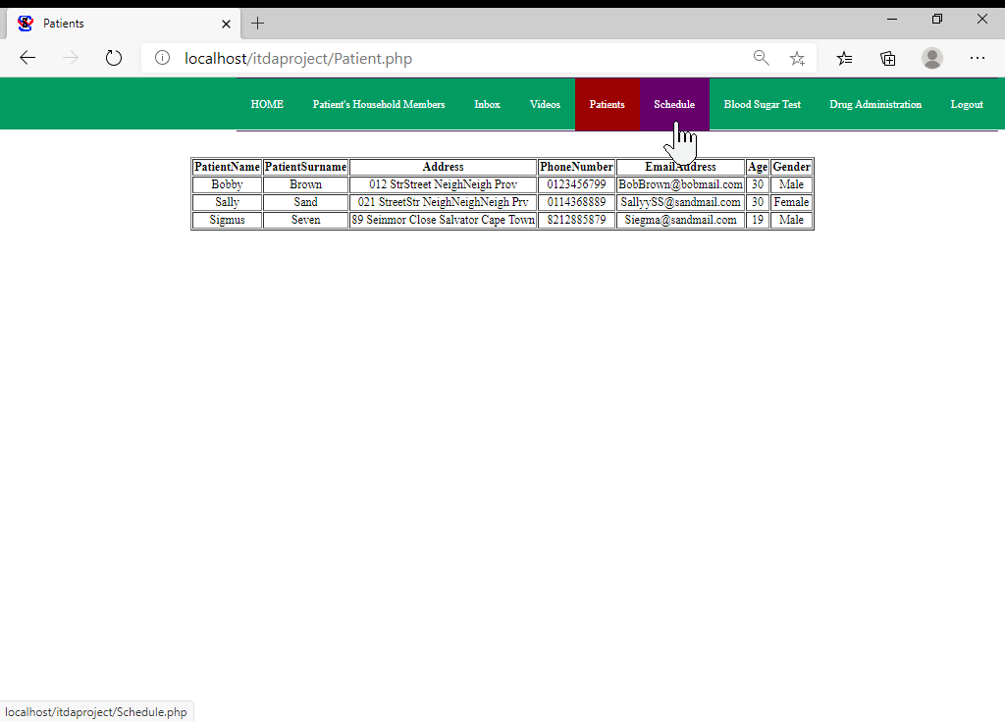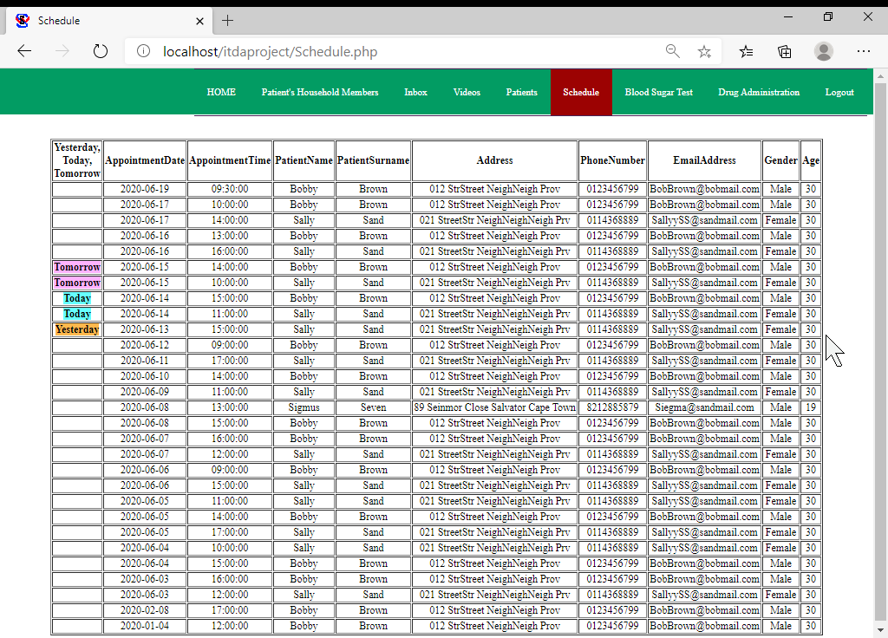

As shown in the image above the `Schedule` tab displays all the appointments that the signed in community healthcare worker has been assigned to. The appointments of yesterday, today and tomorrow are also specifically pointed out to the user, which in turn helps differentiate between past appointments and future ones.

Next we will navigate to the “Blood Sugar Test” tab:

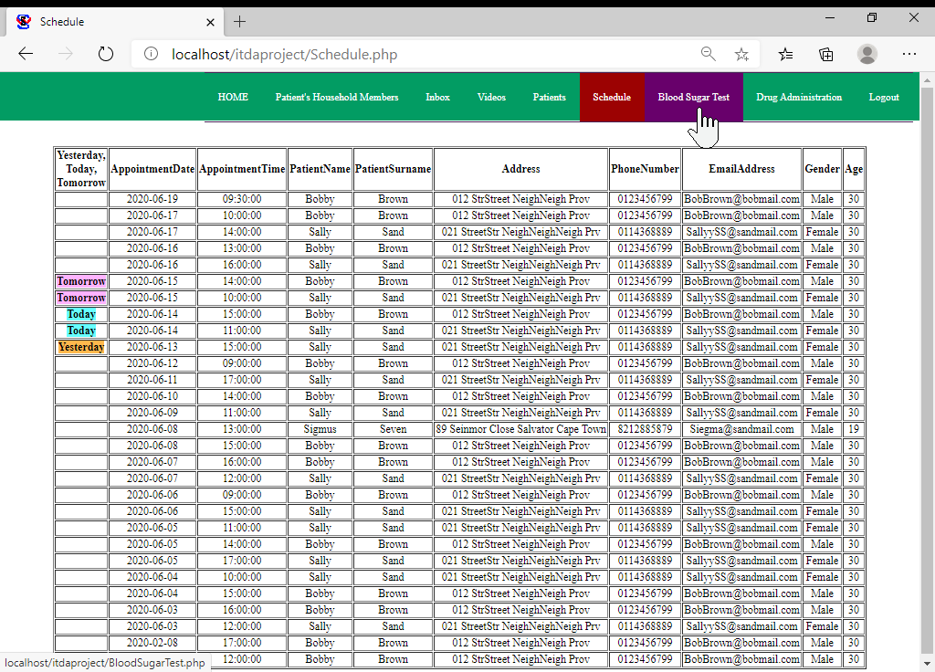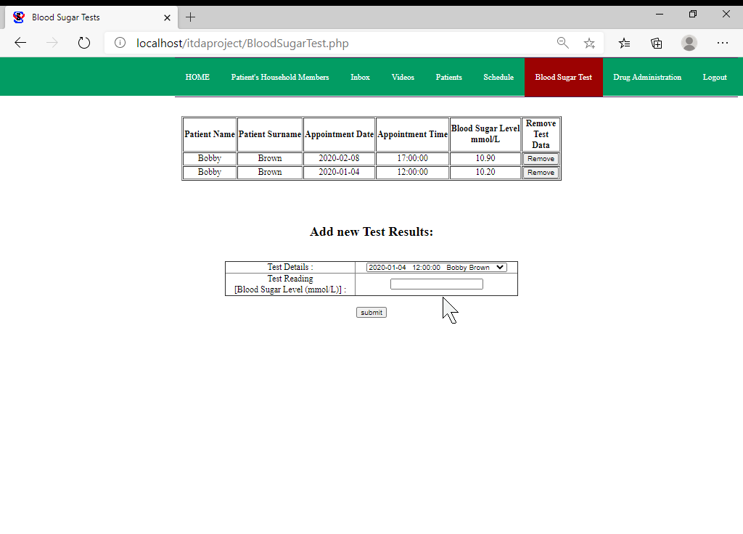

As shown in the image above the “Blood Sugar Test” tab directs the logged in community healthcare worker to a page that displays the results of blood sugar tests conducted by them in past and also allows for new test information to be added.

Let’s assume a community healthcare worker wishes to insert the details of a test they conducted today. The first step they would have to take is to select the appointment details (associated to the appointment during which the test was conducted) from the dropdown menu as shown below:

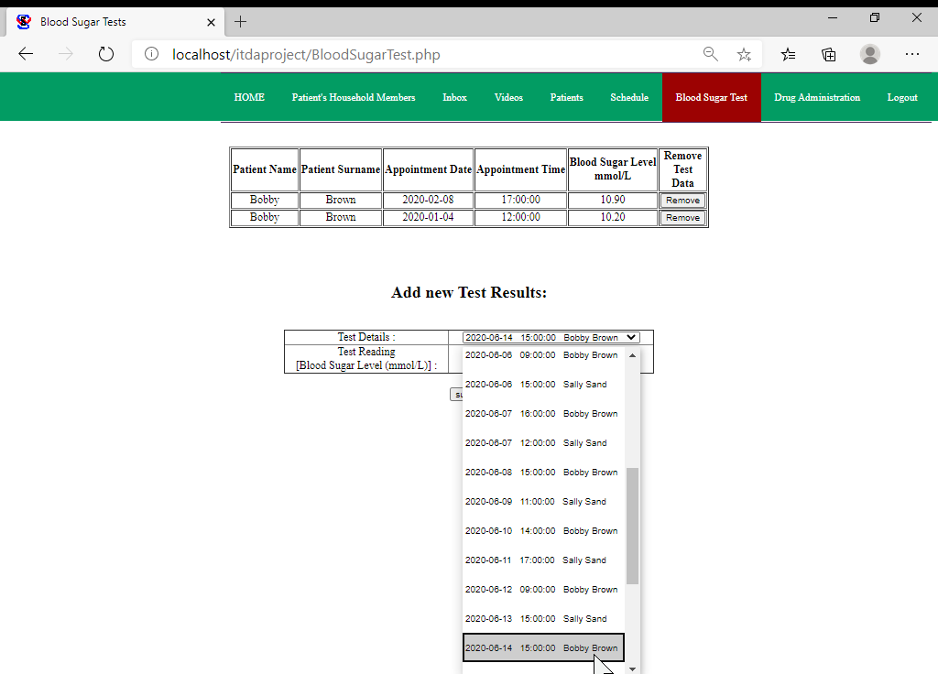

Next they would have to insert the blood sugar reading they recorded, where after they would be able to insert the new information to the database as displayed below:

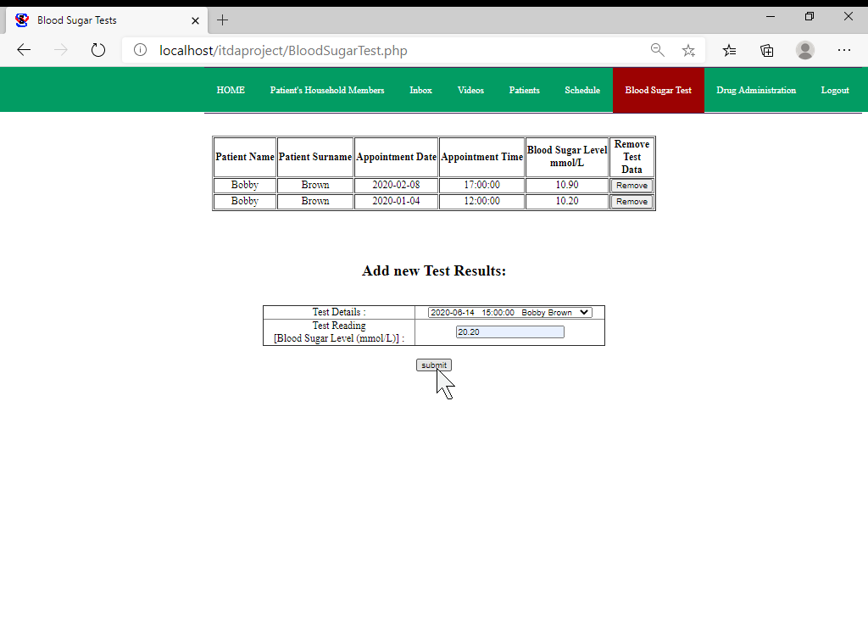

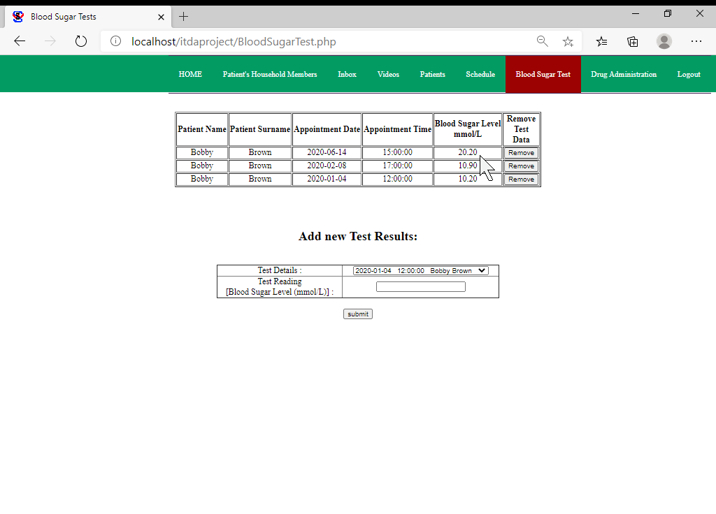

In the case where the community healthcare worker deems it necessary to delete a blood sugar reading they entered into the database previously, they would be able to do so by clicking on the `remove` button next to the reading they wish to delete as shown below:

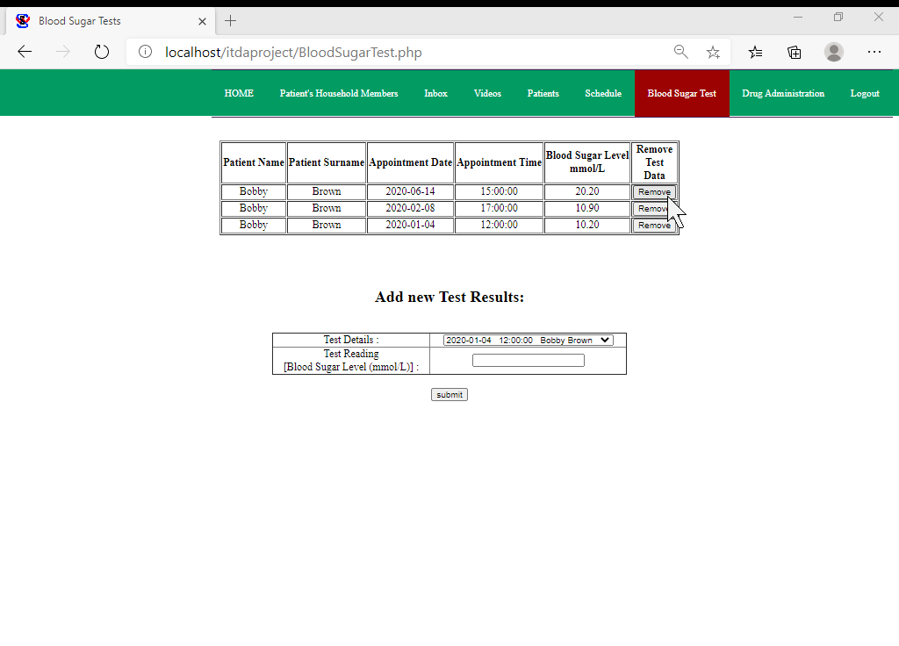

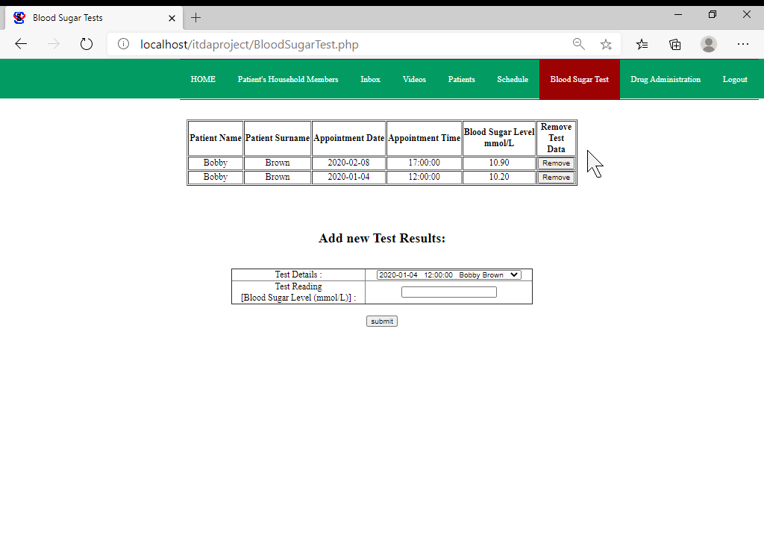

Due to the limited amount of information associated to each reading I did not feel it necessary to include the option to update a reading as an incorrect reading can simply be deleted and the correct information can be inserted anew.

Next we will navigate to the `Drug Administration` tab:

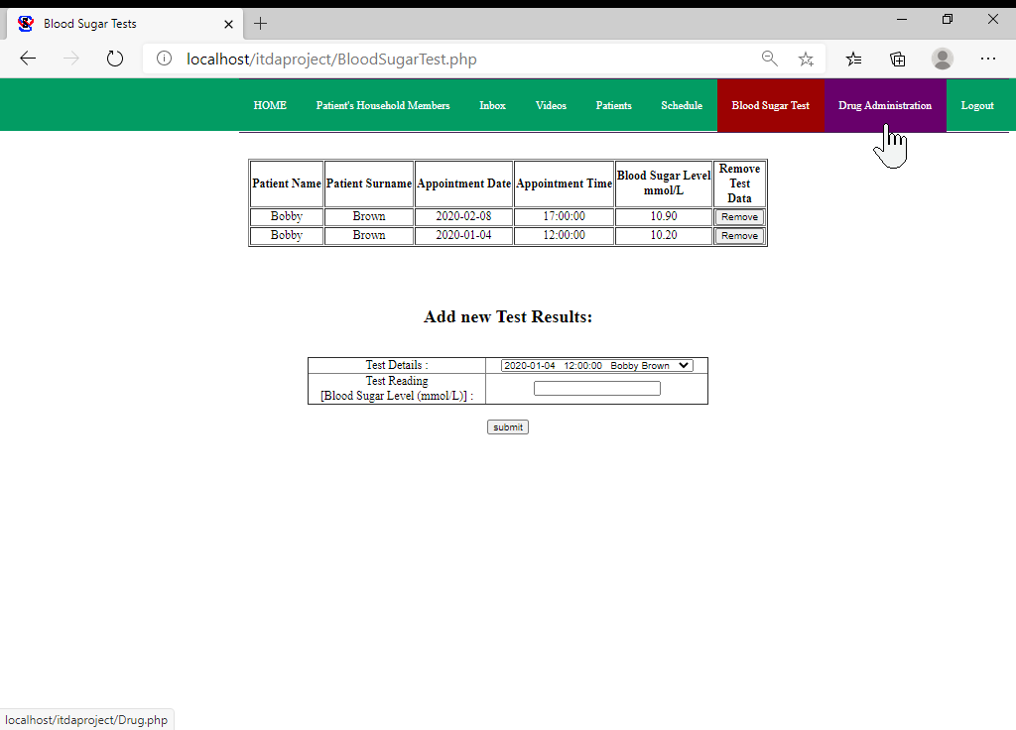

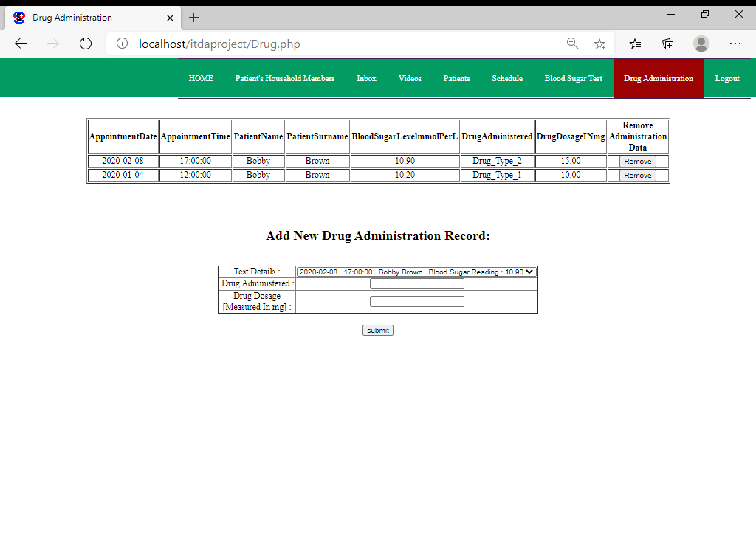

As shown above the “Drug Administration” page deals with information associated to the drugs the community healthcare worker administrates following a blood sugar test (as described in the scenario). The first step in administrating drugs to a patient involves selecting their blood sugar test results from the dropdown menu as shown in the screenshot beneath:

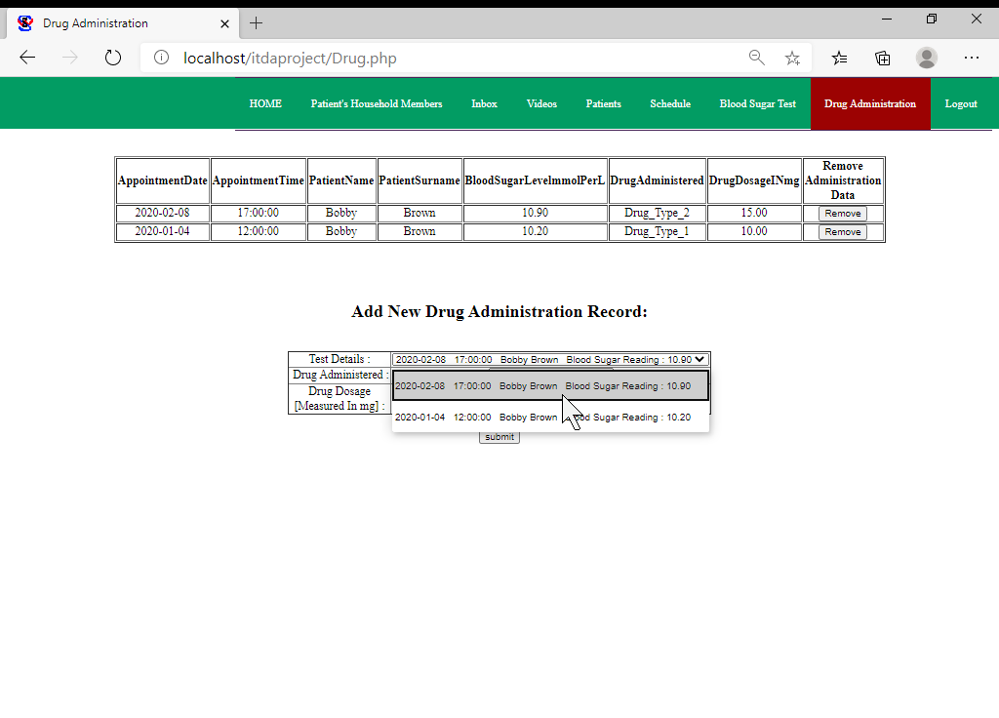

After the relevant test data has been selected the information pertaining to the drug is entered and submitted:

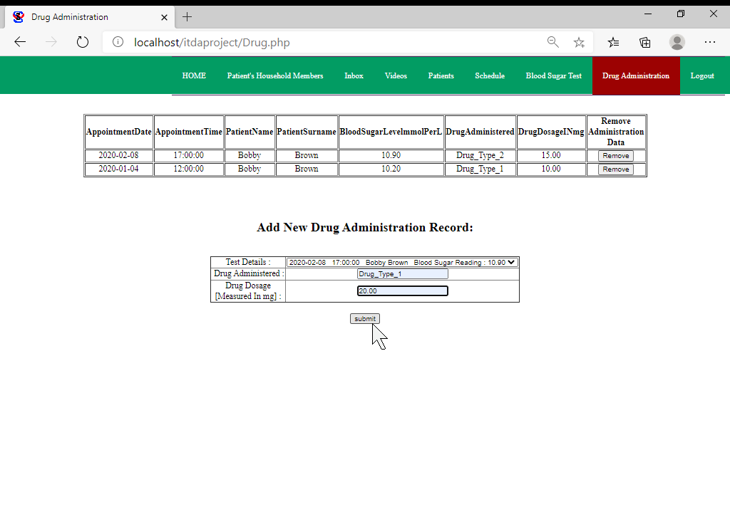

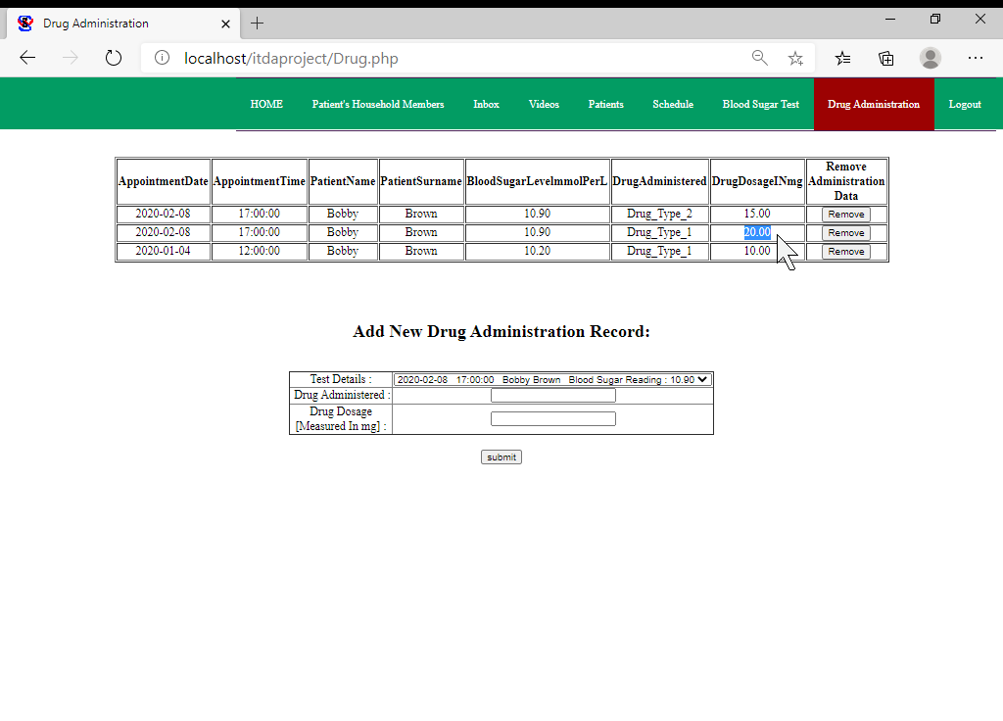

In the case that the community healthcare worker wishes to remove drug administration information they previously entered into the system, they can do so by clicking on the relevant “Remove” button as shown below :

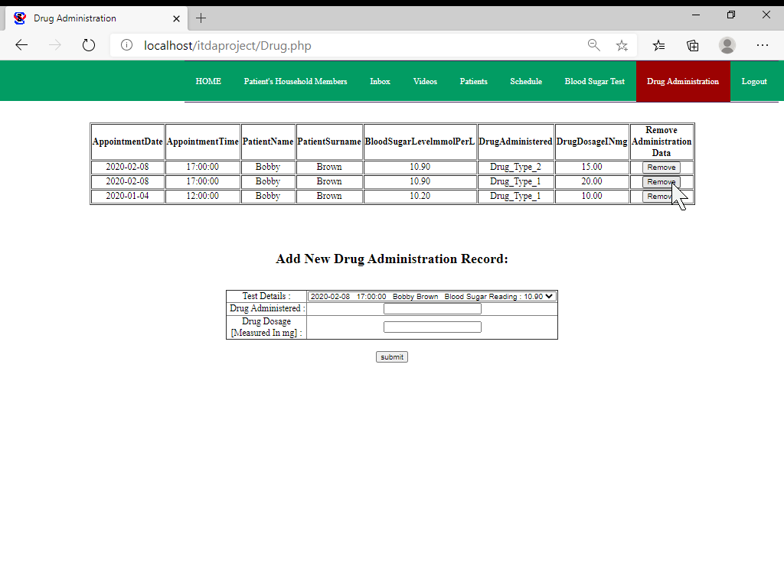

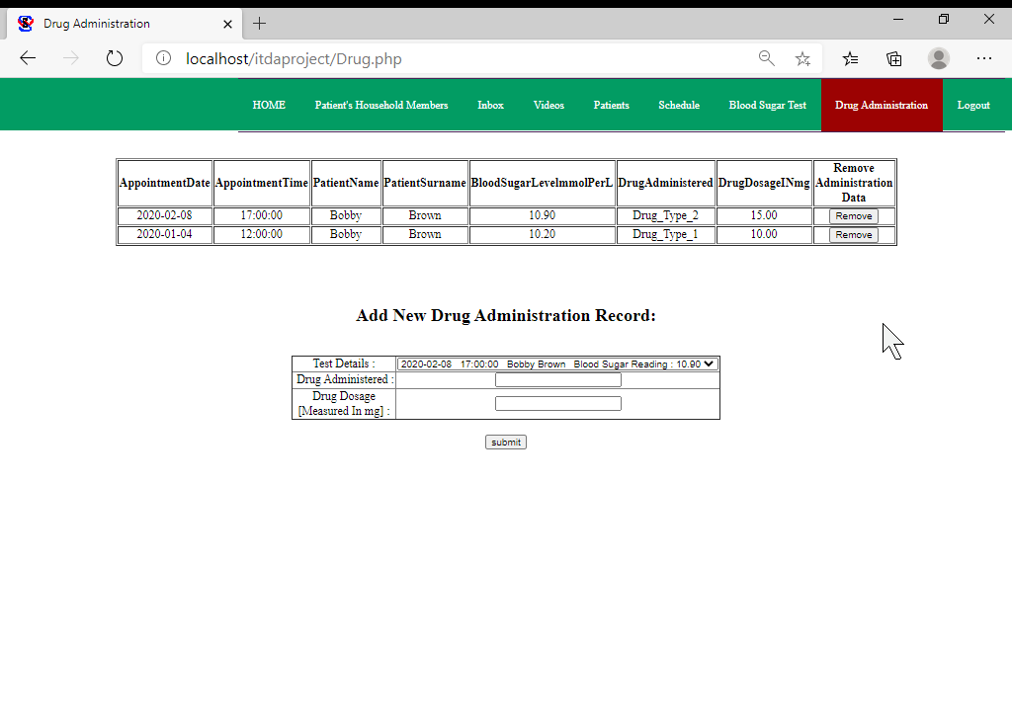

I once again did not deem it necessary to include update functionality due to the limited information associated to drug administrations conducted by community healthcare workers.

The final tab of the navigation bar is the “Logout” tab that redirects the logged in community healthcare worker back to the login page and gets rid of their current session’s information, requiring them to log in once more in order to access the features provided by the interface:

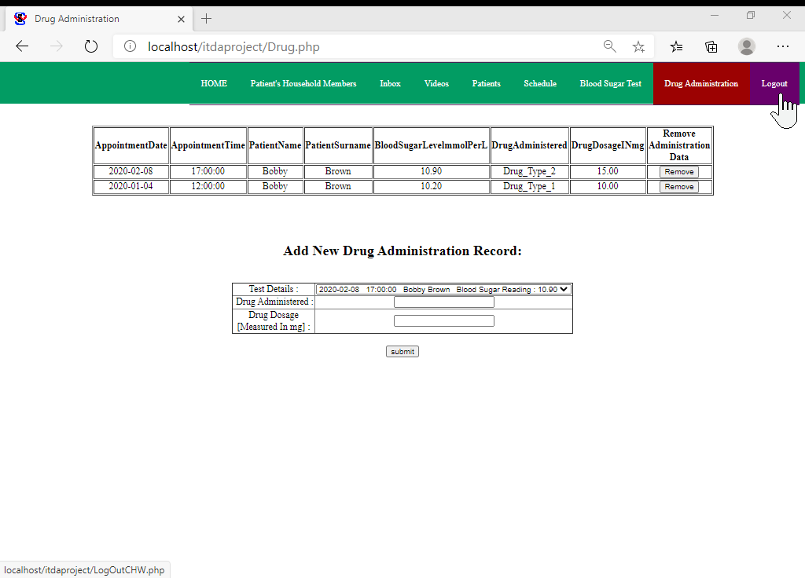

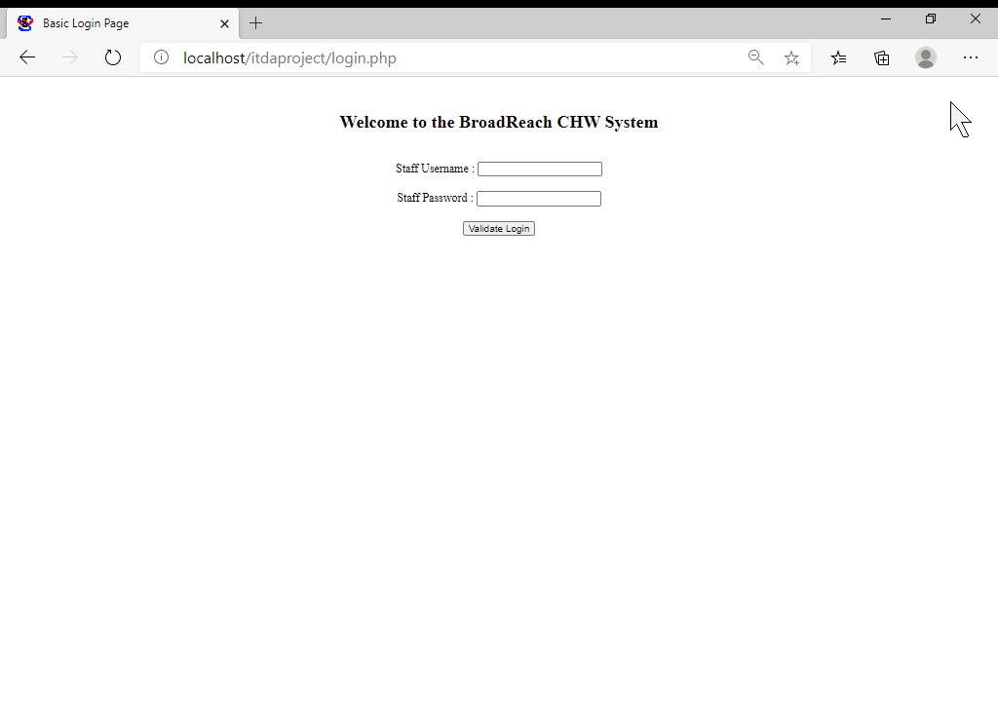

## Code Samples

The following image displays the logic for the login screen:

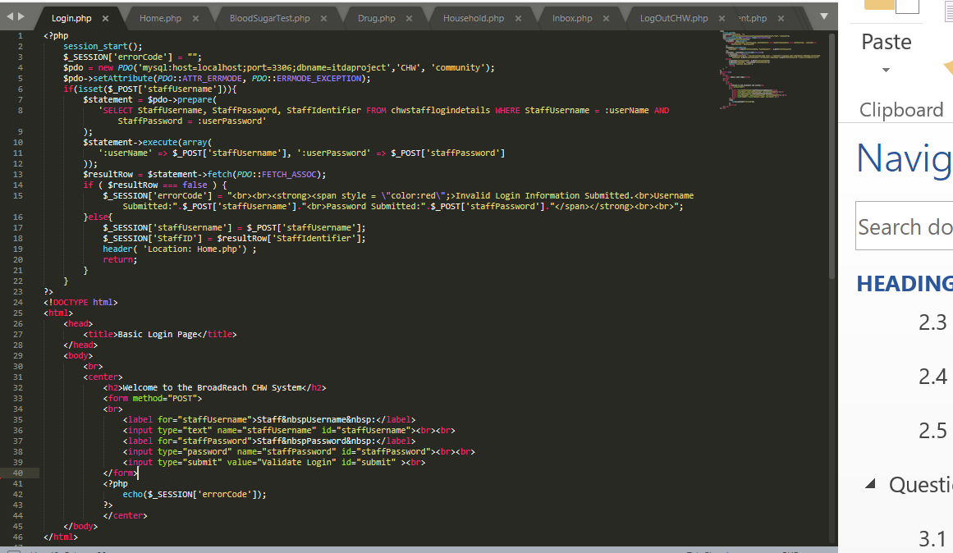

Note that lines 3 till 5 deal with the connection to the database that in this case uses the “CHW” user’s details created in Question 3.5. Line 6 till 22 deal with the logic that allows valid users to log in and displays an error to those that provide invalid login details.

The following image displays the code behind the Home page:

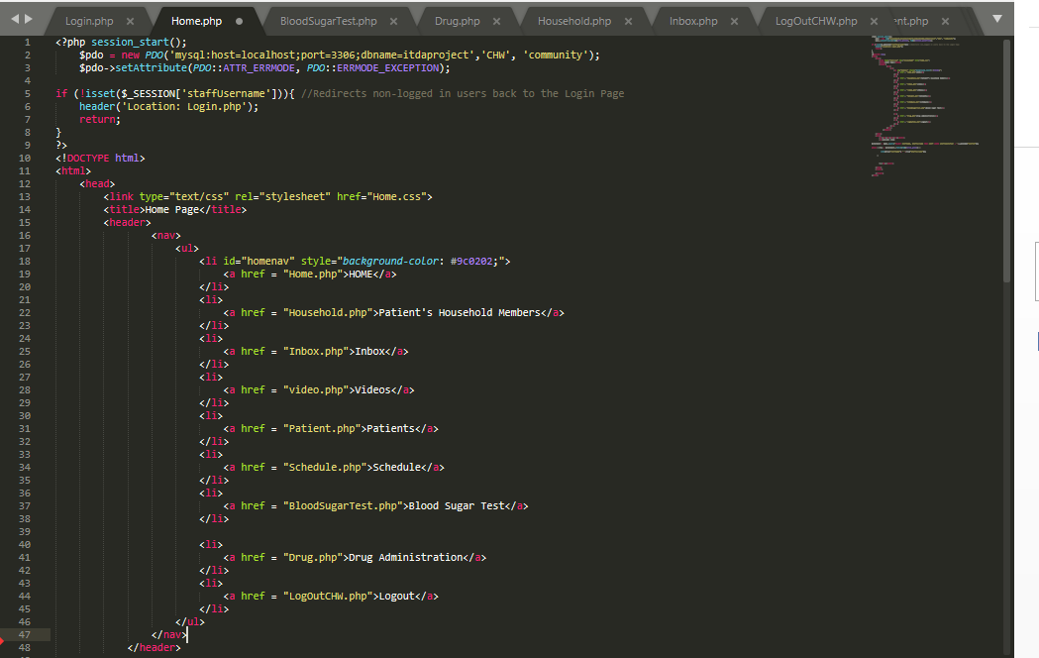

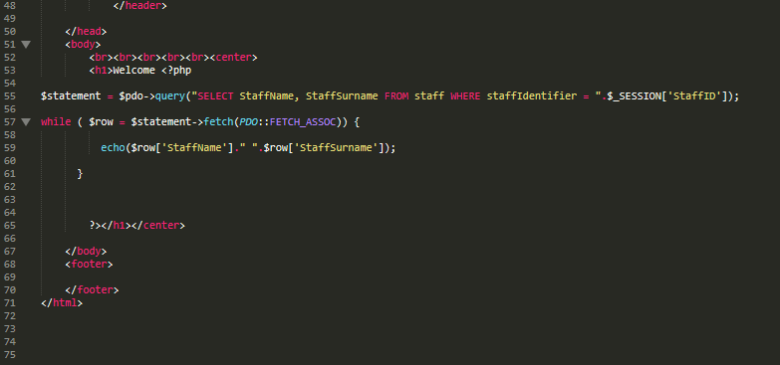

Note that lines 12 till 48 contains the code for the navigation bar that’s similar across all pages that feature it. Lines 55 till 61 are responsible for retrieving the logged in user’s name and surname from the database in order to welcome them personally.

The following few screenshots display code samples from the BloodSugarTest page:

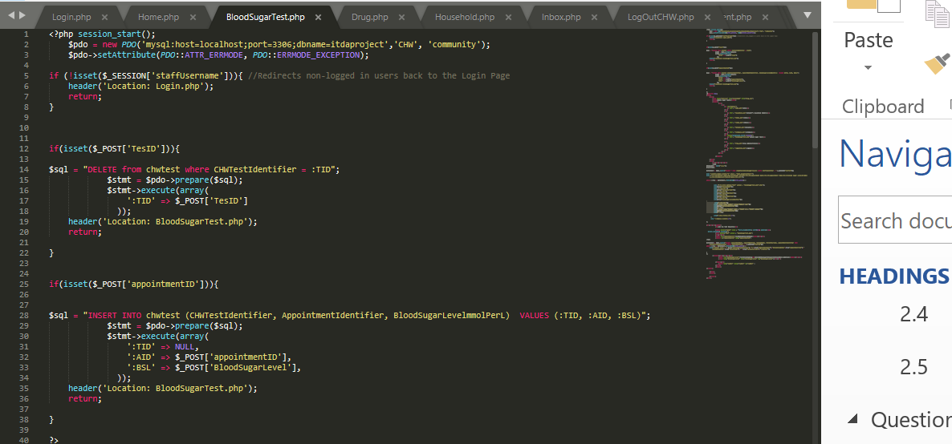

Lines 12 till 22 deal with information being deleted from the chwtest table, while lines 25 till 38 deal with information being inserted to the table.

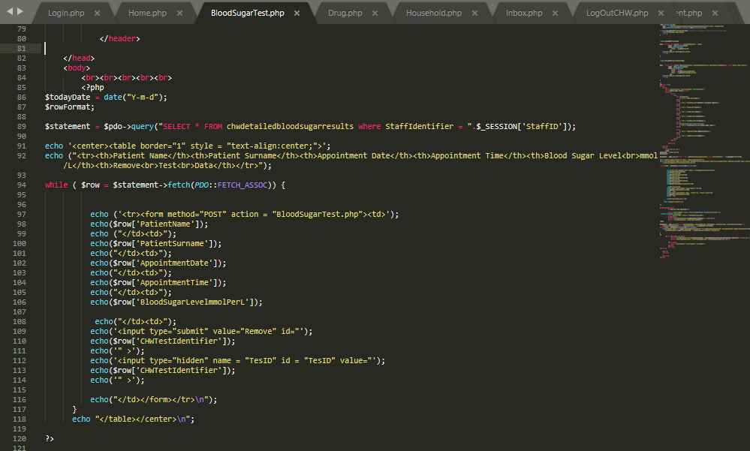

Lines 85 till 120 display how the table illustrating blood sugar results gets formatted after retrieving information from the database.

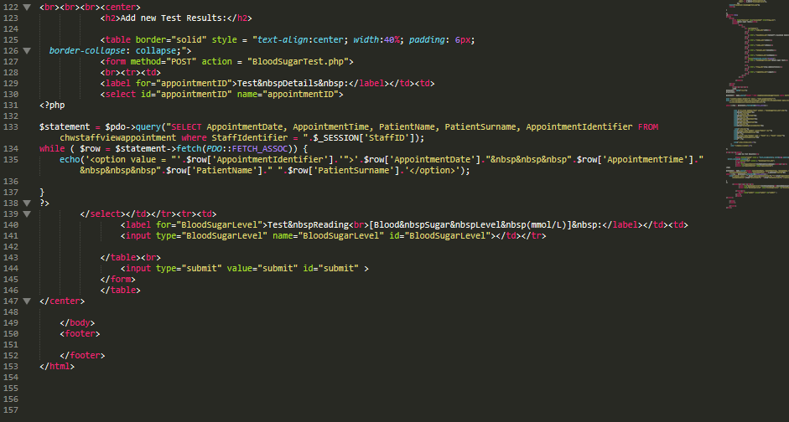

Lines 125 till 146 display the code associated to the table via which new test results are captured.

The following images display code associated to the “Drug” page via which new drugs are administered by the community healthcare worker to their patients.

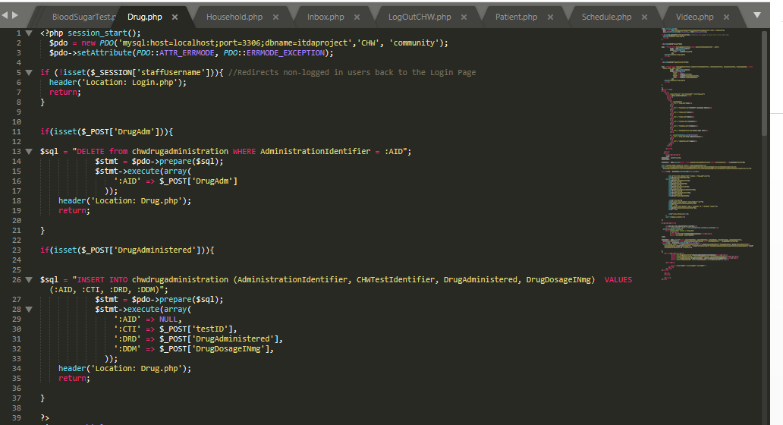

Lines 11 till 21 deal with information being deleted form the chwdrugadministration table whereas lines 26 till 37 deal with information being inserted into it.

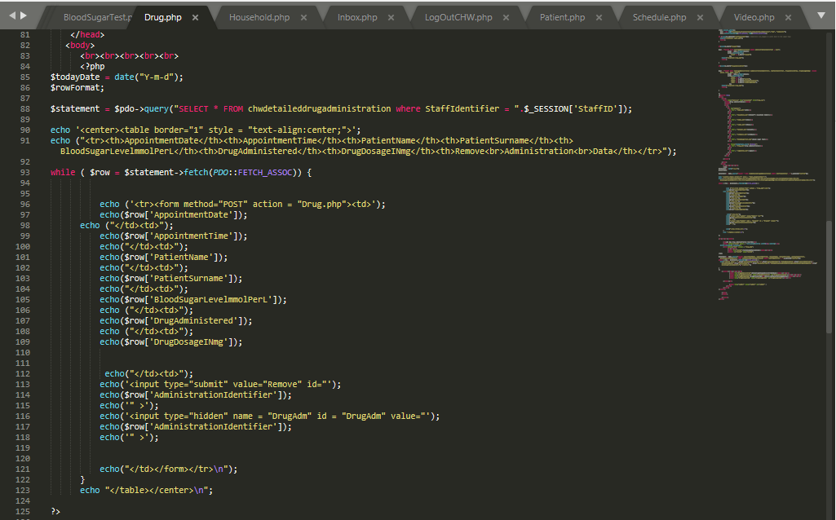

Lines 84 till 125 deal with the formatting and retrieving of drug administration information via the chwdetaileddrugadministration view created in Question 3.4.

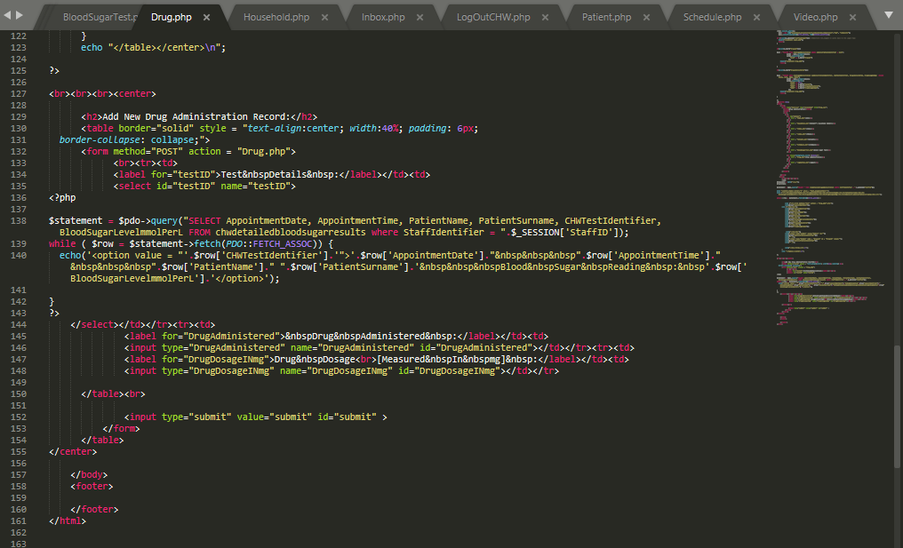

Lines 130 till 154 create the table through which new drug administration information can be added to the database.

The following images display parts of the code that in turn create the “Household” page via which information relating to the household members of patients can be managed:

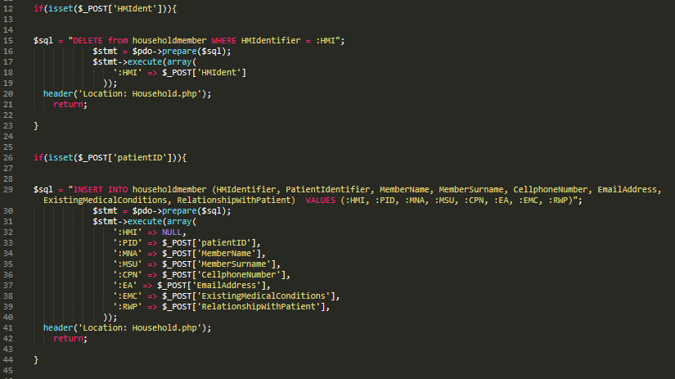

Lines 12 till 23 deal with a household member’s information being deleted from the database where lines 26 till 44 deal with a new household member’s information being added to the database.

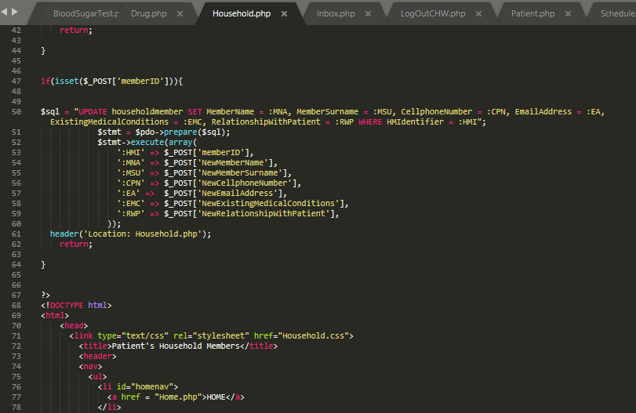

Lines 47 till 64 deal with the details of a household member being updated in the database.

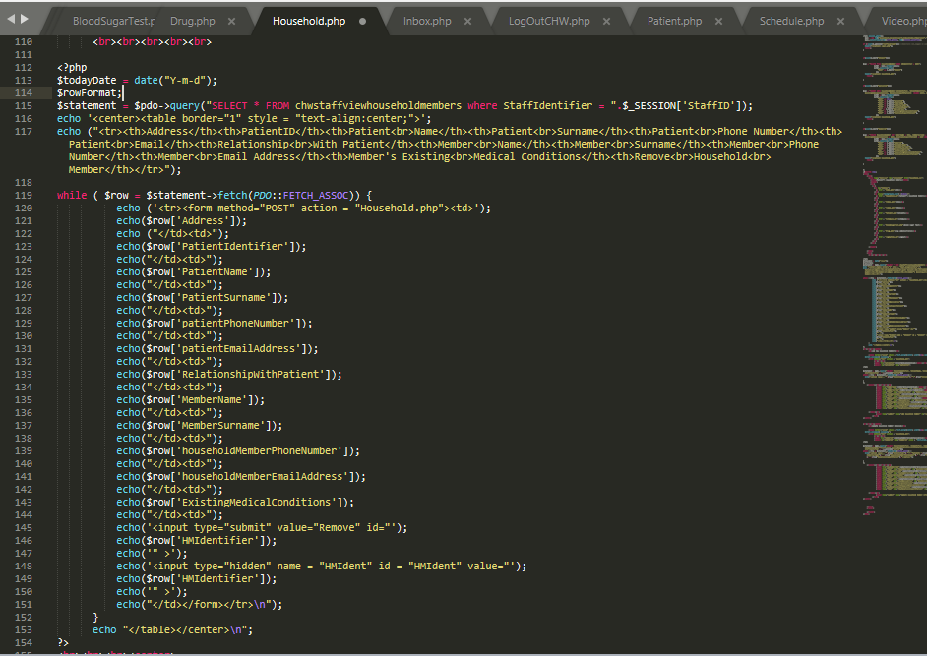

Lines 112 till 154 are responsible for retrieving and formatting the information that displays details of patients and their household members via the chwstaffviewhouseholdmembers view created in Question 3.4.

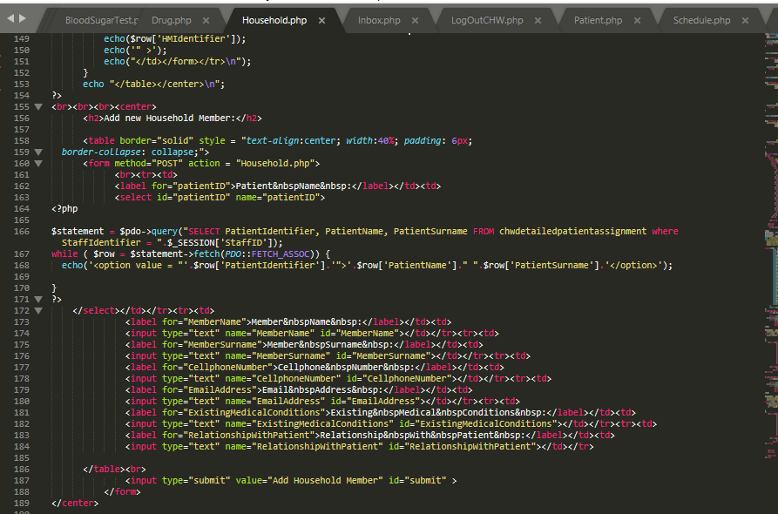

Lines 158 till 188 are responsible for the creation of the table via which a new household member’s information can be added to the database.

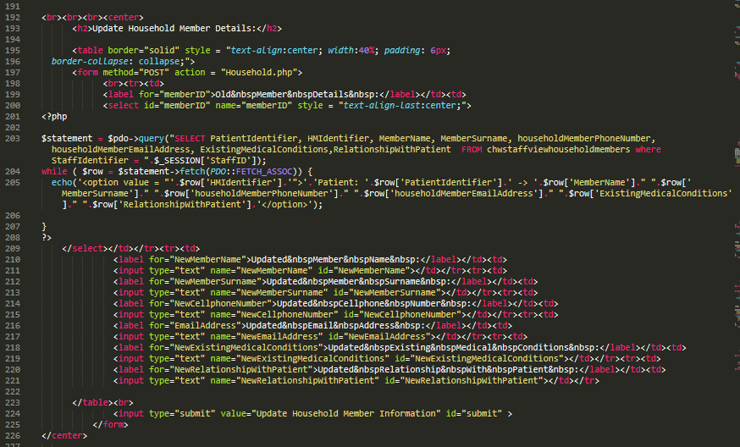

Lines 195 till 225 are responsible for creating the table through which the information of household members can be updated in the database.

The following Screenshot displays a part of the code responsible for the “Inbox” page’s functionality:

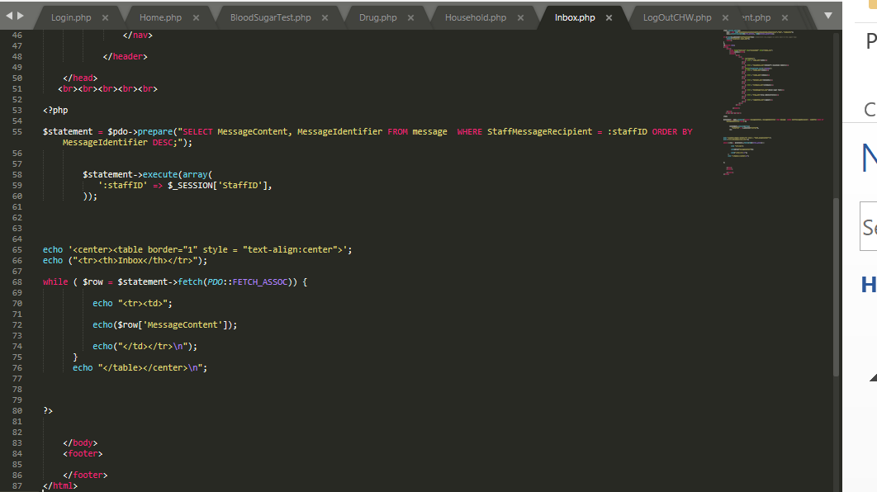

Lines 53 through to 80 are responsible for retrieving all messages issued to the currently logged in community healthcare worker, displaying the newest messages at the top of the table.

The following code illustrates the logout functionality of the interface called upon when “Logout” is selected from the navigation bar:

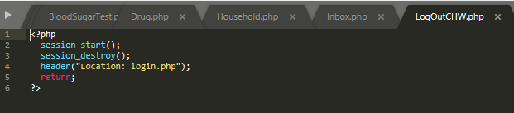

The following image displays the code (line 53 till 82) responsible for retrieving the information pertaining to patients assigned to the currently logged in community healthcare worker and displaying it in tabular form on the “Patients” page:

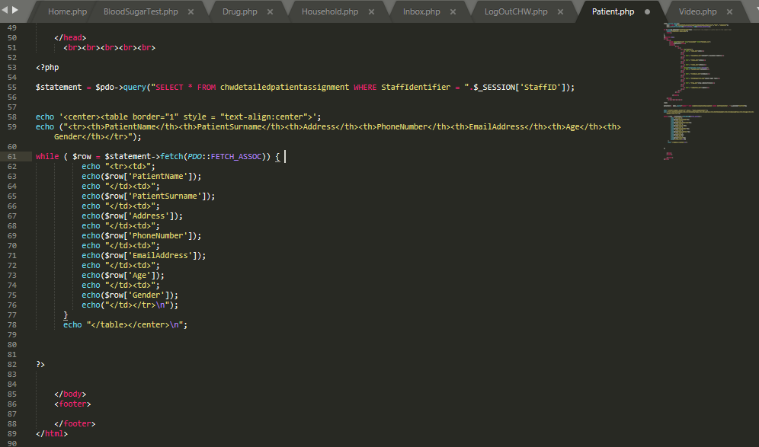

Lines 53 till 108 displayed in the following two images are responsible for creating the table displaying the community healthcare worker’s appointment information on the “Schedule” page:

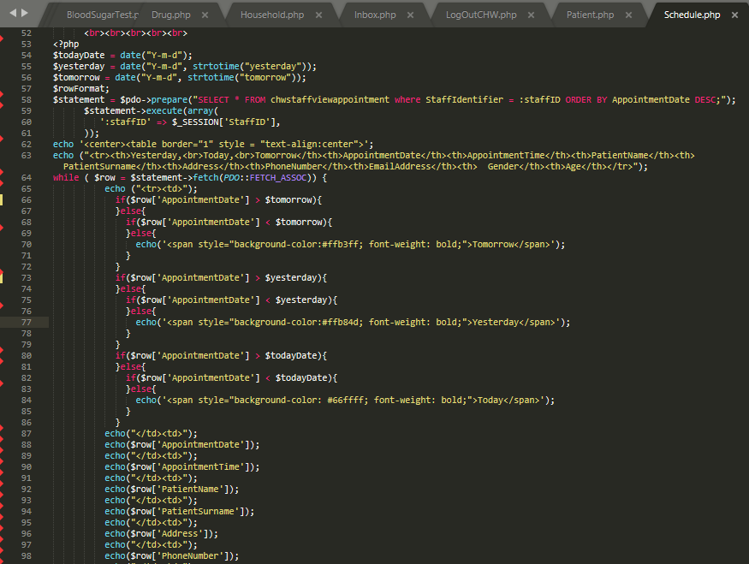 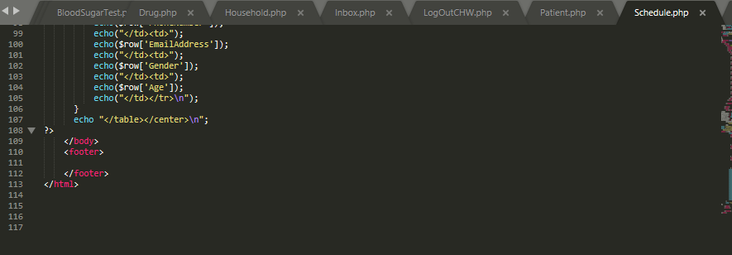

Lines 54 till 90 in the following image is responsible for retrieving and formatting information related to educational videos from the database and display it in tabular form to the community healthcare worker: 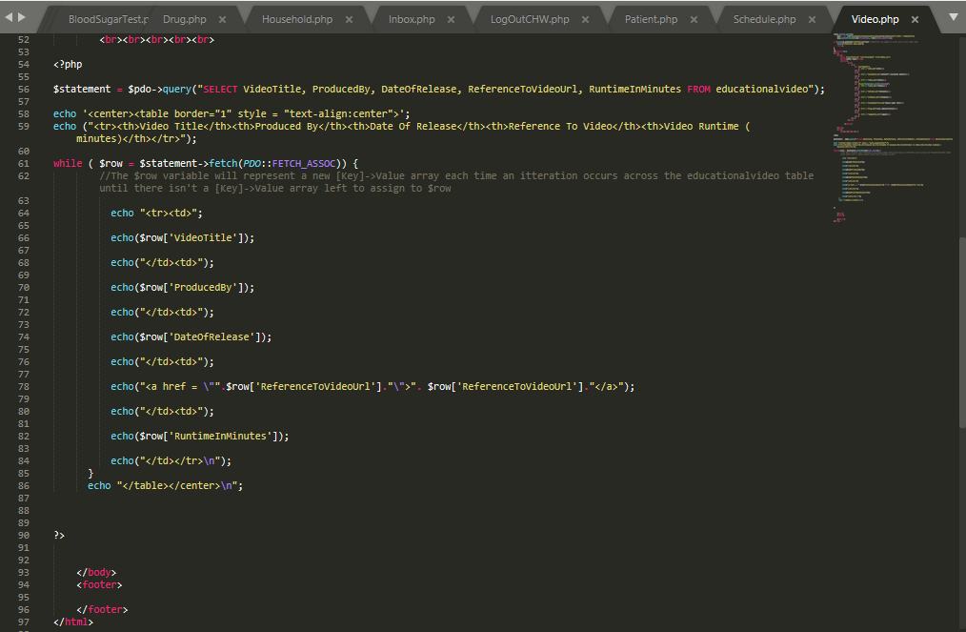

# Bibliography

Baron, A. & Chipman, M., 2000. *Creating and Optimizing Views in SQL Server.* [Online]   
Available at: https://www.informit.com/articles/article.aspx?p=130855  
[Accessed 26 May 2020].

Bowman, J. S., 2002. *Practical SQL: Making the Best Use of Views.* [Online]   
Available at: https://www.informit.com/articles/article.aspx?p=26641  
[Accessed 03 June 2020].

Buckler, C., 2011. *How to Create Triggers in MySQL.* [Online]   
Available at: https://www.sitepoint.com/how-to-create-mysql-triggers/  
[Accessed 27 May 2020].

Connolly, T. & Begg, C., 2015. Logical Database Design Methodology for the Relational Model. In: *Database Systems A Practical Approach to Design, Implementation, and Management 6th Edition.* s.l.:Pearson, p. 553.

Cox, J., 2010. *Introduction to MySQL Triggers.* [Online]   
Available at: https://code.tutsplus.com/articles/introduction-to-mysql-triggers--net-12226  
[Accessed 27 May 2020].

Geschwinde, E. & Schoenig, H.-J., 2002. *An Introduction to SQL.* [Online]   
Available at: https://www.informit.com/articles/article.aspx?p=25959  
[Accessed 02 June 2020].

Gilfillan, I., 2005. *MySQL Stored Procedures: Part 1.* [Online]   
Available at: https://www.databasejournal.com/features/mysql/article.php/3525581/MySQL-Stored-Procedures-Part-1.htm  
[Accessed 02 June 2020].

Gravelle, R., 2012. *The Wonderful (and not so Wonderful) Things about MySQL Triggers.* [Online]   
Available at: https://www.databasejournal.com/features/mysql/the-wonderful-and-not-so-wonderful-things-about-mysql-triggers.html  
[Accessed 27 May 2020].

Harkins, S., 2003. *Relational databases: Applying the First Normal Form.* [Online]   
Available at: https://www.techrepublic.com/article/relational-databases-applying-the-first-normal-form/  
[Accessed 20 May 2020].

Lafferty, P., 2017. *MySQL Stored Procedures 101.* [Online]   
Available at: https://medium.com/@peter.lafferty/mysql-stored-procedures-101-6b4fe230967  
[Accessed 02 June 2020].

Palmer, J., 2020. *Grant Permissions to a MySQL User on Linux via Command Line.* [Online]   
Available at: https://www.liquidweb.com/kb/grant-permissions-to-a-mysql-user-on-linux-via-command-line/  
[Accessed 11 June 2020].

Punt, T., 2012. *Action Automation with MySQL Triggers.* [Online]   
Available at: https://www.sitepoint.com/action-automation-with-mysql-triggers/  
[Accessed 27 May 2020].

Razzoli, F., 2019. *MySQL stored procedures: all ways to produce an output.* [Online]   
Available at: https://federico-razzoli.com/mysql-stored-procedures-all-ways-to-produce-an-output  
[Accessed 01 June 2020].

SQL WORLD, 2019. *Second Normal Form | 2NF with Examples | 2nd Normal Form.* [Online]   
Available at: https://www.complexsql.com/second-normal-form/  
[Accessed 20 May 2020].

Ulman, L., 2003. *MySQL Database Design - Third Normal Form.* [Online]   
Available at: https://www.peachpit.com/articles/article.aspx?p=30885&seqNum=6  
[Accessed 20 May 2020].